Just In Time Quick Check

Standard of Learning (SOL) 2.15a
Strand: Probability and Statistics

Standard of Learning (SOL) 2.15a
The student will collect, organize, and represent data in pictographs and bar graphs.

Grade Level Skills:
- Collect and organize data using various forms of data collection (e.g., lists, tables, objects, pictures, symbols, tally marks, charts). Data points, collected by students, should be limited to 16 or fewer for no more than four categories.
- Represent data in pictographs and bar graphs (limited to 16 or fewer data points for no more than four categories).
Just in Time Quick Check
Just in Time Quick Check Teacher Notes

Supporting Resources:
- VDOE Mathematics Instructional Plans (MIPS)
- 2.15ab - Real Data! (Word) / PDF Version
- 2.15ab - What Does the Data Tell Us? (Word) / PDF Version
- VDOE Word Wall Cards: Grade 2 (Word) | (PDF))
  - Table
  - Bar Graph
  - Pictograph

Supporting and Prerequisite SOL: 1.12a, K.11a

SOL 2.15a - Just in Time Quick Check
- James went on a walk in the forest. He made this tally chart of the animals he saw.

Animals | Tally
Rabbit | |||
Eagle | |
Squirrel | |||| ||
Fox | |||

Use the tally chart to create a bar graph.
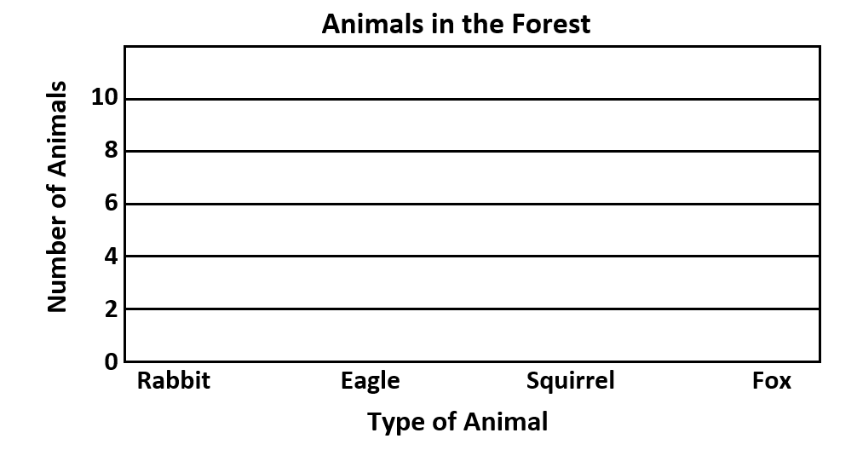

- Create a pictograph using the data in the tally chart. Give the pictograph a title.

Animals | Tally
Rabbit | |||
Eagle | |
Squirrel | |||| ||
Fox | |||

_______________________
Rabbit | .
Eagle | .
Squirrel | .
Fox | .
Key: = 2 animals

- This picture shows the balls in the school gym. 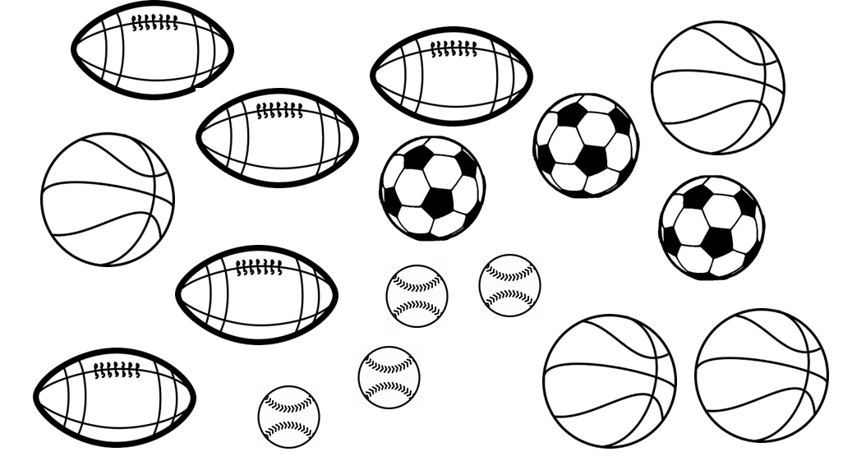
- Complete the tally chart to show the number of each type of ball.

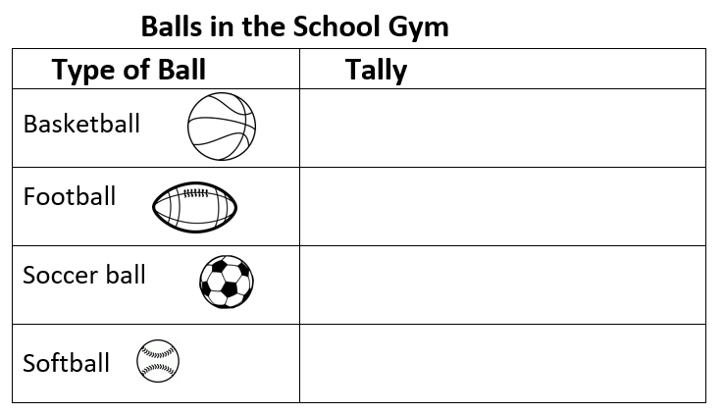

- Create a pictograph to show the same information in the tally chart.
  - Use the symbol in the key.
  - Give the pictograph a title.

_________________________
Key: = 2 balls

SOL 2.15a - Just in Time Quick Check Teacher Notes
Common Errors/Misconceptions and their Possible Indications

- James went on a walk in the forest. He made this tally chart of the animals he saw.
Type of Animal
Animals | Tally
Rabbit | |||
Eagle | |
Squirrel | |||| ||
Fox | |||

Use the tally chart above to create a bar graph.
Students may shade a bar next to the animal’s name instead of above the names, or they may not leave space between the bars. These students need more experiences creating bar graphs to represent data collected.
Students may not stop the bar used to represent an odd number halfway between the horizontal lines, which may indicate students do not understand how to use the scale when determining the height of the bar. These students may need more experiences creating graphs with different scale increments. Opportunities to first represent the same data on two bar graphs having different scale increments and then compare and contrast the resulting graphs will be beneficial.

- Create a pictograph using the data in the tally chart. Give the pictograph a title.
Animals | Tally
Rabbit | |||
Eagle | |
Squirrel | |||| ||
Fox | |||

_______________________

Rabbit | .
Eagle | .
Squirrel | .
Fox | .
Key: = 2 animals

Students who use the same number of complete circles for each category as the number of animals may not understand how to use the information in the key to represent the number of animals. These students may need more experience counting by twos or translating the tallies to a number. Opportunities to use counters to represent the tallies and then group the counters to correspond to the symbol in the key may help students develop an understanding of the relationship between these different representations of the same data. Some students may have difficulty deciding how to represent an odd number of animals using a circle (or oval).
Students might represent each category with a different picture. In a pictograph, all symbols must remain the same for each category and must correspond to the symbol in the key. Creating class pictographs to represent data collected during daily activities (e.g., the number of different genres of books checked out from the library, the number of students buying different foods from the cafeteria, etc.) may be helpful.

- This picture shows the balls in the school gym.
- Complete the tally chart to show the number of each type of ball.

Students may not include all of the balls shown in the picture, which may indicate the students need more experience organizing data sets to develop strategies for keeping track when data are provided in a picture. Students may benefit from exposure to peers’ strategies for organizing pictorial data shared and modeled during classroom discussions.
- Create a pictograph to show the same information in the tally chart.
  - Use the symbol in the key.
  - Give the pictograph a title.

_________________________
Key: = 2 balls

Students might have difficulty transferring the data from the picture into the graph using the triangle symbol. They may use one triangle to represent each ball, which indicates the students are counting by ones instead of by twos. These students will benefit from more experiences collecting data using a table or chart and creating a pictograph where each symbol represents more than one data element. Students may need to be reminded that they need to list the names of the balls in the left column.

