Just In Time Quick Check

Standard of Learning (SOL) 2.12b
Strand: Measurement and Geometry

Standard of Learning (SOL) 2.12
The student will identify and create figures with at least one line of symmetry.

Grade Level Skills:
- Identify figures with at least one line of symmetry, using various concrete materials (e.g., mirrors, paper folding, pattern blocks).
- Determine a line of symmetry that results in two figures that have the same size and shape and explain reasoning.
- Create figures with at least one line of symmetry using various concrete materials.
Just in Time Quick Check
Just in Time Quick Check Teacher Notes

Supporting Resources:
- VDOE Mathematics Instructional Plans (MIPS)
  - 2.12ab – Symmetrical Cube Designs (Word) / PDF Version
  - 2.12ab – Symmetrical Shape Fun (Word) / PDF Version
- VDOE Co-Teaching Mathematics Instruction Plans (MIPS)
  - 2.12 – Symmetry (Word) / PDF Version
- VDOE Word Wall Cards: Grade 2 (Word / PDF)
  - Symmetry
Supporting and Prerequisite SOL: 2.12a

SOL 2.12b - Just in Time Quick Check
- Part of a design is shown. The line touching the shapes will be a line of symmetry after the design is completed. In order to complete the design:
    - Cut out the shapes at the bottom of the page. Use the shapes to complete the design.
    - Be sure your design uses the line of symmetry.

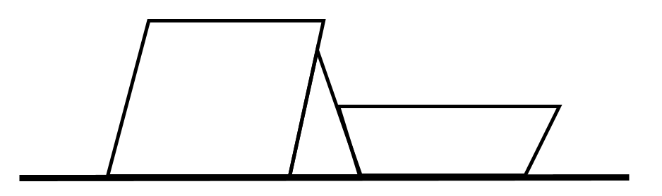

Some of the figures below have at least one line of symmetry.
- Circle every figure that has at least one line of symmetry. Draw a line of symmetry on each of these figures.
- Put an X on the figures that do not have at least one line of symmetry.
- Write a sentence to tell how you decided which figures had at least one line of symmetry and which ones did not.

__________________________________________________
__________________________________________________

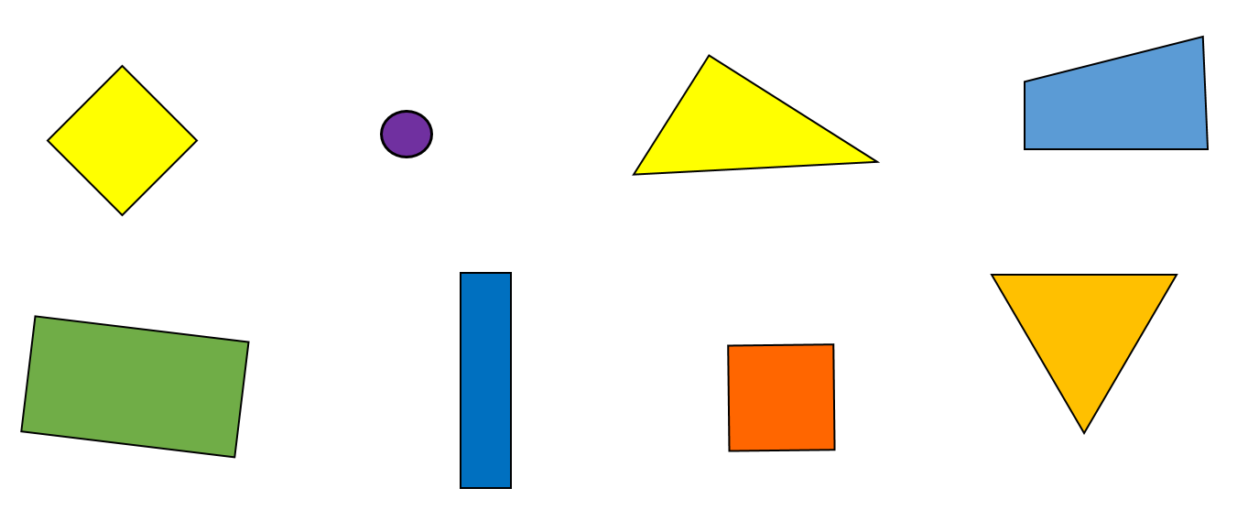

SOL 2.12b - Just in Time Quick Check Teacher Notes
Common Errors/Misconceptions and their Possible Indications
- Part of a design is shown. The line touching the shapes will be a line of symmetry after the design is completed. In order to complete the design:
    - Cut out the shapes at the bottom of the page. Use the shapes to complete the design.
    - Be sure your design uses the line of symmetry.
Students may build designs below the line that are the same image as above but not a mirror image. As students engage in additional symmetry lessons, it may help for these students to think about actually flipping the image to the other side. Folding along the line of symmetry to trace the design on the back of the paper with a marker, or using mirrors or miras, may also help students see what the symmetrical image should look like.

Some of these figures have at least one line of symmetry.
- Circle every figure that has at least one line of symmetry. Draw a line of symmetry on each of these figures. Use a piece of string or a ruler if needed.
- Put an X on the figures that do not have at least one line of symmetry.
- Write a sentence to tell how you decided.

__________________________________________________
__________________________________________________
Students may find it more difficult to recognize figures that have a line of symmetry when the line of symmetry is not horizontal or vertical. Student may have difficulty determining which triangle is not symmetrical and which has at least one line of symmetry. Students may believe all figures with four sides have at least one line of symmetry and circle all of the quadrilaterals. Teachers may find it helpful to use examples and nonexamples to help students see symmetry. Students benefit from hearing classmates’ reasoning about lines of symmetry, and hands-on materials (e.g. using string to determine lines of symmetry on pattern blocks or with figures on geoboards, paper figures that can be folded, etc.) will be helpful.

