Just In Time Quick Check

Standard of Learning (SOL) 2.12a
Strand: Measurement and Geometry

Standard of Learning (SOL) 2.12a
The student will draw a line of symmetry in a figure.

Grade Level Skills:
- Draw a line of symmetry in a figure.
- Determine a line of symmetry that results in two figures that have the same size and shape and explain reasoning.
Just in Time Quick Check
Just in Time Quick Check Teacher Notes

Supporting Resources:
- VDOE Mathematics Instructional Plans (MIPS)
  - 2.12ab – Symmetrical Cube Designs (Word) / PDF Version
  - 2.12ab – Symmetrical Shape Fun (Word) / PDF Version
- VDOE Co-Teaching Mathematics Instruction Plans (MIPS)
  - 2.12 – Symmetry (Word) / PDF Version
- VDOE Word Wall Cards: Grade 2 (Word) | (PDF)
  - Symmetry
Supporting and Prerequisite SOL: none

SOL 2.12a - Just in Time Quick Check

- Draw a line of symmetry for each shape.

- Circle the examples that show a line of symmetry. Explain how you know.
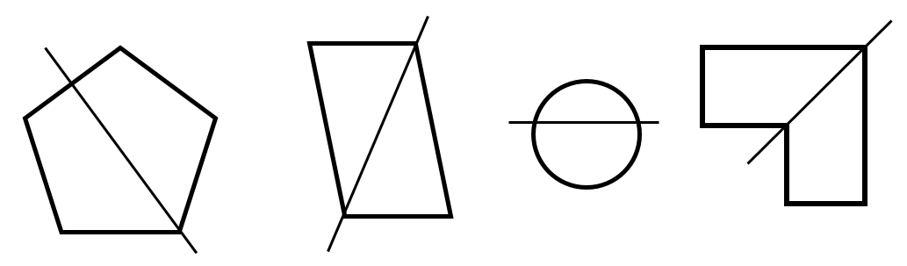

_________________________________________________
_________________________________________________
_________________________________________________

SOL 2.12a - Just in Time Quick Check Teacher Notes
Common Errors/Misconceptions and their Possible Indications

- Draw a line of symmetry for each shape.

≈≈

Students may draw a horizontal line that is not at the correct location, resulting in two figures that are not congruent. Students may also draw their lines vertically. Students will benefit from opportunities to use lines to divide a variety of figures into two parts and discuss whether the line results in two parts that are mirror images (reflections). Considering and discussing examples and nonexamples of lines of symmetry with classmates will be beneficial.

Students may draw a line from the vertex at the top of the triangle to the middle of the base of the triangle, which may indicate they are having difficulty finding a line of symmetry that is not horizontal or vertical. Students will benefit from opportunities to explore symmetry with figures in a variety of orientations. They may also find it helpful to actually fold figures to find the line of symmetry.

Students may draw a diagonal line to show symmetry. While a diagonal line in this case does subdivide the rectangle into equal parts, the parts are not mirror images of each other; therefore, the diagonal is not a line of symmetry.
It may help students to cut out the shapes and fold them to see where the line of symmetry is and how the two sides match up (are congruent). Paper folding and mirrors/miras may be helpful for students to see that both sides match when the line of symmetry is drawn.
- Circle the examples that show a line of symmetry. Explain how you know.

_______________________________________________
_______________________________________________
_______________________________________________
Students may not select the pentagon because the line of symmetry is not vertical. Students may select the parallelogram because the diagonal creates two triangles that are the same size and shape (congruent) but not symmetrical. Students may select the circle because of the horizontal line but fail to recognize that the two parts are not equal or symmetrical. Students may not select the hexagon because it is a concave figure.
Students need additional hands-on experiences to consider and discuss examples and nonexamples of lines of symmetry. Cutting out shapes and folding along the line, as well as activities with mirrors will help students confirm or reconsider their decisions.

