Just In Time Quick Check

Standard of Learning (SOL) 2.11
Strand: Measurement and Geometry

Standard of Learning (SOL) 2.11
The student will read temperature to the nearest 10 degrees.

Grade Level Skills:
- Identify different types of thermometers as instruments used to measure temperature.
- Read temperature in Fahrenheit to the nearest ten degrees on thermometers (real world, physical model, and pictorial representations).
Just in Time Quick Check
Just in Time Quick Check Teacher Notes

Supporting Resources:
- VDOE Mathematics Instructional Plans (MIPS)
  - 2.11 - A Fine Day For … (Word) / PDF Version
- VDOE Word Wall Cards: Grade 2 (Word) | (PDF)
  - Thermometer
Supporting and Prerequisite SOL: 2.2a, 1.1d, K.9

SOL 2.11 - Just in Time Quick Check
- Color the thermometer to show a temperature of 70 degrees Fahrenheit.
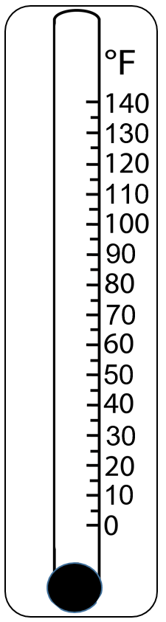

- The temperature shown on this thermometer is close to _________________.

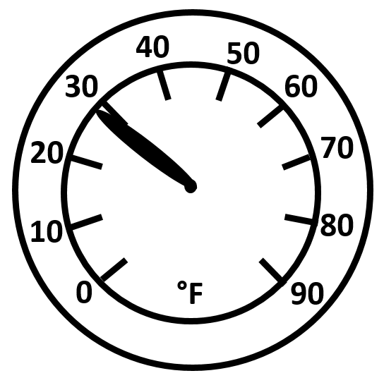

SOL 2.11 - Just in Time Quick Check Teacher Notes
Common Errors/Misconceptions and their Possible Indications
- Color the thermometer to show a temperature of 70 degrees Fahrenheit.
Students may disregard the numbers and color the entire thermometer, or they may color the thermometer to show 65°F or 75°F. These students would benefit from more experiences reading temperatures on thermometers and representing different temperatures using pictorial representations. Incorporating measurement activities with physical thermometers into the regular daily classroom routine is helpful in building conceptual understanding of temperature and the Fahrenheit scale.

- The temperature shown on this thermometer is close to _________________.
Students who say the temperature is close to 20°F instead of 30°F may need additional experiences reading thermometers to the nearest ten degrees. Students may benefit from representing the same temperature on a picture of a vertical thermometer and a circular thermometer, as this helps connect the models and may help students recognize the similarities and differences.
Some students may have difficulty with “close to,” which may indicate they do not understand the connection between reading a thermometer to the nearest ten degrees and rounding numbers to the nearest ten. Using a portion of a labeled number line that counts by tens to create a circular model of a thermometer may help students build this understanding.

