Just In Time Quick Check

Standard of Learning (SOL) 2.8b
Strand: Measurement and Geometry

Standard of Learning (SOL) 2.8b
The student will estimate and measure weight to the nearest pound.

Grade Level Skills:
- Identify different types of scales as instruments to measure weight.
- Estimate and then measure the weight of objects to the nearest pound using a scale.
Just in Time Quick Check
Just in Time Quick Check Teacher Notes

Supporting Resources:
- VDOE Mathematics Instructional Plans (MIPS)
  - 2.8b – How Much Does It Weigh (Word / PDF Version
- VDOE Word Wall Cards: Grade 2 (Word) | (PDF)
  - Pound
  - Scale: Weight
Supporting and Prerequisite SOL: 1.10, K.9

SOL 2.8b - Just in Time Quick Check

- Circle each tool that you could use to measure weight.
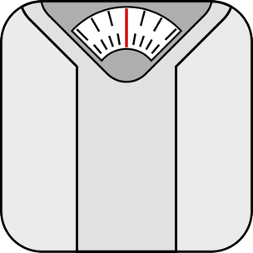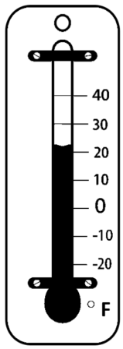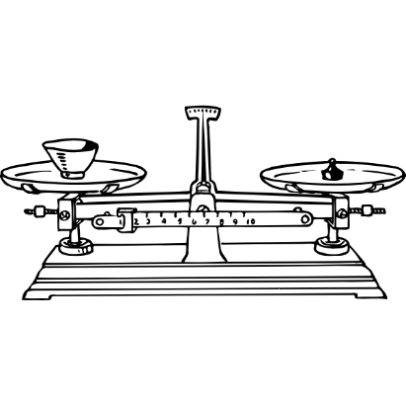

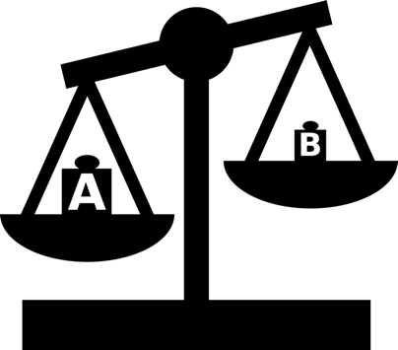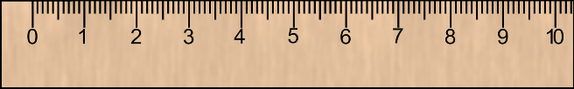

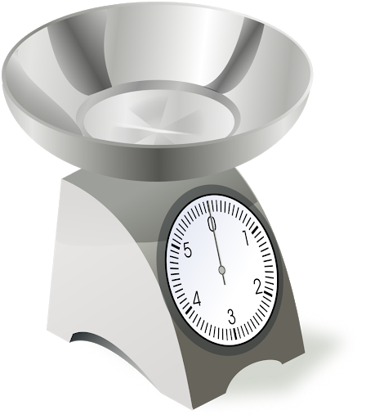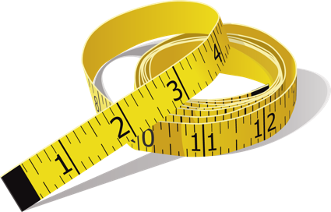

Note to teacher: Provide the student with a set of 4-5 objects that range in weight from less than one pound to more than one pound. At least 1 of the objects should weigh about 1 pound. Students will need a scale to weigh objects in part b and part c.

- Pick one object that you estimate to weigh about one pound.

  - Which object did you pick? _________________________________________________

Use a scale to find the weight and record the object’s weight on the line below.

______________________________________________________________________
  - Think about the weight of the object from question 2a to help you with this question.
For each object your teacher gave you, decide if you think it has a weight that is more than one pound, less than one pound, or about the same as one pound. Record the names of the objects in the chart below.

Objects I think weigh less than one pound: | Objects I think weigh more than one pound: | Objects I think weigh about the same as one pound:

  - Use the scale. Weigh each object. Write the object and its weight in the chart below.
Objects that weigh less than one pound: | Objects that weigh more than one pound: | Objects that weigh about the same as one pound:

SOL 2.8b - Just in Time Quick Check Teacher Notes
Common Errors/Misconceptions and their Possible Indications

- Circle each tool that you could use to measure weight.

Students may not recognize the kitchen scale in the bottom row or the balances as tools that can be used to measure weight. These students need more hands-on experiences measuring the weights of objects using different types of scales. Opportunities to measure the same object using different scales helps students make sense of the similarities and differences among these tools and understand that the weight of an object remains the same even when different scales are used to determine that weight.

Note to teacher: Provide the student with a set of 4-5 objects that range in weight from less than one pound to more than one pound. At least 1 of the objects should weigh about 1 pound. Students will need a scale to weigh objects in part b and part c.

- Pick one object that you estimate to weigh about one pound.

  - Which object did you pick? _________________________________________________

Use a scale to find the weight and record the object’s weight on the line below.
____________________________________________________________________ Students who are unable to identify an object that weighs about one pound need more experiences with everyday objects to establish benchmarks for this weight. Students who record an incorrect weight for the object they selected will benefit from more opportunities to use a variety of scales to determine the weights of objects.
  - Think about the weight of the object from question 2a to help you with this question.
For each object your teacher gave you, decide if you think it has a weight that is more than one pound, less than one pound, or about the same as one pound. Record the names of the objects in the chart below.

Objects I think weigh less than one pound: | Objects I think weigh more than one pound: | Objects I think weigh about the same as one pound:
Students should use their knowledge of the object weighed in the first part of this question to make reasonable estimates for the chart. Students who selected an object in 2a that was not close to one pound will need to determine the object that is close to one pound prior to comparing it to the objects for question 2b. Some students may not use the benchmark at all. For example, if the object picked for question 2a weighed 5 pounds and an object chosen for question 3 is heavier, the estimate should be more than 1 pound. Students who are unable to use the weight found for the first object need more opportunities to estimate, weigh, and compare weights of everyday objects.
  - Use the scale. Weigh each object. Write the object and its weight in the chart below.
Objects that weigh less than one pound: | Objects that weigh more than one pound: | Objects that weigh about the same as one pound:
Students who are unable to find the weight of an object need to have practice using a variety of scales and determining the weight in standard units. In earlier experiences, students will have used non-standard units and may be confused when the unit changes to a standard unit. Give students the opportunity to use standard units in the same ways they have experienced non-standard units. Let them add one-pound weights to a balance scale until the two sides are even (balanced). Have students add standard weights to a kitchen or spring scale to see that each time a one-pound weight is added, the dial points to the number equivalent to the number of pounds on the scale. Activities such as these help students develop benchmarks for standard units and understand how different types of scales are used to measure weight.

