Just In Time Quick Check

Standard of Learning (SOL) 2.8a
Strand: Measurement and Geometry

Standard of Learning (SOL) 2.8a
The student will estimate and measure length to the nearest inch.

Grade Level Skills:
- Identify a ruler as an instrument to measure length.
- Estimate and then measure the length of various line segments and objects to the nearest inch using a ruler.
Just in Time Quick Check
Just in Time Quick Check Teacher Notes

Supporting Resources:
- VDOE Mathematics Instructional Plans (MIPS)
  - 2.8a – Kite Tail Measurement (Word) / PDF Version
- VDOE Word Wall Cards: Grade 2 (Word / PDF)
  - Ruler
Supporting and Prerequisite SOL: 1.10, K.9

SOL 2.8a - Just in Time Quick Check

- Circle each tool that you could use to measure length.

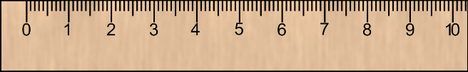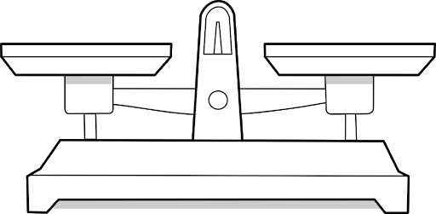
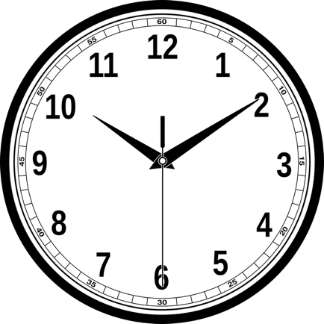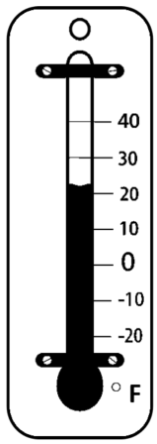

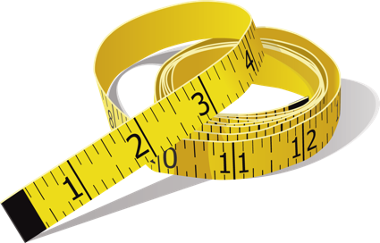

- About how many inches long is this pencil? ____________ inches

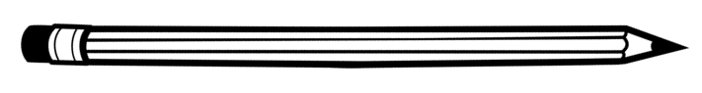
Use a ruler to measure the length of this pencil to the nearest inch. ___________ inches
- Estimate the length of this crayon. ____________inches

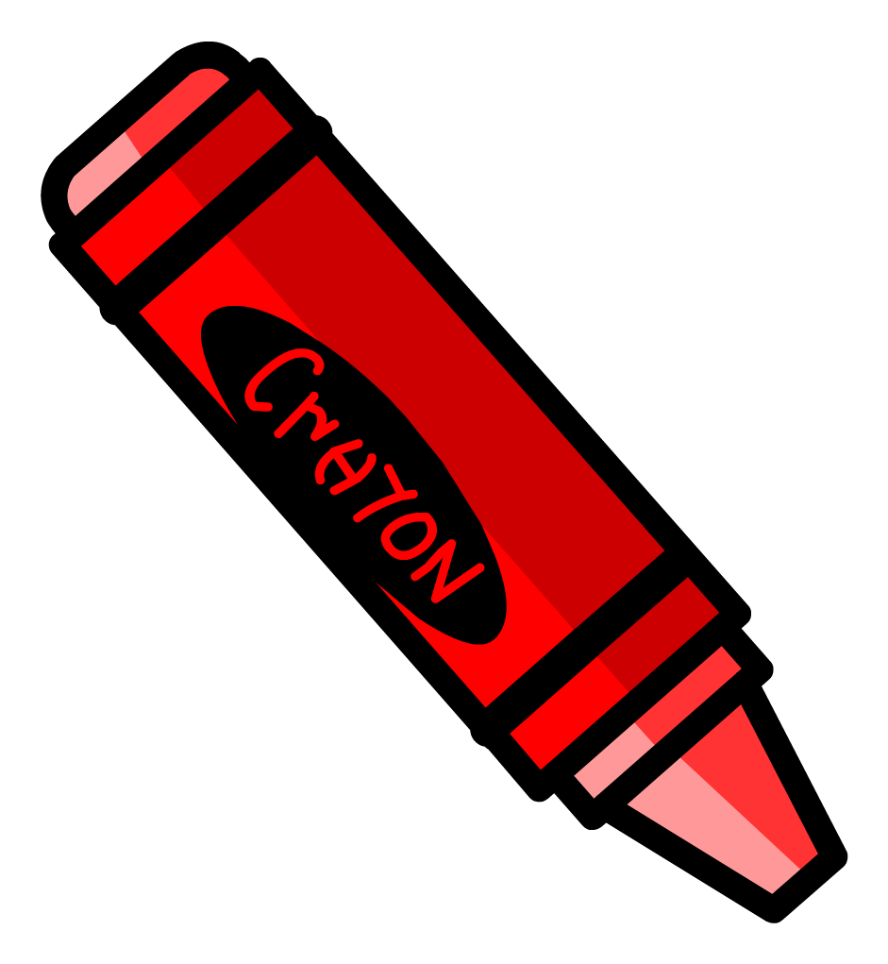
Use a ruler. Find the length of this crayon to the nearest inch. ____________ inches

SOL 2.8a - Just in Time Quick Check Teacher Notes
Common Errors/Misconceptions and their Possible Indications

- Circle each tool that you could use to measure length.

Students may choose the wrong instrument to measure length. Students who do not understand which tool to use when measuring length may be confused about the attribute being measured. Additional practice measuring “how long” with standard (e.g., rulers, inch square tiles, etc.) and non-standard units (e.g. toothpicks, paperclips, shoes, string, cubes, etc.) will help build understanding of length as well as the features of the tools used to measure length.
- About how many inches long is this pencil? ____________ inches

Use a ruler to measure the length of this pencil to the nearest inch. ___________ inches
Some students may provide “guesses” that seem unrelated to the length of the pencil. This may indicate the students need more opportunities to develop the concept of one inch. Discussions of real-world objects around the room that are about 1 inch long will provide benchmarks that help students understand the size of 1 inch. Re-examining an estimate after determining the actual length helps students develop a sense of the reasonableness of their estimates.
Students may report the length to the nearest inch as 6 inches, which may indicate students are counting inches from the end of the ruler instead of from zero. Students may benefit from constructing their own ruler from alternating colors of one-inch paper strips. Constructing a ruler in this way and then using it to measure length helps build conceptual understanding for measuring length and the tools used in measuring.
- Estimate the length of this crayon. ____________inches

Use a ruler. Find the length of this crayon to the nearest inch. ____________ inches
Students may report a length of five inches, which likely indicates the students are counting the tick marks and including zero in their count. Students may report one inch, indicating the students may have been influenced by the orientation of the crayon and measured the width of the crayon instead of the length. Students need more experiences measuring objects that are in a variety of orientations. Students may benefit from using rulers without numbers, on which they can label the units and then measure, and rulers that do not start at zero (“broken” rulers). Measuring with these instruments may foster understanding that one can measure from any starting place on the ruler and that the length of an object represents a count of units, or spaces between the tick marks.

