Just In Time Quick Check
Standard of Learning (SOL) 2.7a
Strand: Measurement and Geometry

Standard of Learning (SOL) 2.7a
The student will count and compare a collection of pennies, nickels, dimes, and quarters whose total value is $2.00 or less.

Grade Level Skills:
- Determine the value of a collection of coins and one-dollar bills whose total value is $2.00 or less.
- Count by ones, fives, tens, and twenty-fives to determine the value of a collection of coins whose total value is $2.00 or less.
- Compare the values of two sets of coins and one-dollar bills (each set having a total value of $2.00 or less), using the terms greater than, less than, or equal to.

Just in Time Quick Check

Just in Time Quick Check Teacher Notes

Supporting Resources:
- VDOE Mathematics Instructional Plans (MIPS)
- 2.7ab - Cool Coin Comparisons (Word) / PDF Version
- 2.7ab - Race to a Dollar or Two! (Word) / PDF Version
- VDOE Co-Teaching Mathematics Instruction Plans (MIPS)
  - 2.7 - Coin Collection Comparisons (Word) / PDF Version
- VDOE Word Wall Cards: Grade 2 (Word) | (PDF)
  - Penny
  - Nickel
  - Nickel = Five Pennies
  - Dime
  - Dime = Ten Pennies
  - Quarter
  - Quarter = Twenty-Five Pennies
  - Dollar
- VDOE Rich Mathematical Tasks
  - 2.7ab Coins in Pocket Task Template (Word) / PDF Version
  - 2.7ab Coins in Pocket Student Version of Task (Word) / PDF Version
  - 2.7ab Coins in Pocket Anchor Papers (Word) / PDF Version
  - 2.7ab Coins in Pocket Anchor Papers Scoring Rationales (Word) / PDF Version
Supporting and Prerequisite SOL: 1.8a, K.7

SOL 2.7a - Just in Time Quick Check
- What is the value of this set of money? _______________
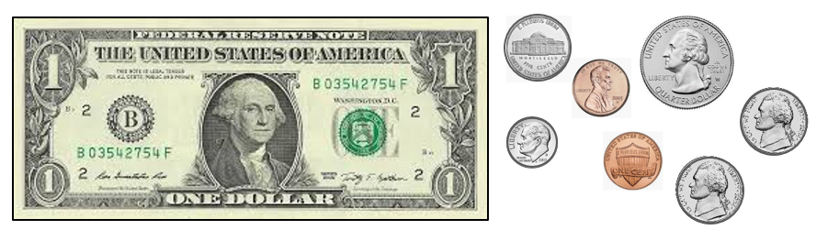

- Kathy has $1.70 in her pocket. She does not have any one-dollar bills.
Use the symbols in the key to draw a picture showing what coins Kathy might have in her pocket.
Key:
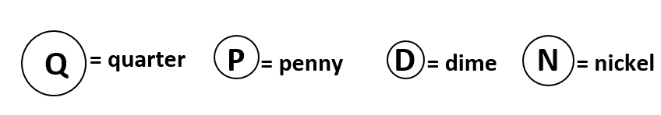
Kathy’s Money:
- Look at the two sets of money.

Set A Set B
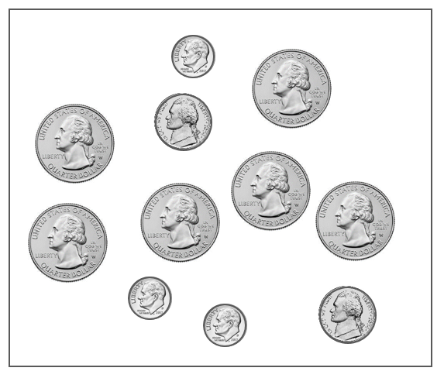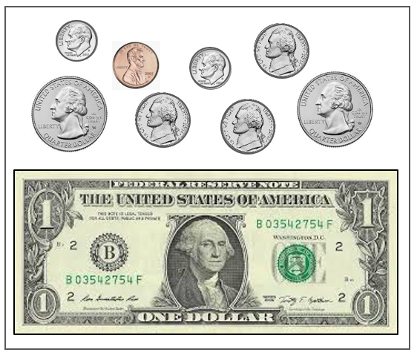

Circle the words that make this sentence true.
The total value of the money in Set A is [ greater than, less than, equal to ] the total value of the money in Set B.

Write a sentence that tells how you decided which words to circle.
________________________________________
________________________________________
________________________________________
________________________________________

SOL 2.7a - Just in Time Quick Check Teacher Notes
Common Errors/Misconceptions and their Possible Indications
- What is the value of this set of money?
Students who say the value is $1.72 or $1.57 may have counted the nickel that shows the reverse image (Monticello) as a quarter ($1.72) or as a dime ($1.57). These students need additional opportunities to explore coins and their characteristics. Some students may omit one or more coins, especially when given a set that has not been arranged in groups of like coins from greatest to least. These students would benefit from more experiences counting physical sets of coins that have not been arranged prior to counting. They may also benefit from hearing strategies their peers use for counting sets of coins. Some students may also benefit from using a hundred chart when determining the value of a set of bills and coins.
- Kathy has $1.70 in her pocket. She does not have any one-dollar bills.
Use the symbols in the key to draw a picture showing what coins Kathy might have in her pocket.
Students may have difficulty using only coins to represent an amount of money greater than one dollar. These students need more experiences counting given collections of coins that are greater than one dollar as well as opportunities to represent a given amount of money in more than one way. Activities where students are collaborating with peers to compare and contrast different ways to represent a given value may be helpful. Some students may struggle to count by fives, tens, and/or twenty-fives and will need additional practice counting in order to help them count sets of coins. Providing a hundred chart to keep track while counting may be helpful to some students.
Students may represent 17 cents or $1.07 instead of $1.70, which may indicate students have not yet developed an understanding of the notation used to represent dollars and cents. More experiences sharing different representations for given values may be helpful for these students (e.g., given an amount of money stated orally, represent that amount using coins in two different ways and write that amount using “cents” notation and dollar/decimal notation).

- Look at the two sets of money.
Set A Set B
Circle the words that make this sentence true.
The total value of the money in Set A is [ greater than, less than, equal to ] the total value of the money in Set B.
Write a sentence that tells how you decided which words to circle.
________________________________________
________________________________________
Some students may believe that the value of Set A is less because Set B contains a one-dollar bill. Other students may determine that Set A has a greater value than Set B based solely on the number of coins and not because of the values of the coins. Students who are able to accurately determine the values of the two sets but are unable to compare the values of sets and support their thinking will benefit from hearing their peers’ strategies and reasoning as they compare the value of two sets of money.

