Just In Time Quick Check

Standard of Learning (SOL) 2.4a
Strand: Number and Number Sense

Standard of Learning (SOL) 2.4a
The student will name and write fractions represented by a set, region, or length model for halves, fourths, eighths, thirds, and sixths.

Grade Level Skills:
- Recognize fractions as representing equal-size parts of a whole.
- Name and write fractions represented by a set model showing halves, fourths, eighths, thirds, and sixths.
- Name and write fractions represented by a region/area model showing halves, fourths, eighths, thirds, and sixths.
- Name and write fractions represented by a length model showing halves, fourths, eighths, thirds, and sixths.
Just in Time Quick Check
Just in Time Quick Check Teacher Notes

Supporting Resources:
- VDOE Mathematics Instructional Plans (MIPS)
  - Fair Shares (word)/PDF
  - Cookie Fractions (word)/PDF
  - Pattern Block Fractions (word)/PDF
- VDOE Co-Teaching Mathematics Instruction Plans (MIPS)
  - Fair Shares Co-Teach (word)/PDF
- VDOE Word Wall Cards: Grade 2 Word/PDF
  - Fraction: Half and Fourth
  - Fraction: Third
  - Fraction: Sixths
  - Fraction: Eighths
Supporting and Prerequisite SOL: 2.4b, 1.4a, 1.4b, K.5

SOL 2.4a - Just in Time Quick Check

- Write the fraction for each picture.
- What fraction of the circle is shaded gray? _________

- On the number line, the arrow is pointing to the fraction ________. 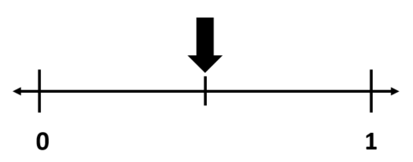

- Write the fraction of this set that is shaded black. _________

- Look at each model.
  - Circle the model if all of its parts are equal.
  - Draw an X on the model if its parts are not equal.
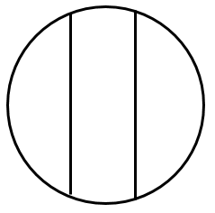

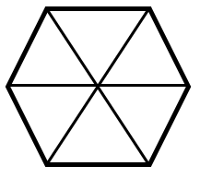

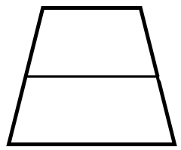
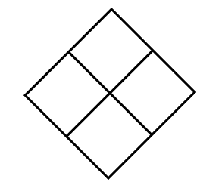

SOL 2.4a - Just in Time Quick Check Teacher Notes
Common Errors/Misconceptions and their Possible Indications
- Write the fraction for each picture.
- What fraction of the circle is shaded gray? _________
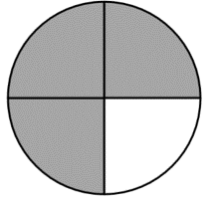
Students may write the fraction $\frac{1}{3}$ because 1 part is not shaded and 3 parts are shaded gray, or $\frac{3}{1}$ because there are 3 parts shaded gray and 1 part unshaded. Students may think the numerator is the number of parts for one color and the denominator is the number of parts for the other color. These students do not recognize the part-whole relationship represented by fraction notation and would benefit from explicit instruction in and practice with the naming conventions for fractions.
- On the number line, the arrow is pointing to the fraction ________.
Students may think the denominator for the fraction is 3, because there are three tick marks on the number line; since the arrow is pointing to the second tick mark, they may write $\frac{2}{3}$ . This error may indicate a misconception that the denominator for a fraction modeled on a number line represents the number of tick marks on the number line instead of the number of equal spaces between whole numbers. These students may benefit from creating number lines, which includes determining the number of tick marks needed to create the number of equal parts between the whole numbers. Gluing same-size strips of alternating colors of paper end-to-end to create physical models of number lines may also help students build understanding for these linear models and what is being counted.
- Write the fraction of this set that is shaded black. _________

Students may not understand that the unit is the set that includes the three figures (i.e., this whole set has three parts). Students may write the fraction $\frac{2}{1}$ or $\frac{1}{2}$ to represent this picture because they are focusing on the parts only and not on the whole set. These students would benefit from building set models using concrete manipulatives and naming the fractions represented.
Students might also write 2, because two of the figures are shaded black. These students may not have an understanding that a fraction of a set would have a numerator and a denominator. Students may benefit from creating multiple representations for a given fraction (set model, linear model, area/region model) and describing the parts and the whole in each model.
- Look at each model.
  - Circle the model if all of its parts are equal.
  - Draw an X on the model if its parts are not equal.

Students may think that this model shows thirds because there are three parts in the circle and the two line segments appear to be spaced apart evenly. Students may see the parts as equal because of the spacing of the vertical line segments. These students would benefit from cutting the circle into the three parts shown and comparing the parts by covering to show that the three parts are not all the same size.

Students may focus on the length and width of the rectangle, which are not the same, and for that reason identify this model as one in which the parts are not equal. Paper folding activities, in which rectangular strips of paper of different lengths are folded into congruent fractional parts, may help students focus on the subdivided parts of the rectangle, which are the same size, even though the length and width are different.

Students may not believe the triangles that make up the hexagon are equal parts because of their different spatial orientations. These students may benefit from combining same-sized pattern blocks in different orientations to make one whole.

Students may think this model shows halves because the vertical line segment separating the figure into two parts appears to be halfway between the top of the figure and its base. These students do not understand that the parts within the whole must be the same size. Cutting out this figure and folding along the line segment that subdivides the figure will help students recognize that the parts are not equal even though they have the same height.
Students may benefit from activities in which they start with a whole and break or cut the whole into additional parts. Directly comparing (covering or tracing) to determine whether the parts are the same size or different sizes after each break or cut helps students develop understanding of this concept. As the whole is divided into more parts, students begin to understand that each part becomes smaller (e.g., folding a paper in half one time, creates two equal halves; folding it in half again, creates four equal fourths, which creates smaller pieces or parts; folding it in half again, creates eight equal eighths, which is even smaller pieces or parts). The same process can be applied to relate thirds and sixths.
Teachers are encouraged not only to have students create models that have equal parts but also to have students create and discuss models that have parts that are not the same size.

Students may not consider the parts within the figure to be equal because they are not horizontally oriented. Presenting students with fraction models (and models of polygons in general) that are not “sitting” on a horizontal base and with models they can physically rotate and then reconsider helps develop an understanding that changing orientation does not change size or area.

