Just In Time Quick Check

Standard of Learning (SOL) 2.3b
Strand: Number and Number Sense

Standard of Learning (SOL) 2.3b
The student will write the ordinal numbers 1st through 20th.

Grade Level Skills:
- Write 1st, 2nd, 3rd, through 20th in numerals.
Just in Time Quick Check
Just in Time Quick Check Teacher Notes

Supporting Resources:
- VDOE Mathematics Instructional Plans (MIPS)
  - 2.3ab - Ordinals (Word) / (PDF)
  - 2.3ab - Hermit Crab Ordinal Numbers / (PDF)
- VDOE Word Wall Cards: Grade 2 (Word) | (PDF)
  - Ordinals
Supporting and Prerequisite SOL: 2.3a, 1.3, K.1b, K.3a

SOL 2.3b - Just in Time Quick Check

- There are 20 children lined up.
Finish labeling the children in order using ordinal numerals.
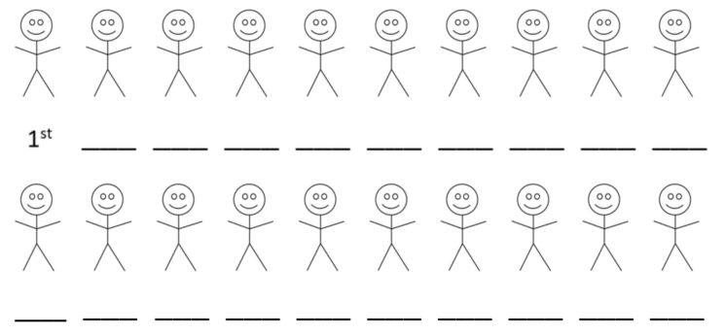

SOL 2.3b - Just in Time Quick Check Teacher Notes
Common Errors/Misconceptions and their Possible Indications
- There are 20 children lined up.
Finish labeling the children in order using ordinal numerals.

A student may use the wrong notation such as 1th, 2th or 5st or write the ordinal word instead of the numeral. The student may need more direct instruction with the vocabulary in word form and which final letters are used behind the number to create the ordinal in this form (e.g., first = 1st, second = 2nd, etc.).

A student may be able to orally complete this task but not be able to write the ordinal numbers correctly. This student may need more practice with recording ordinal numbers for concrete items.

