Just In Time Quick Check

Standard of Learning (SOL) 2.2a
Strand: Number and Number Sense

Standard of Learning (SOL) 2.2a
The student will count forward by twos, fives, and tens to 120, starting a various multiples of 2, 5, or 10.

Grade Level Skills:
- Determine patterns created by counting by twos, fives, and tens to 120 on number charts.
- Describe patterns in skip counting and use those patterns to predict the next number in the counting sequence.
- Skip count by twos, fives, and tens to 120 from various multiples of 2, 5 or 10, using manipulatives, a hundred chart, mental mathematics, a calculator, and/or paper and pencil.
- Skip count by two to 120 starting from any multiple of 2.
- Skip count by five to 120 starting at any multiple of 5.
- Skip count by 10 to 120 starting at any multiple of 10.
Just in Time Quick Check
Just in Time Quick Check Teacher Notes

Supporting Resources:
- VDOE Mathematics Instructional Plans (MIPS)
  - 2.2ab - Guess My Pattern (Word) / (PDF)
- VDOE Word Wall Cards: Grade 2 (Word) | (PDF)
  - Number model of 2
  - Pattern
  - Transfer a growing pattern
- VDOE Instructional Videos for Teachers
  - Using a Beaded Number Line (grades K-2)
Supporting and Prerequisite SOL: 1.1a, 1.1b, 1.1d, K.1a, K.3a, K.3d

SOL 2.2a - Just in Time Quick Check

- This picture shows John’s lollipops. How many lollipops does John have? How do you know?
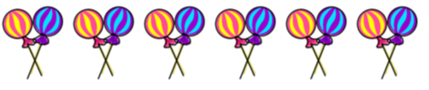

- Alberto is counting. He says, “30, 40, 50, 60.” What are the next three numbers in his pattern?

________________ , ________________ , ________________

What is Alberto counting by? _______________________

- This is a group of 5 flowers.
I have four of these groups of flowers. How many flowers do I have?
- Find 45 in the number chart.
Starting at 45, color each number you would say when you count by 5 to 100.

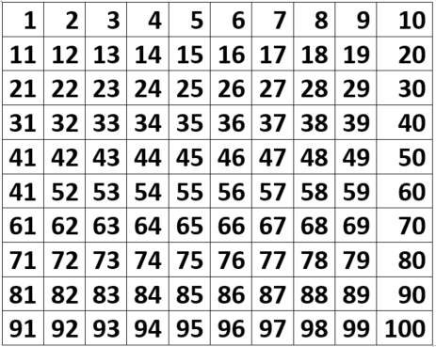

SOL 2.2a - Just in Time Quick Check Teacher Notes
Common Errors/Misconceptions and their Possible Indications

- This picture shows John’s lollipops. How many lollipops does John have? How do you know?
A student may answer “6” and tell you or point to the images to show he or she is counting each pair as one. You may ask the student to tell how they know or count the lollipops for you. A student who is not able to count by twos may need practice with one-to-one counting to confirm that each set includes two items. This student may also benefit from practice in counting by twos using sets of items and counting by twos using a hundred chart to build conceptual understanding.

- Alberto is counting. He says, “30, 40, 50, 60.” What are the next three numbers in his pattern?

________________ , ________________ , ________________

What is Alberto counting by? _______________________

The student may write “10, 20, 30.” While this error shows an understanding that the pattern shows skip counting by tens, this error may indicate that the student is unable to count on from a given decade or a lack of understanding that the given pattern continues to increase. A student may also copy the numbers (30, 40, 50) from the original question. This student will need more practice with making and counting sets of ten. They may need a number line or hundreds board to practice counting by tens and counting on to a given decade by tens using and grouping sets of items by ten to build conceptual understanding prior to rote skip counting. Conceptual understanding of skip counting is the precursor to recognizing number patterns, counting money, and telling time.

- This is a group of 5 flowers.
I have four of these groups of flowers. How many flowers do I have?

A student who answers “5” is unable to take the information and use it to skip count by fives. The student may simply count the flowers in the illustration instead of understanding they would need to count that group of flowers four times. A student with an understanding of number patterns may draw additional sets of flowers to be able to count them. This would show that the student understands groups of five but is still in need of a concrete representation. A student who counts by fives or writes the numbers by fives without drawing additional flowers has a grasp of skip counting by fives and an ability to hold quantities in their head, facilitating mental math. Conceptual understanding of skip counting is the precursor to recognizing number patterns, counting money, and telling time.

- Find 45 in the number chart.
Starting at 45, color each number you would say when you count by 5 to 100.

If possible, teachers are encouraged to watch the student as they complete the task to determine if the student is counting by fives in sequence (e.g. starting by coloring 45, 50, 55, 60, 65, etc.).
A student who begins at 5 and colors all the multiples of five may not feel comfortable with counting on by fives from any multiple of five. A student who colors 45, 55, 65, 75, etc. may be focusing on the 5 in the ones place. A student who colors all the numbers with the 5 in the ones place and then all the numbers with a 0 in tens place may have an understanding of a number pattern and how to use the hundreds chart to look for number patterns, but this student has not yet demonstrated skip counting by fives. Each of these students may benefit from practice with making and counting sets of five using concrete representations, including counters or other manipulatives, and using those sets alongside a hundred chart to foster conceptual understanding for skip counting by fives. This practice should begin with counting by fives from zero and move to counting by fives from other numbers.

