Just In Time Quick Check

Standard of Learning (SOL) 2.1d
Strand: Number and Number Sense

Standard of Learning (SOL) 2.1d
The student will round two-digit numbers to the nearest ten.

Grade Level Skills:
- Round two-digit numbers to the nearest ten.
Just in Time Quick Check
Just in Time Quick Check Teacher Notes

Supporting Resources:
- VDOE Mathematics Instructional Plans (MIPS)
  - 2.1d - Rounding on the Hundreds Chart (Word) / (PDF)
  - 2.1d - Rounding with Base-10 Blocks (Word) / (PDF)
- VDOE Word Wall Cards: Grade 2 (Word) | (PDF)
  - Place Value
  - Round
  - Greater Than
  - Less Than
- VDOE Instructional Videos for Teachers
  - Using a Beaded Number Line (grades K-2)
Supporting and Prerequisite SOL: none

SOL 2.1d - Just in Time Quick Check
- Sam has 37 cookies. Round 37 to the nearest ten. Use words, numbers, or pictures to show how you know.

- Round the following numbers to the nearest 10. You may use the number line or number chart to show your thinking.

85 will round to ______________ 96 will round to _______________

21 will round to ______________ 65 will round to _______________

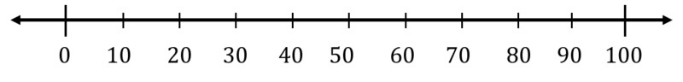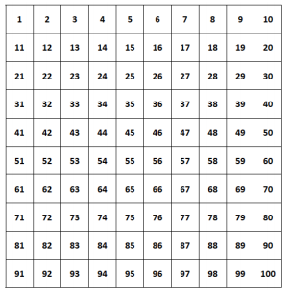

SOL 2.1d - Just in Time Quick Check Teacher Notes
Common Errors/Misconceptions and their Possible Indications
- Sam has 37 cookies. Round 37 to the nearest ten. Use words, numbers, or pictures to show how you know.
Students need a firm understanding of place value to round numbers to the nearest ten. Students who give a number that is not a ten, such as 38 or 35, may benefit from using a number line or number chart/hundreds chart to assist in visualizing the range between tens. Students who are able to round a number to the nearest ten without the use of a number line or manipulatives have a good understanding of place value and have surpassed the need for concrete or pictorial representations.
- Round the following numbers to the nearest 10. You may use the number line or number chart to show your thinking.

85 will round to ______________ 96 will round to _______________

21 will round to ______________ 65 will round to _______________

Students who are able to round numbers without a representation have a clear understanding of the conventions of rounding. When students use the number line, they must have a good grasp of counting order or place value to locate the number on the line. When rounding 43 to the nearest ten, for example, the students will place the the dot closer to the 40 than the 50, and may be able to identify the number to which 43 rounds more easily than students who have difficulty locating the number on the line. If 43 is placed near 30, it may indicate that the student reverses the tens and ones. Students who have difficulty locating a number on the line may need more practice with counting sequences, including starting at any number and counting up or back from that number, and more practice with a number line before using it as a tool for rounding.
While the number chart is a more useful tool for rounding than the number line for some students, it may be a more difficult tool for others because the tens are represented only on the right side of the chart. Students who have difficulty identifying the tens that a number falls between on this chart may benefit from rewriting the tens on the left side of the chart in the margin. It may be helpful for students to see the connection between the number chart and the number line by cutting apart the number chart and taping the strips together as a number path/number line.
Students who are able to locate the number on the line or the chart and identify the surrounding tens but unable to identify the number to which 43 rounds will need practice with the concept and conventions of rounding to the nearest ten.

