Just In Time Quick Check

Standard of Learning (SOL) 2.1a
Strand: Number and Number Sense

Standard of Learning (SOL) 2.1a
The student will read, write, and identify the place and value of each digit in a three-digit numeral, with and without models.

Grade Level Skills:
- Demonstrate understanding of the ten-to-one relationships among ones, tens, and hundreds, using manipulatives.
- Write numerals, using a model or pictorial representation (i.e., a picture of base-10 blocks).
- Read three-digit numbers when shown a numeral, a model of the number, or a pictorial representation of the number.
- Identify and write the place (ones, tens, hundreds) of each digit in a three-digit numeral.
- Determine the value of each digit in a three-digit numeral (e.g., in 352, the 5 represents 5 tens and its value is 50).
- Use models to represent numbers in multiple ways, according to place value (e.g., 256 can be 1 hundred, 14 tens, and 16 ones, 25 tens and 6 ones, etc.).
Just in Time Quick Check
Just in Time Quick Check Teacher Notes

Supporting Resources:
- VDOE Mathematics Instructional Plans (MIPS)
2.1a – Close to 500 (word)/ PDF Version
- VDOE Word Wall Cards: Grade 2 (Word) | (PDF)
  - Place value
- VDOE Instructional Videos for Teachers:
- Developing Early Number Sense (grades K-2)
Supporting and Prerequisite SOL: 1.1a, 1.1b, 1.1d, 1.5a, 1.5b, K.1a, K.1b, K.3a, K.3d

SOL 2.1a - Just in Time Quick Check

- A number has:
- three tens
- seven ones
- six hundreds
Write this number. ______________________

- Write the number shown in this model._____________________
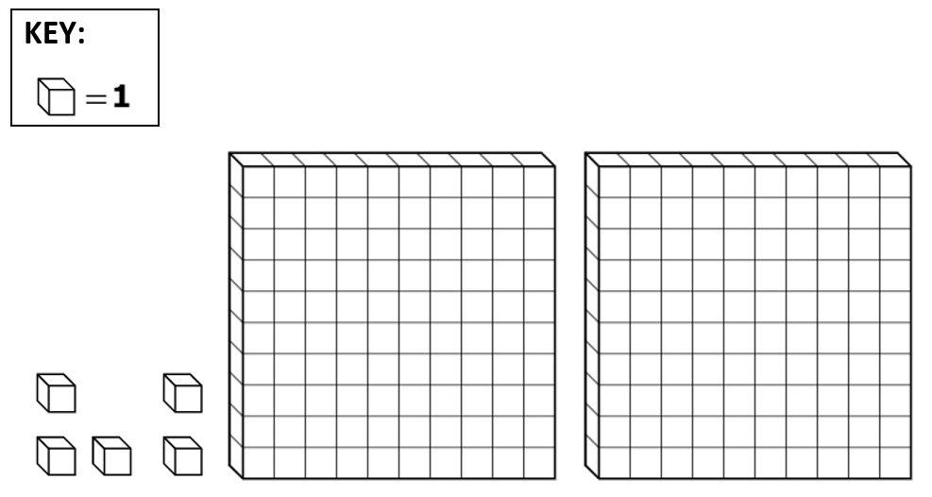

- Sam used cubes to make 129.
- Draw cubes to show 129 on this work mat.
H | T | O
- Draw cubes to show another way to make 129 on this work mat.
H | T | O

SOL 2.1a - Just in Time Quick Check Teacher Notes
Common Errors/Misconceptions and their Possible Indications
- A number has:
- three tens
- seven ones
- six hundreds
Write this number. ______________________
A student may use the numerals in the order given rather than using the place value position described. This student may benefit from using manipulatives to first represent and then write the value described in each bullet. This student may also benefit from using a place value mat for recording.
- Write the number shown in this model._____________________
A student may write 52, 502, or 25 in error. These errors may indicate a lack of understanding of the values associated with the base-10 manipulatives, inattention to the key, or difficulty translating from the model to standard form when one of the place value positions is not included in the model (e.g., there are no tens in the model shown). Using a place value mat to organize the values represented by each type of block in the model may help the student develop this understanding. The student may also benefit from experience translating concrete models to pictorial representations of those models.
- Sam used cubes to make 129.
- Draw cubes to show 129 on this work mat.
H | T | O
- Draw cubes to show another way to make 129 on this work mat.
H | T | O
A student may draw 129 unit cubes, which is an accurate representation; however, this may indicate that the student is only able to count by ones to determine the total number of objects in a set. A student relying solely on counting by ones will benefit from activities that involve counting sets of objects by twos, fives, and tens and representing that set using a variety of groupings.
A student may accurately represent 129 using one hundreds flat, two tens rods, and nine unit cubes but then may use one hundreds flat and twenty-nine tens rods to show the number a different way. This may indicate the student has a rote process for “trading” and a lack of understanding that the base-10 manipulatives provide a physical model structure of the base-10 number system. Activities in which a student constructs sets of ten for trading help build a conceptual understanding of the ten-to-one relationship between adjacent place value positions and the structure of the base-10 number system overall.

