Just In Time Quick Check

Standard of Learning (SOL) 1.13
Strand: Patterns, Functions, and Algebra

Standard of Learning (SOL) 1.13
The student will sort and classify concrete objects according to one or two attributes.

Grade Level Skills:
- Sort and classify concrete objects into appropriate subsets (categories) based on one or two attributes, such as size, shape, color, and/or thickness (e.g., sort a set of objects that are both red and thick).
- Label attributes of a set of objects that has been sorted.
- Name multiple ways to sort a set of objects.
Just in Time Quick Check
Just in Time Quick Check Teacher Notes

Supporting Resources:
- VDOE Mathematics Instructional Plans (MIPS)
  - 1.13 – Attribute Trains (Word) / (PDF)
- VDOE Co-Teaching Mathematics Instruction Plans (MIPS)
  - 1.13 – Sorting and Classifying by Attributes (Word) / (PDF)
Supporting and Prerequisite SOL: 1.8, 1.11a, K.12

SOL 1.13 - Just in Time Quick Check: Student Interview

Materials Needed: Prepare Set 1 and Set 2 of the shape cut-outs prior to administering the Quick Check. Provide sorting boards as needed.

- Provide shape cut-outs (Set 1) to the student. Ask the student to sort the shapes into two groups. Once complete, ask the student to explain to how they sorted the shapes. If student hesitates to explain how they sorted the shapes into two groups, ask “How are all of these alike? And these?”
Student’s Description:

- Provide shape cut-outs (Set 2) to the student. Ask the student to sort the shapes into three groups. Once complete, ask the student to explain how they sorted the shapes. If student hesitates to explain how they sorted the shapes into the three groups, ask “How are all of these alike? And these? And these?
Student’s Description:

Group 2
Group 1

Group 3

Group 2

Group 1

Shapes – Set 1

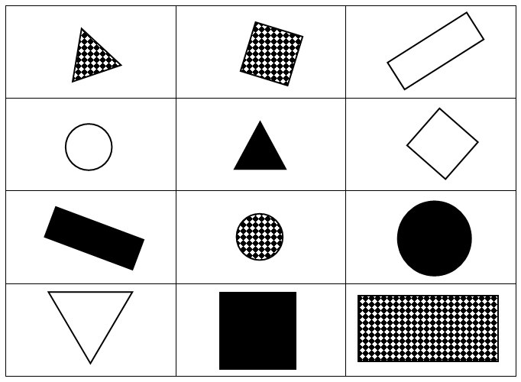

Shapes - Set 2

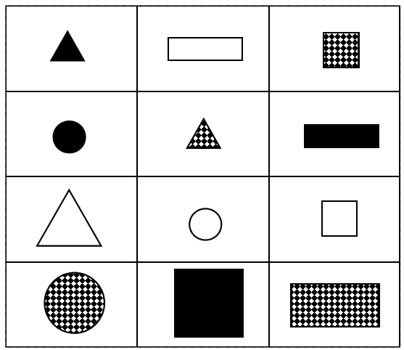

SOL 1.13 - Just in Time Quick Check Teacher Notes
Common Errors/Misconceptions and their Possible Indications
Materials Needed: Prepare Set 1 and Set 2 of the shape cut-outs prior to administering the Quick Check. Provide sorting boards as needed.
- Provide shape cut-outs (Set 1) to the student. Ask the student to sort the shapes into two groups. Once complete, ask the student to explain to how they sorted the shapes. If student hesitates to explain how they sorted the shapes into two groups, ask “How are all of these alike? And these?”
Student’s Description:
If a student is unable to sort the shapes into two groups they may need a prompt to help them focus on an object’s attributes. Ask questions like, “What shape is this?” “What attributes make this shape?” or select 2 different shapes and ask, “What is the same and what is different about these two shapes?” If the student still is unable to answer, limit the amount of shapes for sorting. See if the student is able to sort 4-6 shapes instead of the 12 provided. If a student is still unable to sort the shapes into two groups, they will need more time exploring and describing the characteristics of the shapes to determine how they are alike or different.
Another common misconception is confusing shapes or their characteristics based on the orientation of the shape. For example, a student may not recognize a triangle sitting on one of its vertices or may label a square as a ‘diamond’ because of its orientation. If a student has either of these misconceptions, they will benefit from additional opportunities to explore and describe shapes displayed in various orientations. It is best to provide examples that exist in everyday life.

- Provide shape cut-outs (Set 2) to the student. Ask the student to sort the shapes into three groups. Once complete, ask the student to explain how they sorted the shapes. If student hesitates to explain how they sorted the shapes into the three groups, ask “How are all of these alike? And these? And these?
Student’s Description:
Some students may have trouble sorting according to multiple characteristics or recognizing characteristics beyond obvious general characteristics. If a student still had difficulty sorting the shapes into 3 categories, you may want to try the same activity with a set of attribute blocks since they have color and shape and appeal to visual and tactile learners.
Some students may have difficulty explaining how the set has been sorted or may not apply the rule consistently across all objects in the set.
Students who are still developing their ability to identify attributes in an effort to sort and classify will benefit from hearing how others sort and their reasoning. Classification is a necessary skill for many areas in mathematics (i.e., patterning, measurement, etc.) and therefore should be revisited throughout the school year beginning first with sorting by one attribute, then by two attributes. In all cases, reasoning should be at the center of all classroom discussions.

