Just In Time Quick Check
Standard of Learning (SOL) 1.11b
Strand: Measurement and Geometry

Standard of Learning (SOL) 1.11b
The student will identify and describe representations of circles, squares, rectangles, and triangles in different environments, regardless of orientation, and explain reasoning.

Grade Level Skills:
- Identify and describe representations of circles, squares, rectangles, and triangles, regardless of orientation, in different environments and explain reasoning.
Just in Time Quick Check
Just in Time Quick Check Teacher Notes

Supporting Resources:
- VDOE Mathematics Instructional Plans (MIPS)
  - 1.11b – Shapes (Word) / PDF Version
- VDOE Word Wall Cards: Grade 1 (Word) | (PDF)
  - Plane Figures
  - Square: Right Angle
  - Triangle: Side and Vertex
  - Rectangle: Right Angle
Supporting and Prerequisite SOL: 1.11a, K.10a, K.10b, K.10c

SOL 1.11b - Just in Time Quick Check: Student Interview

Pointing to one picture at a time, ask the student to identify and describe the shape or shapes shown in each picture. Ask the student to explain how they determined their answer. Record student responses next to each picture.

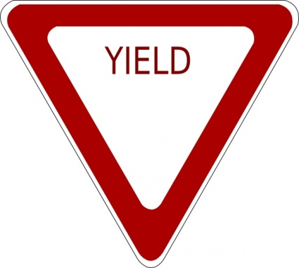

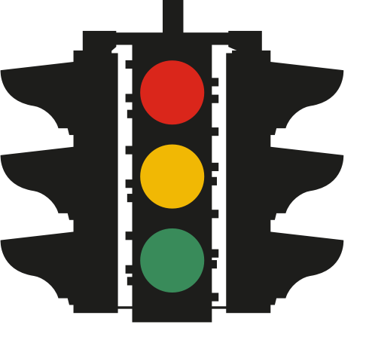

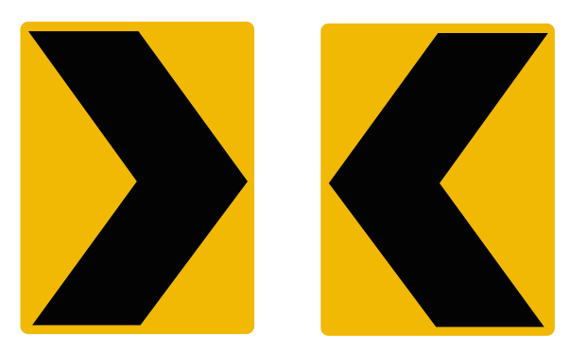

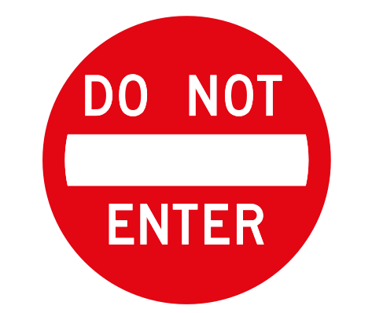

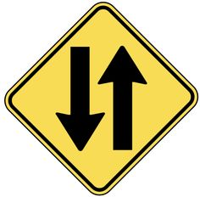

SOL 1.11b - Just in Time Quick Check Teacher Notes
Common Errors/Misconceptions and their Possible Indications

Pointing to one picture at a time, ask the student to identify and describe the shape or shapes shown in each picture. Ask the student to explain how they determined their answer. Record student responses next to each picture.
If the student is unable to identify the triangle in this picture, they may not understand that the orientation of the triangle does not determine its shape. They will benefit from experiences naming and describing triangles in their environment that appear in different orientations.
If the student is unable to identify the circles in this picture further instruction in identifying and naming the characteristics of a circle is needed. Exploring and describing circles found in the classroom or at home may be beneficial. Some students may also see a rectangle around the circles.

If the student is unable to identify the yellow boxes as representations of rectangles, they may need additional opportunities to explore the characteristics of a rectangle. Shape Hunts or I Spy activities can be beneficial in strengthening their ability to identify and describe shapes in their environment.

Students who are unable to identify the circle or the white rectangle in this pictures will benefit from opportunities to seek out and explore shapes both in their classroom and in their environment outside of the classroom. Playing a game such as I Spy can be helpful. For instance, ‘I see a white rectangle. Where do you see a white rectangle?’ Discussions around characteristics of different shapes and comparing squares to rectangles will be important for students who do not yet recognize rectangles with ease.

Students should identify this sign as a square (and possibly a rectangle). If the student is unable to identify the square make a more distinct line around the outside of the shape to show the vertices of the square. A student may identify this as a diamond and therefore need opportunities to recognize squares in different orientations.

