Just In Time Quick Check

Standard of Learning (SOL) 1.9a
Strand: Measurement and Geometry

Standard of Learning (SOL) 1.9a
The student will investigate the passage of time and tell time to the hour and half-hour, using analog and digital clocks.

Grade Level Skills:
- Identify different types of clocks (analog and digital) as instruments to measure time.
- Tell time shown on an analog clock to the hour and half-hour.
- Tell time shown on a digital clock to the hour and half-hour.
- Match a written time (e.g., 1:00, 3:30, 11:00) to the time shown on a digital and analog clock to the hour and half-hour.
Just in Time Quick Check
Just in Time Quick Check Teacher Notes

Supporting Resources:
- VDOE Mathematics Instructional Plans (MIPS)
  - 1.9a - What Time Is It?. (Word) / PDF Version
- VDOE Word Wall Cards: Grade 1 (Word) | (PDF)
  - Clock
Supporting and Prerequisite SOL: K.1b

SOL 1.9a – Just in Time Quick Check

Tell the time shown on each clock.
1. 2.
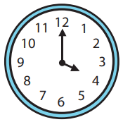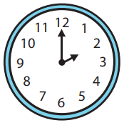

3. 4.
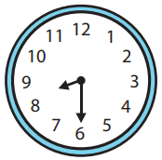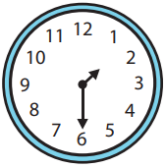

5. 6.
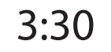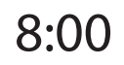

7. 8.
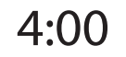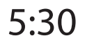

SOL 1.9a - Just in Time Quick Check Teacher Notes
Common Errors/Misconceptions and their Possible Indications

Tell the time shown on each clock.
1. 2.
Some students will confuse the minute hand and the hour hand or not yet understand how to read the time shown (4:00 or 2:00) and may read them as twelve four or twelve two. In addition, some students struggle to tell time correctly when the minute hand is on the twelve and will state the time as “twelve o’clock.” For these students, it may be beneficial to spend some time using only the hour hand and talking about things that happen at certain hours of the day and then have students notice where the hour hand is pointing.
3. 4.
Some students may confuse the hour hand and the minute hand when telling time to the half hour. Students typically struggle to identify the correct hour when the hour hand is between two numbers. The use of ‘geared clocks’ can be beneficial as it illustrates how the hour hand changes as the minute hand progresses around the clock. Helping students make connections between a whole hour and half hour (as it relates to fractional amounts) can also be beneficial in helping students consider what ‘half-hour’ means.
5. 6.

7. 8.

While digital clocks are much more common in the world of our students, understanding how to read and write the time digitally, can be troublesome to some students. Some students will struggle to identify the beginning of the hour as “o’clock” and may need additional opportunities to understand time to the hour and half hour. Throughout the school day, students will benefit from opportunities that call their attention to the time on the classroom clock. Ask them to write the time on the paper/assignment that they may be working on at the time, ask some to read the time and tell how they know. Ask, what time will it be in half an hour and how they know? (It is recommended that this activity focus on time to the hour and half hour and expand, as students are ready.) Referring to the time shown on the clock throughout the day will help students to develop meaning for telling time and provide practice within the context of their day.

