Just In Time Quick Check

Standard of Learning (SOL) 1.5a
Strand: Number and Number Sense

Standard of Learning (SOL) 1.5a
The student, given a familiar problem situation involving magnitude, will select a reasonable order of magnitude from three given quantities: a one-digit numeral, a two-digit numeral, and a three-digit numeral (e.g. 5, 50, 500).

Grade Level Skills:
- Select a reasonable order of magnitude for a given set from three quantities: a one-digit numeral, a two-digit numeral, and a three-digit numeral (e.g. 5, 50, or 500 jelly beans in jars) in a familiar problem situation.
Just in Time Quick Check
Just in Time Quick Check Teacher Notes

Supporting Resources:
- VDOE Mathematics Instructional Plans (MIPS)
  - 1.5ab - Pumpkin Puzzlers (Word) / (PDF)
- VDOE Word Wall Cards: Grade 1 (Word) | (PDF)
  - Greater Than
  - Less Than
Supporting and Prerequisite SOL: 1.5b, K.1a, K.2a, K.2b, K.3a, K.3b

SOL 1.5a - Just in Time Quick Check

- Circle the number that tells about how many marbles are in the jar.

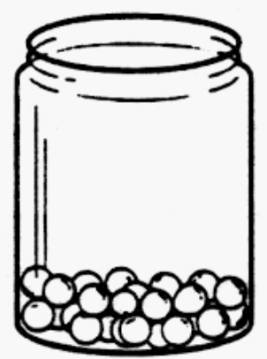 | about 2  about 20  about 200

- About how many flowers are in each picture? Draw a line to match each picture with the number that best describes about how many flowers there are in the picture.

about 6 about 60 about 600

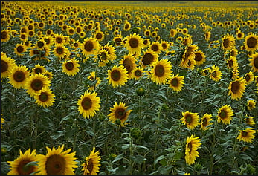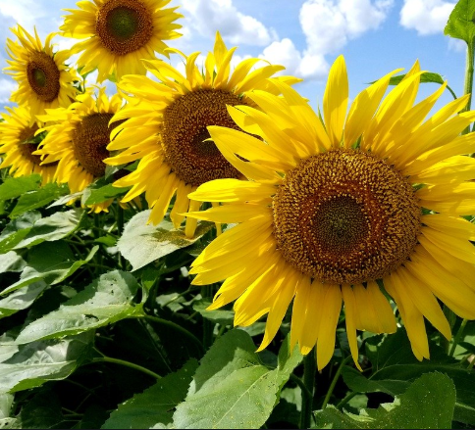

- Put an “X” on the groups that show about 30 objects.

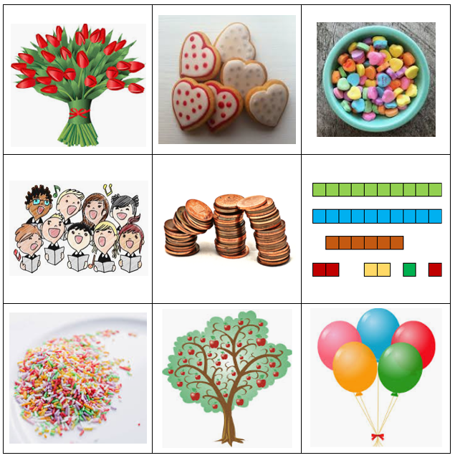

SOL 1.5a - Just in Time Quick Check Teacher Notes
Common Errors/Misconceptions and their Possible Indications

- Circle the number that tells about how many marbles are in the jar.

about 2

about 20

about 200

A student who lacks a sense of magnitude may struggle to estimate that this jar contains approximately 20 marbles and may estimate about 200, knowing that there are more than 2. Even when differences may seem obvious, young students often think that any quantity, beyond their counting range, is a very large quantity, thereby expressing the quantity in the jar hundreds rather than tens. Students will benefit from many experiences with counting, working with different-size sets, comparing quantities that are obvious and those that are not obvious. These experiences should involve ample practice with concrete objects of different sizes and shapes. In addition, it is beneficial to provide students with actual jars of concrete materials to compare and provide one jar with a benchmark number (which might be 10 of that particular item). Students’ sense of magnitude is best activated with concrete models rather than pictorial models.

- About how many flowers are in each picture? Draw a line to match each picture with the number that best describes about how many flowers there are in the picture.

about 6 about 60 about 600

Many students who may not be able to estimate the number of sunflowers in each of the above pictures, may still be developing number conservation (understanding that a quantity in a set doesn’t change when the physical arrangement changes). These students will benefit from opportunities to estimate magnitude with concrete models and have conversations around why a jar of 50 cubes looks like more than a jar of 50 pennies. Students should have many opportunities to compare models and representations of differing quantities, both significant and subtle, as well as the same items and quantities in different physical arrangements.

  - Put an “X” on the groups that show about 30 objects.

The tulips, the connecting cubes, and the tree of apples are all reasonable responses. At this level, students are transitioning in their understanding of magnitude, including developing number conservation. Students who lack a sense of magnitude struggle to consider the relative size of an object or set as reflected in values expressed by factors of 10 (i.e., when given a benchmark of 10 or 100, or of 5 or 50 or 500). They may consider 20 people clustered in a group to be fewer than 5 people spread out in a space. The key idea for young students related to determining a reasonable order of magnitude is that “magnitude” refers to the quantity of objects in a set rather than the area or space covered. Students who lack conservation of area may think that the heart cookies and the candy hearts above are about the same amount because they take up the same amount of space, or that the balloons are more than the pennies because they take up more space. Initially, students should have experiences where the objects should be identical in size. When given a pile of 20 cubes and asked “About how many cubes are in the pile?” will the student estimate that the pile includes about 6 or 20 or 100 cubes? If the response is 20, the student is likely to make the comparison based on the quantity. If the response is 100, the student is likely looking at the area rather than the quantity and needs support for developing a sense of quantity, possibly including cardinality and conservation of number.
It is important to note that developing a sense of magnitude is key to numerical development. Providing opportunities for students to estimate the number of objects in a set, based on appearance, such as how the objects are grouped or clustered, enhances that development. Exploring ways to estimate the number of objects in a set, i.e. to determine a number that is close to the exact amount based on appearance (e.g., clustering, grouping, comparing), enhances the development of number sense and place value. Students should have opportunities to estimate a quantity when given a benchmark of 10 and/or 100 objects, or of 5 or 50 or 500 objects, for example. When asking for an estimate, teachers might ask, “About how much?” or “About how many?” or “Is this about 10 or about 50?”

