Just In Time Quick Check

Standard of Learning (SOL) 1.2b
Strand: Number and Number Sense

Standard of Learning (SOL) 1.2b
The student, given up to 110 objects, will compare two numbers between 0 and 110 represented pictorially or with concrete objects, using the words greater than, less than, or equal to.

Grade Level Skills:
- Compare two numbers between 0 and 110 represented pictorially or with concrete objects, using the words greater than, less than or equal to.
Just in Time Quick Check
Just in Time Quick Check Teacher Notes

Supporting Resources:
- VDOE Mathematics Instructional Plans (MIPS)
  - 1.2abc - Comparing Numbers with Linking Cubes (Word) / PDF Version
  - 1.2bc - More or Less? (Word) / PDF Version
- VDOE Co-Teaching Mathematics Instruction Plans (MIPS)
  - 1.2bc - Comparing Numbers (Word) / PDF Version
- VDOE Word Wall Cards: Grade 1 (Word) | (PDF)
  - Place Value
  - Counting by ones
  - Counting by tens
  - Less than
  - Greater than
  - Equal to
- VDOE Instructional Videos for Teachers
  - Developing Early Number Sense (grades K-2)
  - Using A Beaded Number Line (grades K-2)
Supporting and Prerequisite SOL: 1.1d, K.2a, K.2b

SOL 1.2b - Just in Time Quick Check

Teacher Directions: Show the student two groups of counters (one group of 42 counters and one group of 30 counters), organized in groups of tens and ones. Point to one of the groups and present Task 1. If the student is successful with this Task 1 using concrete objects, go on to Task 2. If the student is unsuccessful, have them compare two smaller quantities of counters before moving on to the pictorial representation in Task 2.

- Here are two groups of counters. Is this group greater than, less than, or equal to the other group?”

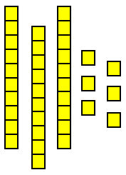
- Circle the words that best describes how to compare the numbers. 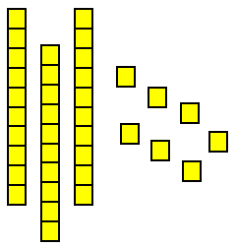
is less than
is greater than
is equal to

- Circle the words that best describe how to compare the numbers.

39
is less than
is greater than
is equal to
65

SOL 1.2b - Just in Time Quick Check Teacher Notes
Common Errors/Misconceptions and their Possible Indications

Teacher Directions: Show the student two groups of counters (one group of 42 counters and one group of 30 counters), organized in groups of tens and ones. Point to one of the groups and present Task 1. If the student is successful with this Task 1 using concrete objects, go on to Task 2. If the student is unsuccessful, have them compare two smaller quantities of counters before moving on to the pictorial representation in Task 2.
- Here are two groups of counters. Is this group greater than, less than, or equal to the other group?”
Students who lack an understanding of place value may have difficulty determining the relationship of the groups to one another. In addition, students’ experience with the vocabulary may contribute to a lack of understanding. They may be familiar with the term “more” but have less experience with “greater” and “less.” Using the terms together, and connecting them to quantities, first using concrete objects, helps to build an understanding of the relationships. Provide opportunities for students to group a collection of objects by tens and ones and then compare the values using these terms. Reinforce the relationship by having students use the inverse relationships, e.g. 37 is greater than 36 and 36 is less than 37. The use of number paths and/or hundreds charts are helpful in comparing numbers in relation to one another.
- Circle the words that best describe how to compare the numbers.
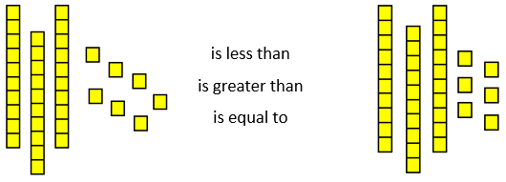
Students may have difficulty connecting the pictorial representations to the actual quantities. For students who struggle, provide additional opportunities to represent quantities with concrete objects, creating a pictorial representation of the objects, and comparing sets using less than, greater than, and equal to.
- Circle the words that best describe how to compare the numbers.

39
is less than
is greater than
is equal to
65
Students recognize simple multi-digit numbers, such as 30 and 42, but do not understand that the position of a digit determines its value. They may focus on the digits alone, rather than the value and magnitude of the numbers. In this example, students may say that 39 is greater because 9 is bigger than 6 and 5. Building numbers by grouping objects into tens and ones or using towers of ten connecting cubes and leftover ones will give the student a better sense of the quantity of the number. Students need concrete representations and pictorial representations before the abstract representation.

