Just In Time Quick Check

Standard of Learning (SOL) 1.1d
Strand: Number and Number Sense

Standard of Learning (SOL) 1.1d
The student will count forward orally by ones, twos, fives, and tens to determine the total number of objects to 110.

Grade Level Skills:
- Count forward orally by ones, twos, fives, and tens to determine the total number of objects to 110.
Just in Time Quick Check
Just in Time Quick Check Teacher Notes

Supporting Resources:
- VDOE Mathematics Instructional Plans (MIPS)
  - Grouping and Counting – Part 1 (Word) / PDF Version
  - Grouping and Counting – Part 2 (Word) / PDF Version
- VDOE Word Wall Cards: Grade 1 (Word) | (PDF)
  - Counting by Ones
  - Counting by Fives
  - Counting by Tens
- VDOE Instructional Videos for Teachers:
  - Developing Early Number Sense (grades K-2)
  - Using a Beaded Number Line (grades K-2)
Supporting and Prerequisite SOL: 1.1a, 1.1b, K.3d

SOL 1.1d - Just in Time Quick Check: Student Interview

- Say: Use the picture cards to count the toes for me. Please count by tens.

Student could accurately count to __________

- Say: Use the picture cards to count the fingers for me. Please count by fives.

Student could accurately count to __________

- Say: Use the picture cards to count the socks for me. Please count by twos.

Student could accurately count to ________

Cards for counting toes – Task 1
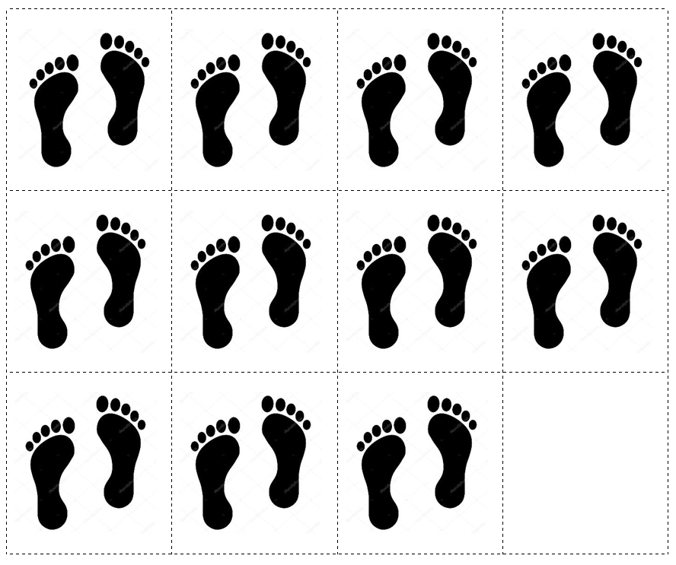

Cards for counting fingers – Task 2
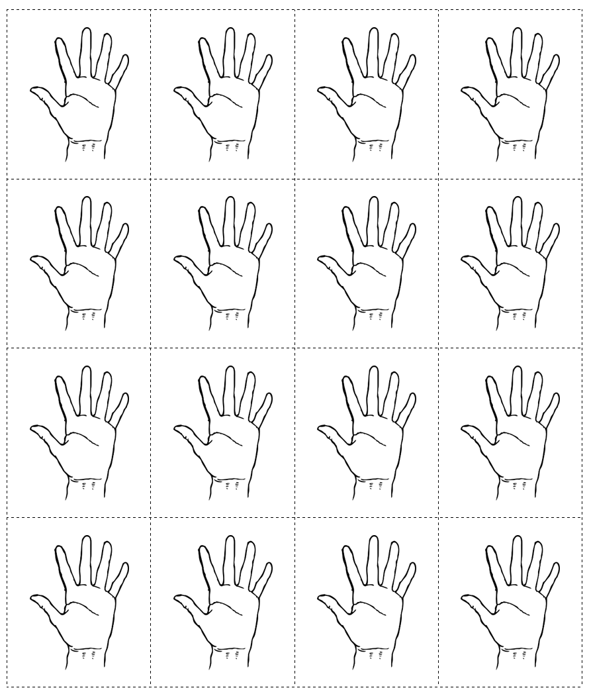

Finger cards, continued

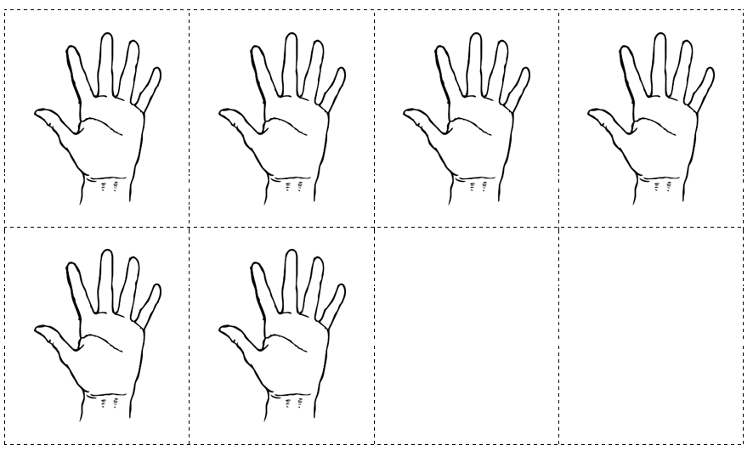

Sock cards – Task 3
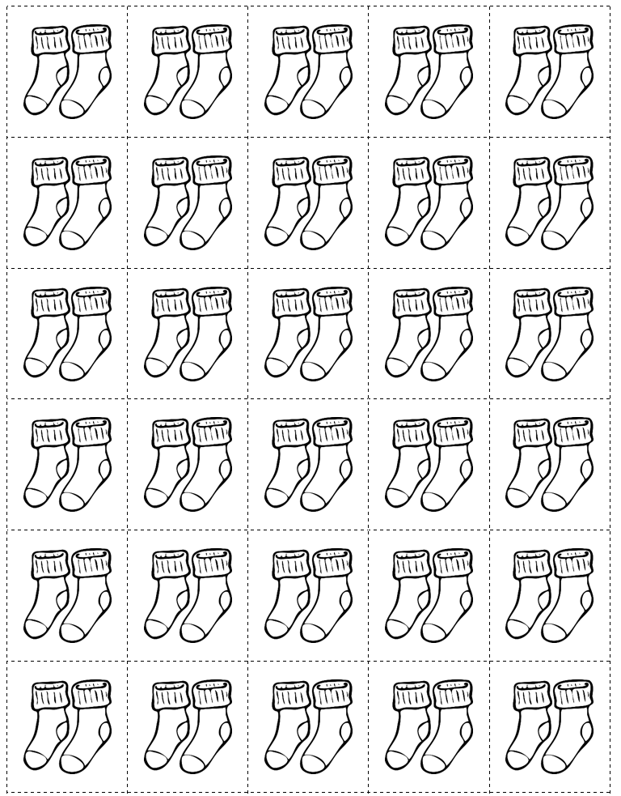

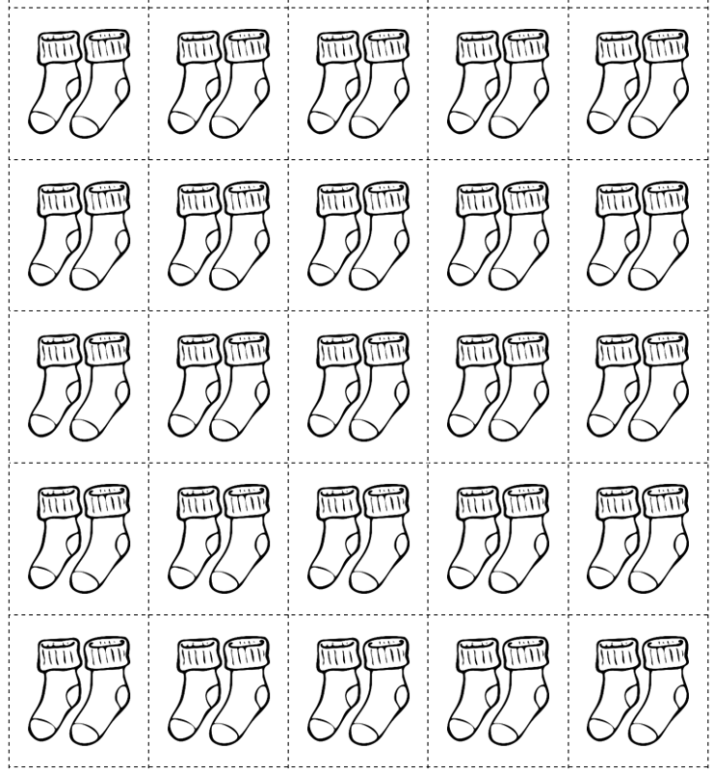

SOL 1.1d - Just in Time Quick Check Teacher Notes
Common Errors/Misconceptions and their Possible Indications

General notes on skip counting: Students may count each picture by ones (each toe, foot, finger, hand, or sock). They may need additional experiences using skip counting to count groups of things. It is important to make skip counting meaningful by counting sets so that students begin to see counting by groups as a shortcut for counting by ones.
If a student is unable to skip count, additional opportunities to count concrete objects by groups is needed. Following ample practice with concrete items, students may be ready to move on to pictorial representations and more abstract representations (i.e., a hundred board with the appropriate columns highlighted) allowing students to explore the visual pattern of the numbers they are counting.
Please see the teacher notes for each question regarding specific support for skip counting by 10s, 5s, and 2s.

- Say: Use the picture cards (for Task 1) to count the toes for me. Please count by tens.
Once students begin having success using skip counting to count concrete objects, they may be ready to move to pictorial representations as well as more abstract representations (i.e., a hundred board with the appropriate columns highlighted) allowing students to explore the visual pattern of the numbers they are counting.
Concrete objects such as, towers of 10, full ten frames, or bead strings can support counting by tens. Quantities should progress in size as students become more adept at skip counting Suggested benchmarks for skip counting by tens are: 30, 60, and 100.

- Say: Use the picture cards (for Task 2) to count the fingers for me. Please count by fives.
Concrete objects such as full five frames, tally marks, hand cards (sample provided), or bead strings will help support skip counting by fives. Suggested benchmarks for skip counting by fives are: 25, 50, and 100.

- Say: Use the picture cards (for Task 3) to count the socks for me. Please count by twos.
Concrete objects such as pairs of shoes, wings, legs, or eyes on birds, legs, arms, hands, or feet on people, or bead strings will help support skip counting by twos. Suggested benchmarks for skip counting by twos are: 10, 20, 50, and 100.

