Just In Time Quick Check

Standard of Learning (SOL) K.13
Strand: Patterns, Functions and Algebra

Standard of Learning (SOL) K.13
The student will identify, describe, extend, create, and transfer repeating patterns.

Grade Level Skills:
- Identify and describe the core (the part of the sequence that repeats) found in repeating patterns of common objects, sounds, movements, and pictures.
- Extend a repeating pattern by adding at least two complete repetitions of the core to the pattern.
- Create a repeating pattern.
- Compare similarities and differences between patterns.
- Transfer a repeating pattern from one representation to another.
Just in Time Quick Check
Just in Time Quick Check Teacher Notes

Supporting Resources:
- VDOE Mathematics Instructional Plans (MIPS)
  - K.13 - People Patterns (Word) / PDF Version
- VDOE Word Wall Cards: Kindergarten (Word) | (PDF)
  - Core
  - Patterns: Repeating
  - Patterns: Transfer a Repeating Pattern
Supporting and Prerequisite SOL: K.12, Foundation Blocks for Early Learning: Standards for Four-Year Olds – 6bc*
*This links to the prerequisite standards found in Foundation Blocks for Preschool. Just in Time Quick Checks have not been created for Foundation Blocks.

SOL K.13 - Just in Time Quick Check: Student Interview

Materials Needed: Pattern Strips A and B (for questions 1 and 2) and any type of manipulative with a variety of characteristics to create a pattern (for questions 3 and 4).
- Show students Pattern Strip A. Ask, the following questions:
- Can you tell me the ‘core’ (the part of the sequence that repeats) in this pattern?
- Can you continue the pattern? (Have student continue the pattern for at least two repetitions of the core.)
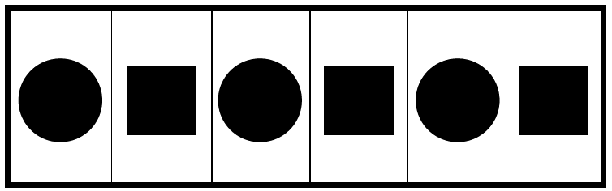
Student Response:
a)
b)

- Look at the pattern strip below.
- Can you tell me the ‘core’ (the part of the sequence that repeats) of this pattern?
- Can you extend/continue the pattern (at least two repetitions of the core)?

Student Response:
a)
b)
- Provide manipulatives of various size, shape, and/or color. Ask student to use some of these objects to create a repeating pattern?
Student Response:

- Can you show another representation of the pattern you created (in number 3)?
Student Response:

PATTERN STRIP A

Pattern Strip B

SOL K.13 - Just in Time Quick Check Teacher Notes
Common Errors/Misconceptions and their Possible Indications

- Show students Pattern Strip A. Ask, the following questions:
- Can you tell me the ‘core’ (the part of the sequence that repeats) in this pattern?
- Can you continue the pattern? (Have student continue the pattern for at least two repetitions of the core.)
Students who are unable to remember what ‘the core’ means may need to be reminded that the ‘core’ is the part of the sequence that repeats. If students are unable to name the core for either pattern, they will need additional experiences identifying patterns and describing what stays the same in a repeating pattern using a variety of symbols, shapes, movements, and objects.
It is possible that students who struggle to identify the core may also have difficulty extending the pattern with a minimum of two core repetitions. Some students may extend the pattern by only two shapes instead of two repetitions of the core; at this level, it is appropriate to ask the student to continue adding to the pattern to ensure that they are able to build at least two repetitions. The teacher may have to remind the student they are using the core to extend the pattern and not just the individual shapes.
- Look at the pattern strip below.
- Can you tell me the ‘core’ (the part of the sequence that repeats) of this pattern?
- Can you extend/continue the pattern (at least two repetitions of the core)?

- Provide manipulatives of various size, shape, and/or color. Ask student to use some of these objects to create a repeating pattern.
Student Response:
Some students may struggle to create a repeating pattern or may place a few shapes that do not build a pattern. In order to determine further what they know, you may need to ask them to tell you about their pattern. Students who are not able to create a repeating pattern will need opportunities to identify repeating patterns in their environment as well as additional experiences building repeating patterns. They will likely benefit from opportunities to notice repeating patterns in their classroom or home and to participate in discussions that focus on what stays the same, what is different.
- Can you show another representation of the pattern you created (in number 3)?
Student Response:
Some students who may be able to extend or create a repeating pattern may not be able to transfer that pattern to another representation. They will benefit from experiences that allow them to see what it means to transfer to another representation (i.e., see a pattern built with boys and girls in the classroom and then describe how we might use two colors of blocks to represent the same pattern). Students can also work in pairs where one student creates a repeating pattern and another child transfers that same pattern to another representation. Students need lots of opportunities to see patterns in their environment, name and describe the pattern, and transfer the pattern to other representations. This can occur as a 3-minute filler while waiting to take students to lunch or the art room, etc. Ask students what patterns they see as you walk down the hall and then have other students describe how the same pattern could be named using letters or movements.

