Just In Time Quick Check
Standard of Learning (SOL) K.11b
Strand: Probability and Statistics

Standard of Learning (SOL) K.11b
The student will read and interpret data in object graphs, picture graphs, and tables.

Grade Level Skills:
- Answer questions related to the gathered data displayed in object graphs, picture graphs, and tables:
- Read the graph to determine the categories of data and the data as a whole (e.g., the total number of responses) and its parts (e.g., five people are wearing sneakers); and
- Interpret the data that represents numerical relationships, including categories with the greatest, the least, or the same.
Just in Time Quick Check
Just in Time Quick Check Teacher Notes

Supporting Resources:
- VDOE Mathematics Instructional Plans (MIPS)
  - K.11ab - Our Favorite Things (Word) / PDF Version
- VDOE Word Wall Cards: Kindergarten (Word) | (PDF)
  - Picture graph
  - Table
Supporting and Prerequisite SOL: K.1a, K.1b, K.2a, Foundation Blocks for Early Learning: Standards for Four-Year Olds – 5b*
*This links to the prerequisite standards found in Foundation Blocks for Preschool. Just in Time Quick Checks have not been created for Foundation Blocks.

SOL K.11b - Just in Time Quick Check

- Ms. Brown asked her students what equipment they liked to use on the playground. She created this picture graph based on the data she collected. Use the picture graph to answer the questions.
On the Playground
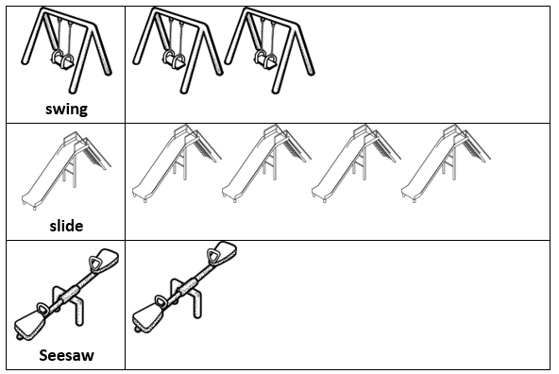
How many students like to slide? __________________

How many students like to 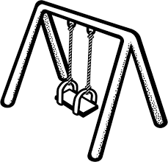 swing? _________________

What do students like to do the least? 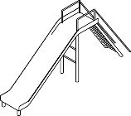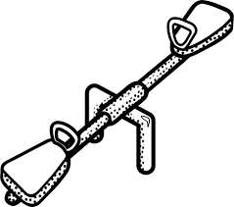

Which received the greatest number of votes?

- Ms. Brown asked her students whether they would rather ride on a boat or a train. She created this table based on how her students voted. Use the table to answer the questions.
Let’s Go
boat | train
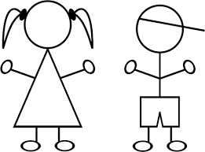

Which received the greatest number of votes?

How many students would rather ride on a train? _________________

How many students answered the question? ____________________

SOL K11.b - Just in Time Quick Check Teacher Notes
Common Errors/Misconceptions and their Possible Indications
- Ms. Brown asked her students what equipment they liked to use on the playground. She created this picture graph based on the data she collected. Use the picture graph to answer the questions.
On the Playground
- How many students like to slide? __________________
- How many students like to swing? _________________
Students who do not understand that the first picture represents the category may count it as a vote answering 5 for the number of students who like to slide and 3 for the number that likes to swing, etc. These students need additional opportunities to engage in creating graphs with the whole class, discussing the parts of a graph, and sharing what they notice and what information the graph provides.
- What do students like to do the least?
- Which received the greatest number of votes?
If a student confuses the words least and greatest when comparing data, they may need additional opportunities to compare three sets using the vocabulary least and most with concrete objects or things readily available in their classroom or home. One strategy might be to have three students grab a handful of small cubes and ask a question like, “Who has the greatest number of cubes?” or “Who has the least number of cubes?” Having students use concrete items and create sets that are more and less than a given set may also be beneficial.

- Ms. Brown asked her students whether they would rather ride on a boat or a train. She created this table based on how her students voted. Use the table to answer the questions.
Let’s Go
boat | train

Which received the greatest number of votes?
A student who selects train for an answer may be confusing greatest and least. They may need additional opportunities to compare sets of data, using the vocabulary greatest and least. They may also need more concrete practice with making sets of things that are greater or less than a given set.
How many students would prefer to ride on a train? ____________
A student may answer 8 or 12 for this question. The answer 8 would show that they counted the wrong group of votes. The answer 12 would show that they were counting all of the votes. This student may need more practice with making object and picture graphs, counting the number of data points, and describing the results.
How many students answered the question? ________________________
Any student who incorrectly answers 8 or 4 may only be counting one set of votes and not all the votes together. This student may need more practice making object or picture graphs with their own data to understand the total number. Students would also benefit from answering questions such as this during whole group graphing activities.

