Just In Time Quick Check
Standard of Learning (SOL) K.9
Strand: Measurement and Geometry

Standard of Learning (SOL) K.9
The student will compare two objects or events, using direct comparisons, according to one or more of the following attributes: length (longer, shorter), height (taller, shorter), weight (heavier, lighter), temperature (hotter, colder), volume (more, less), and time (longer, shorter).

Grade Level Skills:
- Compare and describe lengths of two objects (as longer or shorter), using direct comparison.
- Compare and describe heights of two objects (as taller or shorter), using direct comparison.
- Compare and describe weights of two objects (as heavier or lighter), using direct comparison.
- Compare and describe temperatures of two objects or environment (as hotter or colder), using direct comparison.
- Compare and describe volumes of two containers (as more or less), using direct comparison.
- Compare and describe the amount of time spent on two events (as longer or shorter), using direct comparison.
Just in Time Quick Check
Just in Time Quick Check Teacher Notes

Supporting Resources:
- VDOE Word Wall Cards: Kindergarten (Word) | (PDF)
  - Weight: Heavier/Lighter
  - Length: Longer/Shorter
  - Height: Taller/Shorter
  - Temperature: Hotter/Colder
  - Volume: Less/More
- Mathematics Instructional Plans
  - K.9 - Heavier or Lighter? (Word) / PDF Version
  - K.9 - Hot or Cold? (Word) / PDF Version
  - K.9 - How Long Is It? (Word) / PDF Version
  - K.9 - Taller or Shorter? (Word) / PDF Version
  - K.9 - Time: Longer or Shorter? (Word) / PDF Version
  - K.9 - Volume: More or Less? (Word) / PDF Version
- Co-Teaching Mathematics Instructional Plans
  - K.9 - Comparing Time (Word) / PDF Version
  - K.9 - Comparing Volume (Word) / PDF Version
Supporting and Prerequisite SOL: Foundation Blocks for Early Learning: Standards for Four-Year Olds – 3ac*
*This links to the prerequisite standards found in Foundation Blocks for Preschool. Just in Time Quick Checks have not been created for Foundation Blocks.

SOL K.9 - Just in Time Quick Check: Student Interview
Which of these nails is longer? | Which strip is shorter?
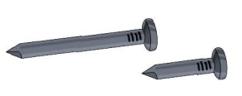 | 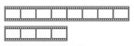

Which of these ladders is taller? | Which of these animals is shorter?
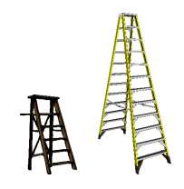 | 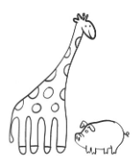

Which of these is heavier? (the cow or the milk carton) | Which of these objects is lighter? (the paper clip or the scissors)
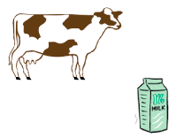 | 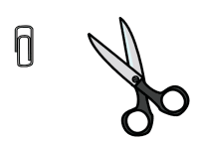

Which picture represents a day that is hotter? | Which of these foods is colder than the other?
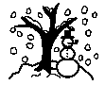

Which of these containers has less juice? | Which of these bottles has more water?
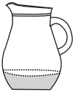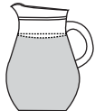

Which of these takes a longer amount of time? | Which of these takes a shorter amount of time?
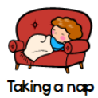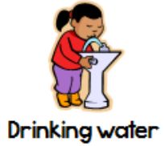 | 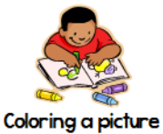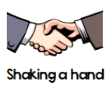

K.9 - Just in Time Quick Check Teacher Recording Sheet

Teacher ask students questions and records student responses and any additional notes in the chart below.

Skill | Response Correct | Response Incorrect | Additional Notes
Lengths of two objects (longer/shorter)
Heights of two objects (taller/shorter)
Weights of two objects (heavier/lighter)
Temperatures of objects or environment (hotter/colder)
Volumes of two containers (more/less)
Time spent on two events (longer/shorter)

K.9 - Just in Time Quick Check Teacher Notes
Common Errors/Misconceptions and their Possible Indications

Some students may understand the vocabulary words long, short, tall, short, heavy, light, hot, cold but may struggle to use them appropriately when making comparisons. These students would benefit from additional opportunities to use these terms when making direct comparisons with items in the classroom and at home. It is recommended that objects, situations, or events that are common and familiar to students be used for further exploration and instruction.
Some students may struggle particularly when comparing volume and time. This may be due to lack of experience. For those struggling with comparing the volume of two containers, provide opportunities to practice this skill throughout the school year. Ensure that students utilize the same measuring unit (i.e., large cubes, small cubes, beans, etc.) to determine which container holds more. For students who struggle with one-to-one correspondence, it may be helpful to provide measuring units that are larger, so that there are fewer to count; then, as students make progress in their counting abilities decrease the size of the unit utilized so that students have additional opportunities to count larger amounts.
Some students will likely struggle with telling which event will take more time. Time is so abstract for young children. As a result, they will need lots of experiences considering which takes longer. Providing opportunities during the school day to compare the length of time an event takes will be beneficial as students are able to consider the length of time. Some ideas might include asking students: Will it take more time to do one jumping jack or ten jumping jacks? Which takes less time – walking across the room or walking to the front office? Testing out these ideas could be helpful to many students who are struggling to identify events that take more or less time. Note: Students are not expected to know how much time an event takes, just be able to directly compare which takes more or less time.

