Just In Time Quick Check

Standard of Learning (SOL) K.4b
Strand: Number and Number Sense

Standard of Learning (SOL) K.4b
The student will investigate and describe part-whole relationships for numbers up to 10.

Grade Level Skills:
- Investigate and describe part-whole relationships for numbers up to 10 using a variety of configurations.
Just in Time Quick Check
Just in Time Quick Check Teacher Notes

Supporting Resources:
- VDOE Mathematics Instructional Plans (MIPS)
  - K.4ab - Bears in Caves (Word) / PDF Version
  - K.4ab - Disappearing Parts (Word) / PDF Version
  - K.4ab - Fill, Shake, and Pour (Word) / PDF Version
  - K.4ab - Subitizing with Dot Cards (Word) / PDF Version
- VDOE Word Wall Cards: Kindergarten (Word) | (PDF)
  - Counting by ones
  - More than
  - Fewer than
- VDOE Rich Mathematical Tasks
  - K.4ab – Picking Apples Task (Word / PDF)
- VDOE Instructional Videos for Teachers
  - Developing Early Number Sense (grades K-2)
  - Using A Beaded Number Line (grades K-2)
Supporting and Prerequisite SOL: K.1a, K.4a, Foundation Blocks for Early Learning: Standards for Four-Year Olds – 1abc*
*This links to the prerequisite standards found in Foundation Blocks for Preschool. Just in Time Quick Checks have not been created for Foundation Blocks.

SOL K.4b - Just in Time Quick Check

Display the dot cards provided (numbers 5-10 out of sequence) in order to determine if the student can easily describe the groups.
- Ask each question for each dot card.
- How many dots?
- How did you figure out the number of dots?

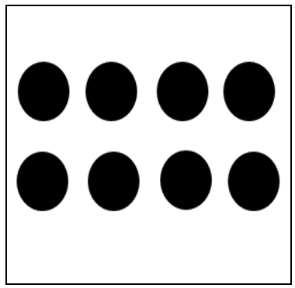
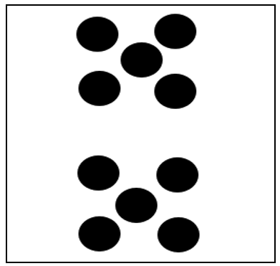

DOT CARDS

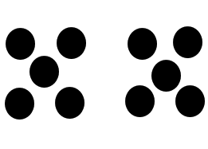
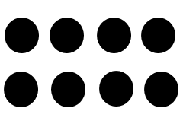

SOL K.4b - Just in Time Quick Check Teacher Notes
Common Errors/Misconceptions and their Possible Indications

Display the dot cards provided (numbers 5-10 out of sequence) in order to determine if the student can easily describe the groups.
- Ask each question for each dot card.
- How many dots?
- How did you figure out the number of dots?

Students in Kindergarten will be working on describing part-whole relationships for numbers up to 10 using a variety of configurations throughout the year. Some students may struggle to describe part-whole relationships for some numbers and may resort to counting all of the dots. These students are not yet able to subitize numbers (see a group of dots without having to count) and need additional work recognizing small groups of numbers. The ability to compose and decompose numbers (seeing the parts of numbers) is foundational for building fact fluency. Kindergarten students will likely be at different ‘working numbers’ but can be engaged in the same activities alongside each other, working on the same skills/activities but with the number(s) where they need the most work. All students will need frequent opportunities to recognize arrangements of small groups of numbers (to five) in a variety of configurations prior to moving on to recognizing those small groups within larger groups. Using dot cards on a daily basis, as a number routine and in stations, is one strategy that will help to strengthen students’ ability to subitize numbers.
Refer to the links to resources on page 1 which include numerous instructional activities that will support students in building the above skills (i.e., Mathematics Instructional Plans and Videos). Additional dot cards can be found in the Kindergarten MIP: Subitizing with Dot Cards.

