Just In Time Quick Check

Standard of Learning (SOL) K.3b
Strand: Number and Number Sense

Standard of Learning (SOL) K.3b
The student will count backward orally by ones when given any number between 1 and 10.

Grade Level Skills:
- Count backward orally by ones when given any number between 1 and 10.

Just in Time Quick Check

Just in Time Quick Check Teacher Notes

Supporting Resources:
- VDOE Mathematics Instructional Plans (MIPS)
  - K.3abc - Garbage (Word) / PDF Version
  - K.3abd - Meaningful Rote Counting (Word) / PDF Version
- VDOE Word Wall Cards: Kindergarten (Word) | (PDF)
  - Counting by Ones
Supporting and Prerequisite SOL: K.3a, Foundation Blocks for Early Learning: Standards for Four-Year Olds - 1a*
*This links to the prerequisite standards found in Foundation Blocks for Preschool. Just in Time Quick Checks have not been created for Foundation Blocks.

Just in Time Quick Check

- Show the student the rocket picture and say: Today, we are going to make this rocket blast off! Do you know what we need to do? That’s right! We need to count down from 10. Can you do that for me? (Make note whether they included zero: …3, 2, 1, 0.)

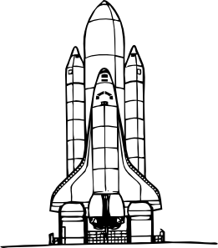

Just in Time Quick Check Teacher Notes
Common Errors/Misconceptions and their Possible Indications

- Show the student the rocket picture and say: Today, we are going to make this rocket blast off! Do you know what we need to do? That’s right! We need to count down from 10. Can you do that for me? (Make note whether they included zero: …3, 2, 1, 0.)

When counting backwards, omitting zero is a common error. This usually indicates a lack of experience and understanding of zero. If this occurs, students need additional practice with counting back including the zero. It can be helpful for students to use pictures or counters as they count backwards.
If a student cannot count back from 10, start with a smaller number – check to see if they can count back from 5 and then 8 as they work up to counting back from 10. Using counters can help students to visually see the result and begin to understand that counting backwards indicates that you have one less each time you say a number.

