Just In Time Quick Check

Standard of Learning (SOL) K.2b
Strand: Number and Number Sense

Standard of Learning (SOL) K.2b
The student, given no more than three sets, each set containing 10 or fewer concrete objects, will compare and order sets from least to greatest and greatest to least.

Grade Level Skills:
- Compare and order three or fewer sets, each set containing 10 or fewer concrete objects, from least to greatest and greatest to least.

Just in Time Quick Check

Just in Time Quick Check Teacher Notes

Supporting Resources:
- VDOE Mathematics Instructional Plans (MIPS)
  - K.2b - Ordering Sets (Word) / PDF Version
- VDOE Word Wall Cards: Grade K (Word / PDF)
  - Counting by Ones
  - More Than
  - Fewer Than
- VDOE Rich Mathematical Tasks
  - K.2ab Building Towers Task (Word / PDF)
- VDOE Instructional Videos for Teachers
  - Developing Early Number Sense (grades K-2)
  - Using A Beaded Number Line (grades K-2)
Supporting and Prerequisite SOL: K.1a, K.2a, Foundation Blocks for Early Learning: Standards for Four-Year Olds - 1abd*
*This links to the prerequisite standards found in Foundation Blocks for Preschool. Just in Time Quick Checks have not been created for Foundation Blocks.

SOL K.2b - Just in Time Quick Check

- Use the three dot cards from set A. Place the cards in front of the student.
  - Place cards set A in front of the student. Say, “Please order these cards from greatest to least?”
  - If you are unsure of how the student ordered the cards, ask additional questions such as, “Tell me how you arranged the cards,” “Which card has the greatest amount?” or “Which card has the least amount?”

- Use the three dot cards from set B. Place the cards in front of the student.
  - Place cards set A in front of the student. Say, “Please order these cards from least to greatest?”
  - If you are unsure of how the student ordered the cards, ask additional questions such as, “Tell me how you arranged the cards,” “Which card has the greatest amount?” or “Which card has the least amount?”

Ordering Cards Set A

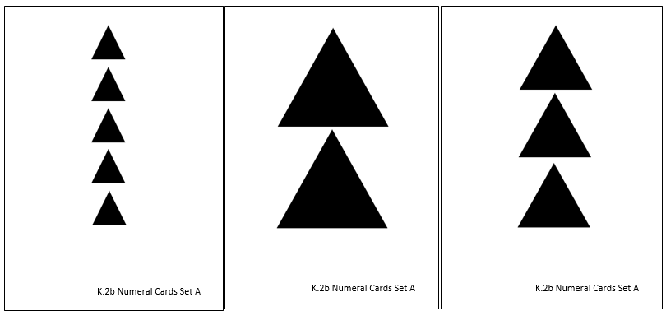

Ordering Cards Set B

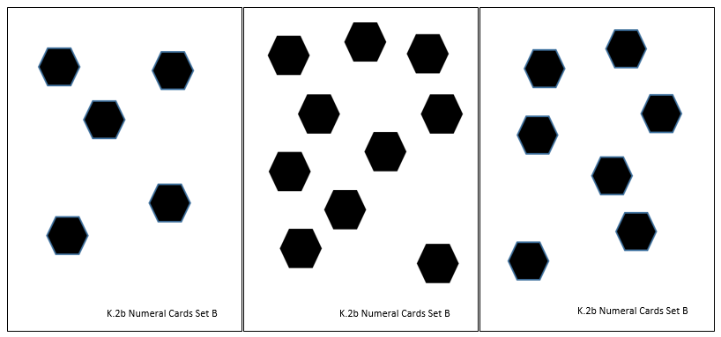

SOL K.2b - Just in Time Quick Check Teacher Notes
Common Errors/Misconceptions and their Possible Indications
- Use the three dot cards from set A. Place the cards in front of the student.
  - Place cards set A in front of the student. Say, “Please order these cards from greatest to least?”
  - If you are unsure of how the student ordered the cards, ask additional questions such as, “Tell me how you arranged the cards,” “Which card has the greatest amount?” or “Which card has the fewest amount?”
A common misconception is that students confuse the size of an object with the number of objects in the set (ex: three small triangles is more than two large triangles). Students with this misconception need more experiences with sets of objects they can count before ordering greatest to least and least to greatest.

- Use the three dot cards from set B. Place the cards in front of the student.
  - Place cards set A in front of the student. Say, “Please order these cards from least to greatest?”
  - If you are unsure of how the student ordered the cards, ask additional questions such as, “Tell me how you arranged the cards,” “Which card has the greatest amount?” or “Which card has the fewest amount?”
Pay close attention to how the student orders the cards. In kindergarten, it is common for students to order cards from right to left, instead of left to right like reading a book. Asking questions about how they ordered them will give you more insight into their understanding about ordering numbers. Providing opportunities for small groups of students to build different quantities and then compare and order their quantities will help students develop their ability to compare and use the terms for comparing and ordering.

