Just In Time Quick Check

Standard of Learning (SOL) K.2a
Strand: Number and Number Sense

Standard of Learning (SOL) K.2a
The student, given no more than three sets, each set containing 10 or fewer concrete objects, will compare and describe one set as having more, fewer, or the same number of objects as the other set(s).

Grade Level Skills:
- Compare and describe no more than three sets of 10 or fewer objects, using the terms more, fewer, and the same.
- Given a set of objects, construct a second set which has more, fewer, or the same number of objects.

Just in Time Quick Check

Just in Time Quick Check Teacher Notes

Supporting Resources:
- VDOE Mathematics Instructional Plans (MIPS)
  - K.2a - Build and Compare (Word) / PDF Version
  - K.2a - How Many Snails? (Word) / PDF Version
  - K.2a - Splash! (Word) / PDF Version
  - K.2a - More, Fewer, or the Same? (Word) / PDF Version
- VDOE Word Wall Cards: Kindergarten (Word) | (PDF)
  - Counting by Ones
  - More Than
  - Fewer Than
- VDOE Rich Mathematical Tasks
  - K.2ab Building Towers Task (Word / PDF)
- VDOE Instructional Videos for Teachers
  - Developing Early Number Sense (grades K-2)
  - Using A Beaded Number Line (grades K-2)
Supporting and Prerequisite SOL: K.1a, Foundation Blocks for Early Learning: Standards for Four-Year Olds – 1abc*
*This links to the prerequisite standards found in Foundation Blocks for Preschool. Just in Time Quick Checks have not been created for Foundation Blocks.

SOL K.2a - Just in Time Quick Check

- Use the two dot cards from each set, one set at a time. Place both cards in front of the student.
  - Place cards set 1 in front of the student. Say, “Which set has fewer?”
  - Repeat with set 2. Say, “Which set has more?”

- Provide the student with a set of 10 counters for this question. Use the dot card from set 3. Place the card in front of the student.
  - Say, “Can you build a set that has the same amount of counters as what you see on the card?”

Numeral Cards Set 1
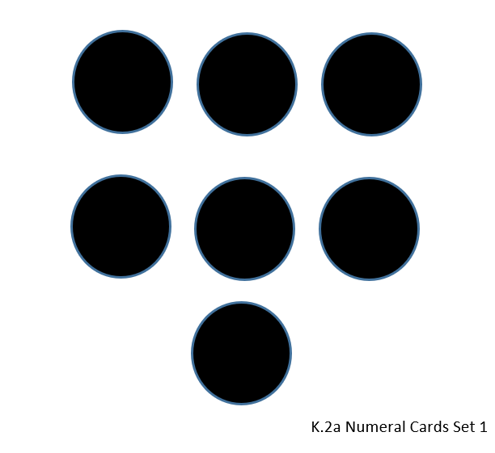
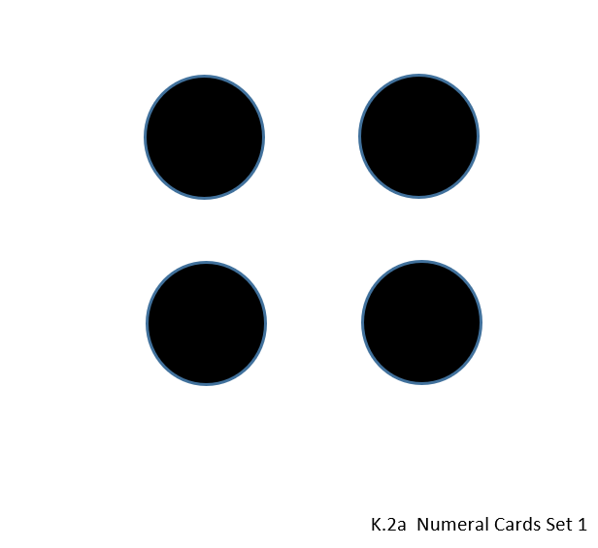

Numeral Cards Set 2
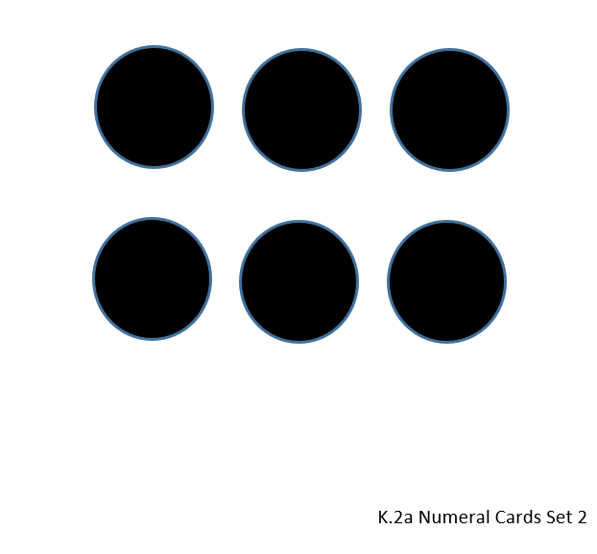
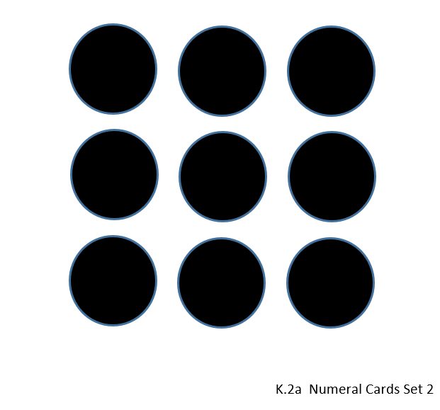

Numeral Cards Set 3

SOL K.2a - Just in Time Quick Check Teacher Notes
Common Errors/Misconceptions and their Possible Indications
- Use the two dot cards from each set, one set at a time. Place both cards in front of the student.
  - Place cards set 1 in front of the student. Say, “Which set has fewer?”
  - Repeat with set 2. Say, “Which set has more?”

Some students have difficulty with selecting the set with “fewer” because they have had less exposure to this word. Students who struggle identifying sets with fewer or more need additional exposure to the term “fewer” and opportunities to use the term when describing quantities. Teachers might ask, “Which is more?” and “Which is fewer?” Asking both questions when comparing amounts will help students connect the words and the concepts of “more” and “fewer.” Having students build a set of a certain quantity, then asking them to build different sets that contain fewer, more, and the same quantity will help to develop an understanding of these terms.

- Provide the student with a set of 10 counters for this question. Use the dot card from set 3. Place the card in front of the student.
  - Say, “Can you build a set that has the same amount of counters as what you see on the card?”

Some students may be confused by perceptual cues presented in the card, such as the length of the row or the spacing of the counters in the set. If this is the case, encourage the student to use matching counters to compare the set and then build a set that shows the same amount.

