VIRGINIA DEPARTMENT OF EDUCATION

Science Instructional Enhancements
for Diverse Learners

Make science learning visible
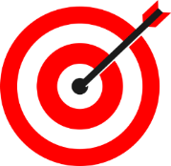
- Establish content and connected language targets to support students in comparing, sequencing, justifying, explaining their thinking, etc.
- Provide multiple ways, including graphs, tables, and illustrations, for students to communicate their thinking
- Use graphic organizers such as mind maps and Venn Diagrams to help students connect their ideas
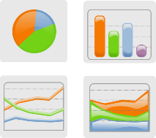
- Draw attention to patterns and relationships in graphs, tables, and other visualizations
- Refer to student-generated word walls and skill anchor charts to support language development and understanding of science concepts and practices
- Employ multiple representations of concepts and allow for opportunities for students to develop and/or interpret models
- Use (and encourage students to use) motion to support understanding and retention of new concepts and key terms
- Post visual displays to cue memory and support written language
- Encourage students to represent their thinking with pictorial representations and other type of models

Use cooperative learning structures and strategies
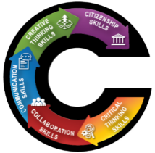
- Structure opportunities for students to collaborate and communicate ideas and make meaning
- Use strategies to support student engagement and science disciplinary discourse
- Use flexible and fluid grouping of students

Support the language of science

All students can learn! High expectations, asset-based thinking, and growth mindsets are key to student success!

- Provide real-world contexts for students to build scientific vocabulary and conceptual understanding
- Explicitly teach the language of science beyond a focus on vocabulary to support conceptual understanding
- Provide sentence starters to support student communication of scientific strategies, processes, and thinking

Reduce cognitive load and allow processing time
- Break tasks and prompts into smaller sections and organize the text using bullet points versus complex paragraphs.
- Read tasks and texts out loud
- Use simple sentences and include only details needed to complete the task
- Reduce number of questions that address same skill or concept
- Reduce visual clutter
- Provide adequate thinking and processing time
- Provide flexible time frames for completing tasks

Connect learning to students’ backgrounds and skills
- Make connections between science concepts and everyday life
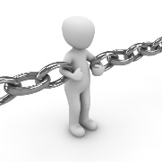
- Craft tasks and prompts that connect with students’ lives and responsibilities
- Highlight scientific contributions and innovations from a variety of different cultures
- Facilitate opportunities for scientific processes or thinking to be explained in student’s home language
High expectations, asset-based thinking, and a growth mindset are key to student success!
Virginia Department of Education 2020

