VIRGINIA DEPARTMENT OF EDUCATION

Mathematics Instructional Enhancements
Diverse Learners

Make Mathematics Learning Visible
- Establish targets that address both content and connected language targets to support students in comparing, sequencing, justifying, explaining their thinking, etc.
- Provide multiple ways for students to communicate their thinking
- Use graphic organizers to help students connect their ideas (e.g., mind maps and Venn Diagrams)
- Draw attention to patterns and relationships in graphics and visuals
- Create and interact with word walls and process and skill anchor charts, both teacher and student generated (e.g., provide solved problems with labels for each step)

Use Graphics, Visuals, Manipulatives, and Motions
- Use multiple representations of concepts and models to supplement verbal and written directions
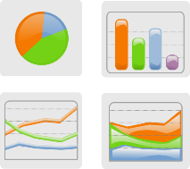
- Use (and encourage students to use) motion to support understanding and retention of new concepts and key terms
- Post visual displays to cue memory and support written language
- Encourage students to represent their thinking with pictorial representations and manipulatives
- Embed lined or graph paper within tasks

Use Cooperative Learning Structures and Strategies
- Structure opportunities to share ideas and make meaning collaboratively
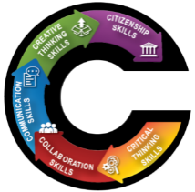
- Use strategies to support student engagement and mathematical discourse (e.g., number talks and talk moves)
- Use flexible and fluid grouping of students

Support the Language of Mathematics
- Model the process of reading and making sense of word problems (e.g., “think-alouds”, “3-read strategy”)
- Explicitly teach mathematics vocabulary to support contextual understanding
- Provide sentence starters to support student communication of mathematical strategies, processes, and thinking

Reduce Cognitive Load and Allow Processing Time
- Break tasks and prompts into smaller sections or consider organizing the text using points
- Use simple sentences and include only details needed to complete the task
- Minimize the number of questions that address the same skill or concept
- Reduce visual clutter and provide structured workspace
- Provide adequate thinking and processing time
- Provide flexible time frames for completing tasks

Connect Learning to Students’ Backgrounds
- Make connections between mathematical ideas and representations with everyday life
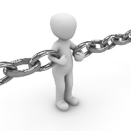
- Craft tasks and prompts that connect with students’ lives and responsibilities
- Support conceptual understanding by inviting students from various cultures to share their strategies
- Facilitate opportunities for mathematical processes to be explained in student’s home language
High expectations, asset-based thinking, and a growth mindset are key to student success!
Virginia Department of Education 2020

