Standards of Learning
Introduction to TestNav 8:
Writing Tool

For use with the Practice Writing Tool
in TestNavTM 8
Updated March 1, 2019

Table of Contents

Standards of Learning Introduction to TestNav 8: 1
Table of Contents 2
Introduction 3
Opening the Practice Items 4
TestNav 8 System Requirements: 4
Launching the TestNav 8 Application: 5
TestNav 8 Application Check: 6
Accessing the Practice Items through the Application: 8
TestNav 8 Features 11
Starting a Test and Navigation Buttons in TestNav: 11
Online Tools Available in TestNav 8 20
Zoom Feature: 21
Accessibility Features Available in TestNav 8 22
Change the background and foreground colors: 23
Highlight Feature: 24
Line Reader Mask: 24
Audio Player on Audio Versions of the Test: 26
Guided Practice Suggestions 27

Introduction

Beginning with the fall 2016 test administration, the Virginia Standards of Learning (SOL) tests will be administered using TestNav 8, a new version of the test delivery software with responsive design. Virginia school divisions will gain the flexibility of administering online SOL tests on a wider variety of devices (e.g., Google™ Chromebooks, Apple iPads®, Android™ tablets), including touch-screen devices. The TestNav 8 software allows tests to be administered securely on these additional devices, while continuing to support the use of traditional Microsoft Windows®-based and Mac OS®-based workstations. In Virginia, test content can be accessed using an installable TestNav 8 application on the device or workstation.

In order to help prepare students for the online administration of the short-paper component of the Writing test, a Practice Writing Tool is being made available in TestNav 8. The Practice Writing Tool can be used to introduce students to the new online navigation, online tools, and overall functionality and appearance of the test delivery system. Providing the Practice Writing Tool in TestNav 8 will also allow school division staff to experience the technical changes and updated system requirements of TestNav 8 prior to its use during online testing.

All Non-Writing and Writing SOL tests will be administered in TestNav 8 beginning with the fall 2016 test administration. This includes the student’s response to the short-paper component of the Writing test.

Opening the Practice Items

The Practice Writing Tool is non-secure; however, it must be accessed via an installable TestNav 8 application that can be used on certain desktops, laptops, and tablets that meet the minimum hardware and software requirements. Before downloading the application, ensure your device meets the minimum requirements for the TestNav 8 installable application.

TestNav 8 System Requirements:
To view the most current TestNav 8 system requirements, go to TestNav System Requirements. From the Web site, active links are provided to the download location and to the setup instructions for each supported device type.

TestNav 8 will look at the font available on the device being used and will look in the order of: Helvetica Neue, Helvetica, Arial, & Sans Serif. If any of these font types are not available, the default font type available on the device will be used.

All Virginia Standards of Learning tests must be administered using the TestNav 8 app and be in kiosk mode. Kiosk mode prevents students from accessing any other web pages or applications besides TestNav while testing.

Please note that an external keyboard is listed as a hardware requirement for some devices. In Virginia, external keyboards will not be required when administering SOL tests on iOS and Android tablets; however, when determining what devices will be used for SOL testing, school divisions are strongly encouraged to consider the level of student experience and familiarity with the device the student will be assigned to use.

Launching the TestNav 8 Application:
After installing the TestNav 8 application on a supported device, open the application. Then select Virginia.

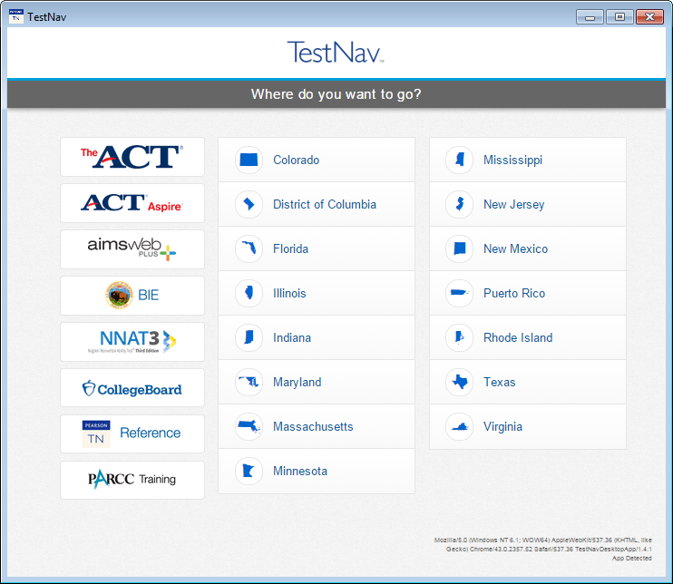

TestNav 8 Application Check:
A Sign In screen for Virginia will appear. Run the application check to ensure that TestNav 8 can run on the device. Select “App Check” from the drop-down list in the upper right corner as shown:

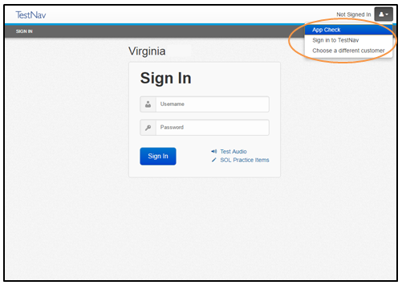

The application check will return an “App Check is complete” message or give the user a red informational message explaining why the application check was not successful.

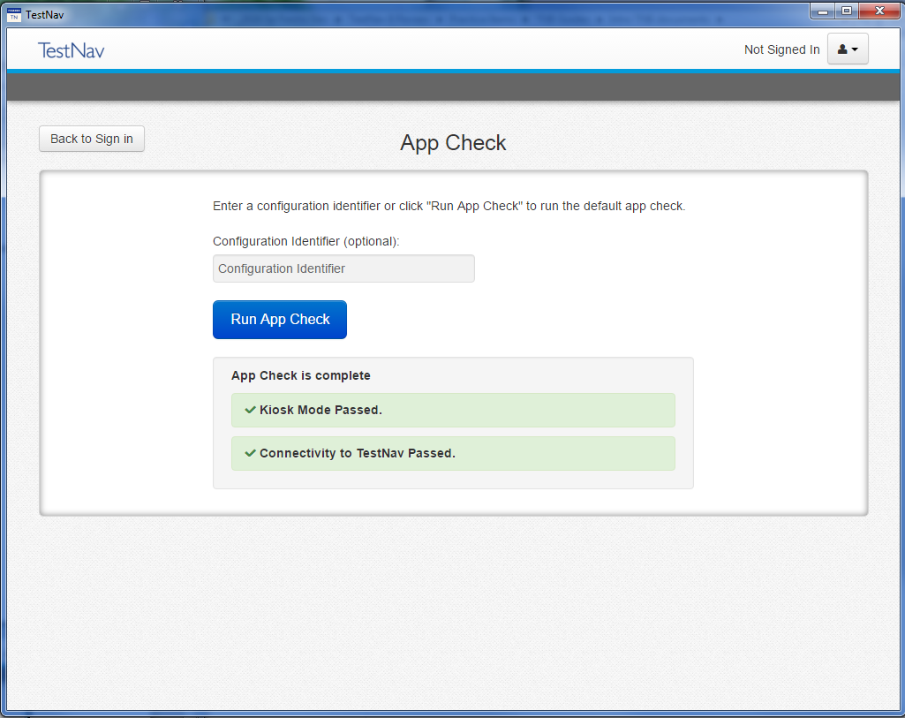

Accessing the Practice Items through the Application:
On an actual SOL test, a username and password are necessary to access a test. Since the Practice Writing Tool is non-secure, a username and password are not necessary. Instead, select the link that says, “SOL Practice Items.”

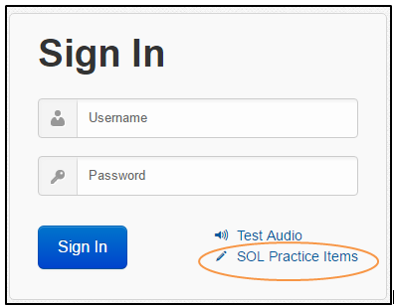

A Standards of Learning Practice Item Sets screen will appear.

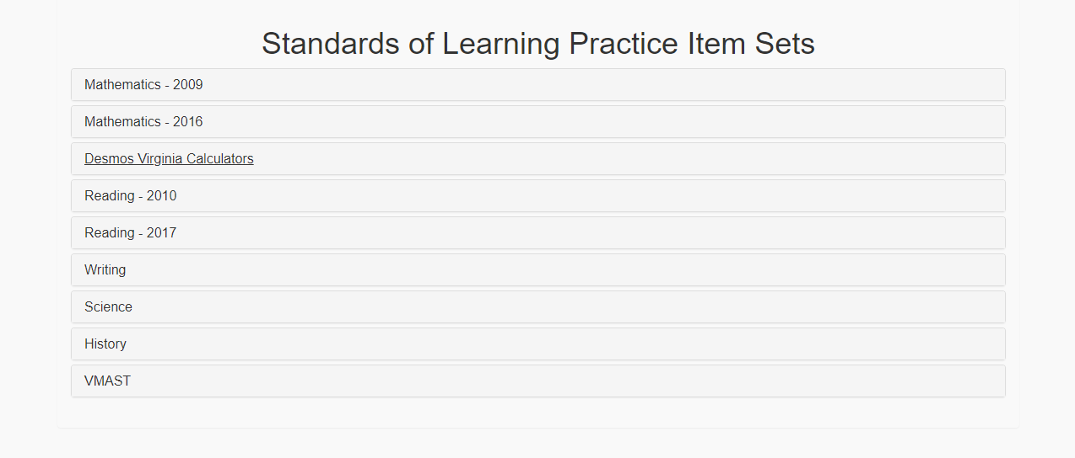

Select Writing. Then select either the Grade 8 Writing Tool or the End of Course Writing Tool.

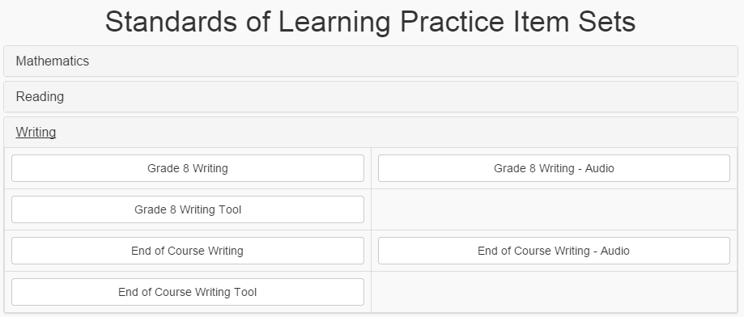

TestNav 8 Features

Starting a Test and Navigation Buttons in TestNav:
Before using the Writing Tool with students, teachers should familiarize themselves with TestNav 8 in order to help students navigate through the testing interface.

On an actual Standards of Learning (SOL) test, a username and password will be required to begin a test. If the test being administered is an audio version of the test, the “Test Audio” button can be selected to set the volume of the audio player prior to sign in.

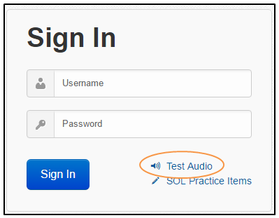

Since the Practice Writing Tool is non-secure, entering Sign In credentials is not necessary. When the Writing Tool is loaded (see pages 9-10 for directions on how to access the Writing Tool from the application), a welcome screen is shown. To begin the Writing Tool, enter a name and select the blue Start Test Now button.

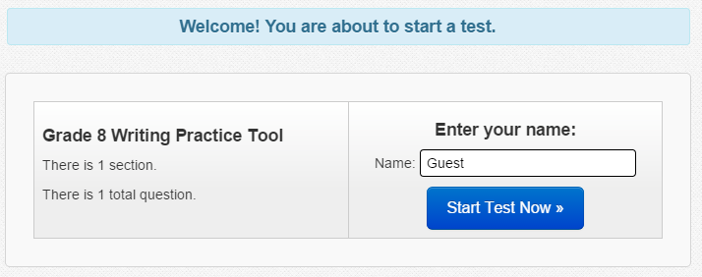

A copyright page will appear on the screen. Agree to the terms of the copyright by checking the box next to the statement, “I agree to the Terms and Conditions.”

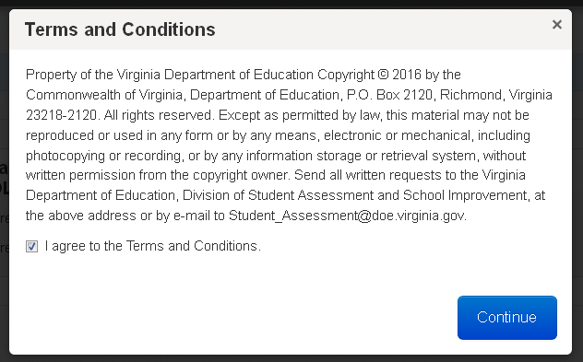

Select Continue to advance to the next screen in order to start Section 1 of the test. Select Start Section to begin using the Practice Writing Tool.

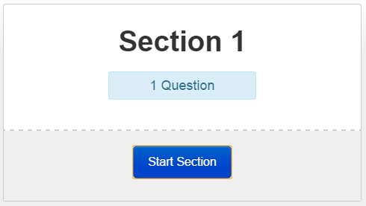

Navigation through TestNav 8 occurs at the top of the screen. Included features are forward and backward arrows, online tools, accessibility features, and access to a drop-down Review screen.

This image gives a description of some of the features found at the top of the screen in TestNav 8.

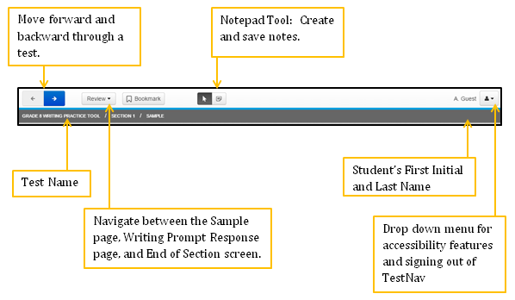

The Forward and Backward Arrows:
The forward and backward arrows can be used to navigate between screens. An arrow button with a blue background indicates a button can be selected. This screenshot is from a screen in the middle of a test and indicates that a student can return to the previous screen or proceed to the next screen.

Review Button and Bookmark Button:
Students can use the Review button as an alternate way to navigate between the three screens within the Writing Tool: the Sample screen, the Writing Prompt Response screen (Question 1), and the End of Section screen. The Bookmark button is typically used to tag an item that needs review at a later time. This feature will likely not be used by students since there is only one “Question” (the Writing Prompt Response screen).

When the Review button is selected, a drop-down menu will appear. All of the screens will be listed. The screen that the student is viewing will be shaded dark gray.
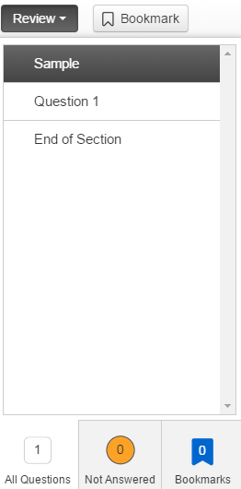
An orange circle to the left of Question 1 indicates that no text has been entered into the writing prompt response area. After one character is entered into the response area, Question 1 will no longer have an orange circle next to it.

End of Section Screen:
This screen indicates whether a response has been entered into the writing prompt response area. The green circle with a check indicates that at least one character has been typed into the response area.

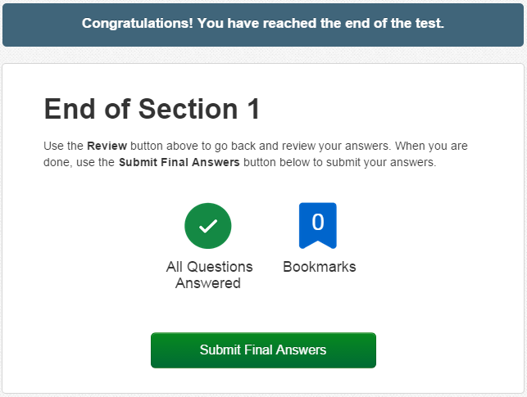

Submitting Final Answers
When the prompt has been fully answered, select the green Submit Final Answers button.
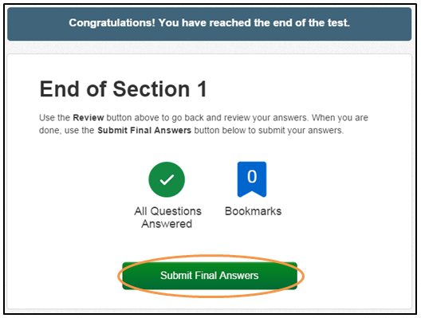
On an actual Standards of Learning Writing test, after selecting the Submit Final Answers button, a warning message will pop up that states, “Are you sure you want to submit final answers? You will not be able to return to this test.” Students will select the green Yes, Submit Final Answers button to submit the response and sign out of TestNav 8. However, in the Practice Writing Tool, the submit screens will be different in order to give the option of printing the response (see the next page).

In this Practice Writing Test, a screen will appear that allows the response to be printed.

Since the testing contractor administers tests for multiple testing programs, there is text on this screen that is not applicable to the Virginia Assessment Program. Please disregard all of the text underneath the Print this page button.
Scroll to the bottom of the screen. The response entered into the Practice Writing Tool is shown next to “Question 1.”

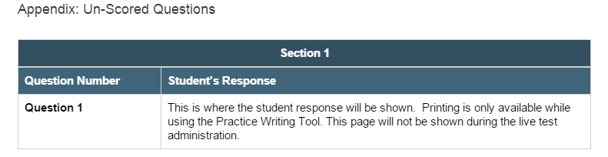
To print the response, scroll back to the top of the page and select the button that says Print this page. An hour glass will show while the page is sent to the default printer for the specific workstation or device. The entire screen page will be printed, which will include the typed response.

To sign out of the Practice Writing Tool, select the blue Sign Out button at the top right of the screen.

It is important to remember that the response must be printed prior to signing out, as the response entered into the Practice Writing Tool is not saved. It is also important to note that printing is only available while using the Practice Writing Tool. This screen will not be shown during the live test administration.

Exiting a Test:
In an actual SOL test, there may be a situation that requires a student to exit the test before the test is completed. In these instances, the student will need to exit the test without submitting it to be scored. In order to exit the test, select on the icon next to the student’s name, located near the top of the screen on the right. Select Sign out of TestNav from the drop-down menu.

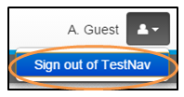
A warning message will pop up on the screen that states, “I want to exit this test and finish later.” Select the blue Save and Return Later button. Note that this method of exiting TestNav will not result in any saved answers while working within the Writing Practice Tool. Saved responses to the prompt will only occur during live, secure testing and not within Practice Writing Tool.
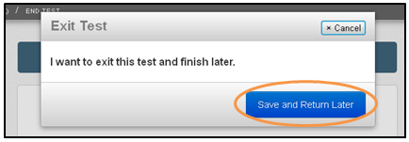

Online Tools Available in TestNav 8
The online tools currently available in the Writing Tool are shown in the table. Directions for practicing these tools with students are provided in the Guided Practice Suggestions document that is available for the Practice Writing Tool. Teachers should be familiar with these tools prior to using the Writing Tool with students.

Location | Tool Icon | Tool Description
Top Tool Bar |  | Pointer: Use to select on screen and to place the cursor within the writing response area.
Top Tool Bar |  | Exhibits: Use to view the writing prompt, the Checklist for Writers, and Shortcut Keys for copying and pasting text. The exhibits tool icon is located on the far right of the screen, halfway down from the top. The online tools will not operate inside the Exhibit window.
Top Tool Bar |  | Notepad: Use to create and save notes.
Gray Toolbar above  Response Area |  | Bold: Use to bold selected text.
Gray Toolbar above  Response Area | 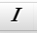 | Italic: Use to italicize selected text.
Gray Toolbar above  Response Area |  | Underline: Use to underline selected text.
Gray Toolbar above  Response Area |  | Bullet List: Use to add bullets to lines of text.
Gray Toolbar above  Response Area |  | Numbered List: Use to add numbered bullets to lines of text.
Gray Toolbar above  Response Area |  | Undo: Use to undo the previous command that was completed.
Gray Toolbar above  Response Area |  | Redo: Use to redo the previous deleted command.
Gray Toolbar above  Response Area | 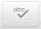 | Spell Check¹: Use to check the spelling of the typed text. If a student types additional sentences they will need to select the Spell Check button again to check the remainder of the response.
Gray Toolbar above  Response Area |  | Character Count: Displays how many characters a student has left within the response area. The maximum number of characters a response can contain is 6,000. This is equivalent to the length of a student’s response in earlier versions of TestNav.

¹ The Spell Check tool will identify (by a red underline) words that need to be reviewed for correct spelling. Some proper nouns, a misspelled word, or a word that is spelled correctly but is not recognized by this particular spell checker could be underlined. Students need to evaluate the results of the spell check carefully when deciding whether a word is misspelled. A student’s score will not be adversely affected by the presence of the red underline on a word that is correctly spelled.

Zoom Feature:

Use the zoom feature to change the size of the text and images on the screen.
- On a PC or Chromebook, press the CTRL and + keys at the same time to zoom in. Press the CTRL and – keys at the same time to zoom out. Press the CTRL and 0 (zero) keys at the same time to return to the default screen size.
- On a Mac, press the COMMAND and + keys at the same time to zoom in. Press the COMMAND and – keys at the same time to zoom out. Press the COMMAND and 0 (zero) keys at the same time to return to the default screen size.
- On a touch screen, touch two points on the screen, and then move your fingers away from each other to zoom in. Touch two points on the screen, and then move your fingers toward each other to zoom out.

Accessibility Features Available in TestNav 8

These are two accessibility features available in TestNav 8 within the Writing Tool. These features are available for all students. Accessibility features are available from the drop-down menu on the upper right corner of the screen. To access a feature, select it from the drop-down list. To remove a selected feature, select the feature again from the drop-down list.

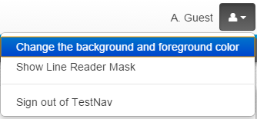

Change the background and foreground colors:
In addition to the standard black text with a white background, there are six other color contrast settings available. Select the button next to the desired contrast setting and then select the blue “Continue” button. The contrast setting will remain until another contrast setting is selected. Selecting a contrast setting other than the default setting may change the default color of the line reader mask.
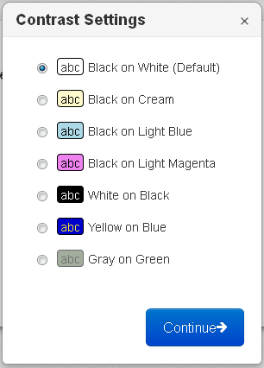

Highlight Feature:
The Highlight feature will only operate on the directions. It will not work on art, on the student responses, or in the Exhibit window. To highlight text, select the text to be highlighted, left click, hold down, and drag over the text. Then select the highlighter color. To remove the highlight, select, and drag over the text. Then select the white box on the left with the red line. If the background color is changed, the highlight color may change to maintain the contrast.

Line Reader Mask:
The Line Reader Mask can be used to show only parts of text or a question at a time. Dragging the diagonal lines at the lower right corner of the outside box resizes the area on the screen covered by the line reader.

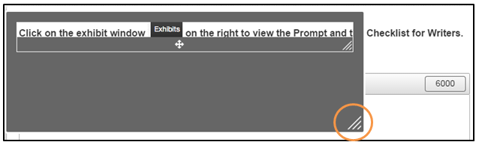
This image shows the line reader tool as gray, which is its color when the contrast settings are set to the default (Black on White). If the contrast settings are changed, the color of the line reader may change as well.

Dragging the diagonal lines at the lower right corner of the inside box resizes the window in which the screen content can be seen.
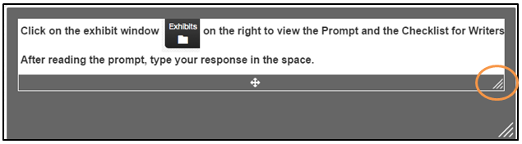
Dragging the cross in the middle of the window moves the window in which the screen content can be seen.
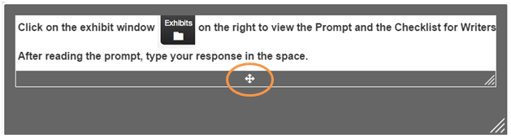

The Line Reader Mask can be moved around the screen by selecting any part of the gray area and dragging it on the screen. Directions for practicing both of these accessibility features (the contrast settings and the Line Reader Mask) with students are provided in the Guided Practice Suggestions for the Practice Writing Tool. Teachers should be familiar with these tools prior to using the writing tool with students.

Audio Player on Audio Versions of the Test:
Some students have an audio accommodation as the most appropriate delivery method for online testing, as indicated in their Individualized Education Program (IEP), Limited English Proficient (LEP) Student Assessment Participation Plan, or 504 Plan. On audio versions of the test, the audio player will be available at the top of the screen. There is not an audio version of the Practice Writing Tool since there is not a prompt provided.

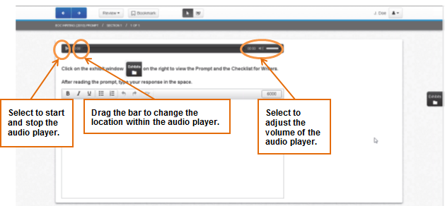

Guided Practice Suggestions

Prior to working with students on the Practice Writing Tool, it is important for teachers to familiarize themselves with the navigation, tools, and accessibility features in TestNav 8.

Teachers and other adults should use the important information found in this document in conjunction with the information found in the Guided Practice Suggestions that are available for the Practice Writing Tool. The Guided Practice Suggestions documents (Grade 8 and EOC) provide specific information for teachers as they guide students through the Writing Tool. Following the suggestions in the guide will ensure that students are exposed to the different tools and features of TestNav 8 prior to actual testing.

