Standards of Learning
Guided Practice Suggestions
For use with the Grade 8 Writing
Practice Items in TestNavTM 8

Table of
Contents

Change Log 2
Introduction to TestNavTM 8: MC/TEI Document 3
Guided Practice Suggestions 3
Grade 8 Writing Practice Item Information and Recommended Guided Practice Suggestions 4

Change Log

Updates to this document will be reflected in the table.
Change Log
Version | Date | Description
V.4 | 4/27/2020 | General information updated.
V.3 | 12/30/2016 | Update information on strikethrough and eliminator tool functions.
V.2 | 10/21/2016 | General information updated.
V.1 | 07/08/2016 | Original Document Posted.

Introduction to TestNavTM 8: MC/TEI Document
The Introduction to TestNav 8: Multiple-Choice/Technology-Enhanced Item Tests document serves as an introduction to the new online navigation, online tools, accessibility features, and overall functionality and appearance of TestNav 8. It is highly recommended that teachers (or other adults) read the Introduction to TestNav 8: Multiple-Choice/Technology-Enhanced Item Tests
document prior to reading this guide, the Guided Practice Suggestions for the Grade 8 Writing practice item set.

Reading the Introduction to TestNav 8: Multiple-Choice/Technology-Enhanced Item Tests document will give teachers an understanding of the features of TestNav 8 prior to working with students. In part, the document provides information on:

- Opening the practice item sets within the required TestNav 8 Application.
- Navigating through the practice item sets.
- Answering technology-enhanced items (TEI) and multiple-choice items.
- Using the online tools.
- Using the accessibility features available in TestNav 8.

This important information should be used in conjunction with the information found in this guide.

Guided Practice Suggestions
This guide provides specific item information for each question in the Grade 8 Writing practice item set, in table format. Along with the item information in the table, there is a column titled “Guided Practice Suggestions.” This column contains information for teachers as they guide students through the practice items. For instance, guided practice suggestions can state, “Use the eliminator tool to place a red ‘X’ on the answers that are not correct,” or, “Make sure students know how to select draggers and place them in the empty boxes using their mouse, keypad, or touchscreen.” Following the suggestions in the table will ensure that students are exposed to all of the different tools within TestNav 8, the different functionality features of TEI, and common messages that may appear as students complete TEI.

Grade 8 Writing Practice Item Information and Recommended Guided Practice Suggestions

Section | Question | Item Type | Answer Key | Guided Practice Suggestions
1 | Rough Draft: Dinosaur Diner | Narrative |  | 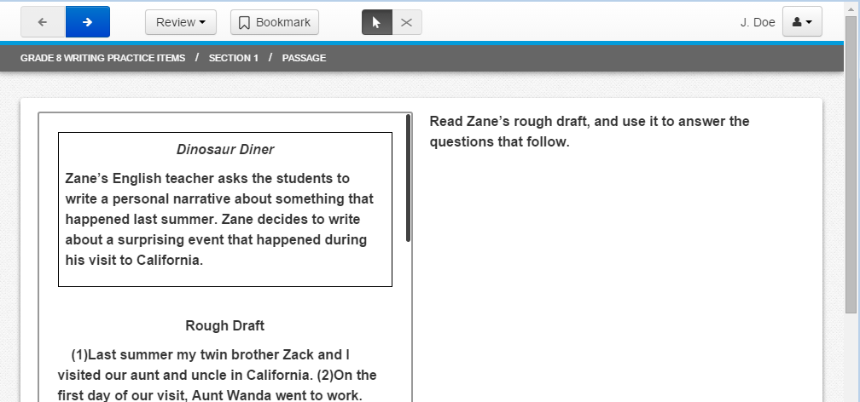  If a passage is longer than one page, it will scroll. On a desktop or laptop computer, have students practice using the bar along the right side of the reading passage to scroll through the passage, as well as the scroll bar on the right side of the screen if necessary. On a touchscreen, use the scroll bar as well as movement of the entire page (shift the page upward with a finger) to scroll through the passage.  Throughout the practice item set, move to the next or previous screen by selecting an arrow in the top left corner of the screen. A blue arrow indicates the button is active and can be selected.
1 | 1 | MC | C | This question asks about a sentence in the first paragraph. Tell students that the passage on the left is scrolled to the location where the student left the passage before moving to this screen. It may be necessary to scroll up to look at the first paragraph.  Have students select the eliminator tool located in the toolbar and then place a red “X” on the answers that are not correct.  To remove an “X” keep the eliminator tool active and select the “X” to remove it. Have students practice removing an “X.”  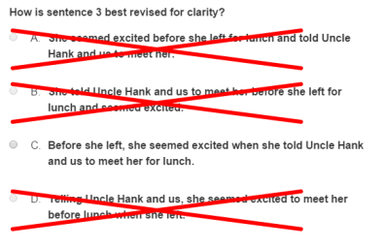
1 | 1 (Cont.) |  |  | Tell students:  Multiple-choice items must be answered in TestNav 8 by selecting the letter of the answer option or the option itself using the mouse, keypad, or touchscreen. On multiple-choice items, once an answer is selected, the item cannot be returned to an unanswered state (no answer selected) unless the student uses the eliminator tool to place an “X” over the selected answer and then selects the “X” again to remove it.  Remind students that placing an “X” on the incorrect answer choices does not complete the item. A selection must be made with the cursor tool in order for the item to be considered “Answered.”
1 | 2 | TEI  Drag and Drop | The sentence should read: Zack just smiled, so I said, QUOTATION MARKS Sure, that would be great, QUOTATION MARKS though I was still thinking about the movie studios. | This is a type of drag and drop technology enhanced item. Have students select and drag the quotation mark to the correct locations.  As soon as the quotation mark is selected and moved, all of the boxes in the sentence shade blue. This indicates that the quotation mark can be placed in any box- whichever location the student chooses as the correct location.  If a student changes his/her mind and wishes to remove a quotation mark, the student should select it and drag it back to the gray box.  This item will be considered “Answered,” once one quotation mark is placed into the sentence. This is so no clue or hint is given as to how many quotation marks should be in the sentence.
1 | 3 | MC | A | 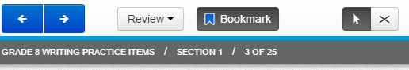  Have students select the Bookmark button and tell them that when they select the Bookmark button, it will turn dark gray. This button would be used to mark a question for review at a later time.  Then have students select the Review button. A drop-down menu will appear. All of the questions in the current section will be listed. The question that the student is viewing on the screen will be shaded dark gray. This question has an orange circle next to it because it has not yet been answered. This question will also have a blue flag next to it because it was just bookmarked.  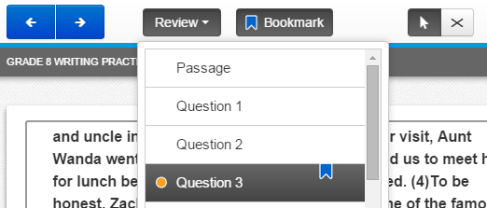  Have students close the Review drop-down menu and deselect the Bookmark button. Then, tell them to look at the Review drop-down menu again to see that the question no longer has a blue flag.
1 | 4 | MC | B | Tell students that the passage on the left is scrolled to the location where the student left the passage before moving to this screen. It may be necessary to scroll to look at sentence 21 in the passage, if the student wishes to do so.
1 | 5 | TEI  Drag and Drop | The word intricate must be placed in the box. | Have students select a dragger and place it in the empty box using the mouse, keypad, or touchscreen.  Selecting a dragger and moving it to the empty box may cause the remaining draggers to shift location in the answer option area.  Have students practice moving the answer choice back to the gray box. The gray box will expand as a word is added back to it, and the word will go back to its original location. Please make sure students are aware of the functionality of this item.  Have students practice using the Line Reader Mask accessibility feature with this item. Select the user drop-down menu in the top right corner of the screen and select Show Line Reader Mask from the menu.  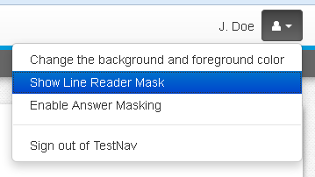
1 | 5 (Cont.) |  |  | The Line Reader Mask will first appear on the left side of the screen. Have students move the tool over to the right side of the screen, over the question. Have students use the corner diagonal line areas to practice resizing the area covered by the line reader and the window through which content can be seen. Have students use the cross to move just the window through which content can be seen. Hold down on any part of the gray area and drag the tool to move the entire tool.  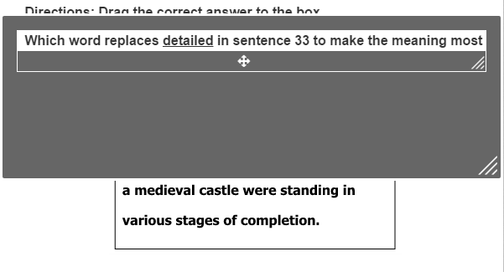  Have students practice moving the line reader to the left side of the screen and practice using it on the reading passage.  To turn off the Line Reader Mask, select the drop-down menu and select Hide Line Reader Mask. If the student does not turn off the Line Reader Mask, it will automatically turn off when the student navigates away from the item.
1 | 6 | MC | D | Have students practice using the Answer Masking accessibility feature with this item. Select the user drop-down menu in the top right corner of the screen and select Enable Answer Masking from the menu.  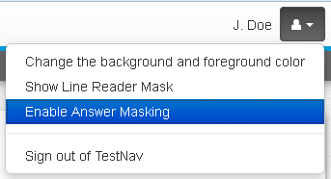  The answer options on multiple-choice items will now be masked as shown in the screenshot.  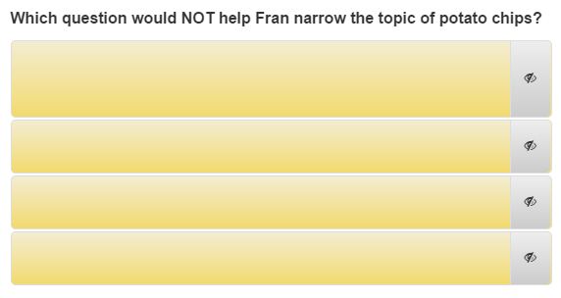
1 | 6 (Cont.) |  |  | Students may show or hide each option by selecting the “eye.”  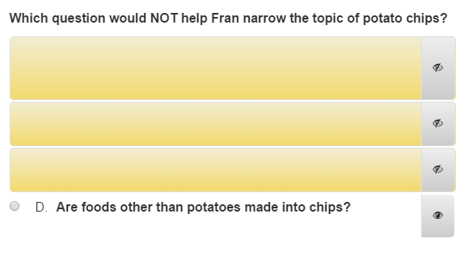  Answer Masking will remain on in each multiple-choice item until it is turned off. To turn off Answer Masking, select the user drop-down menu and select Disable Answer Masking.
1 | Rough Draft: The Potato Chip | Informational |  | On a desktop or laptop computer, have students practice using the bar along the right side of the passage to scroll through the passage, as well as the scroll bar on the right side of the screen if necessary. On a touchscreen, use the scroll bar by the passage or move the entire passage with a finger to scroll through it.  Remind students that when they get to the first question associated with this passage, the reading passage will be in the location where they left it on this screen.
1 | 7 | MC | C | Have students use the highlighter tool to highlight sentences 6 and 7 in the second paragraph.  Have students scroll to the correct location within the rough draft. To highlight using a keyboard, place the cursor next to the sentences, left click, hold down, and drag over the sentences. Then select the highlighter color.* To remove the highlight, left click, hold down, and drag over the sentences. Then select the white box on the left with the red line.  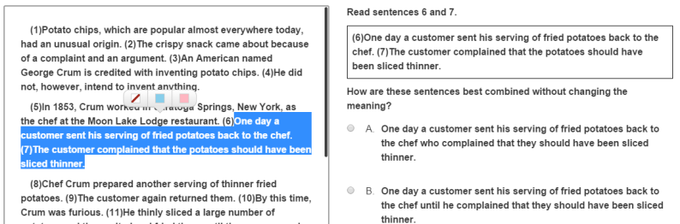  On a touchscreen, hold down on sentence 6 with a finger, and adjust the area to be highlighted with the blue anchors. Then select the highlighter color.* To remove the highlight, hold down on the text with a finger, then select the white box on the left with the red line.  On a touchscreen, the following option message may appear when students highlight text.  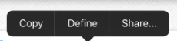  In the practice items, selecting one of the options listed will open a new window and direct students to the internet. This will not occur in the actual testing environment; selecting an option will not direct the students to another screen.
1 | 7 (Cont.) |  |  | Tell students that the highlighter tool will only work on text. It will not work on art (images/pictures).  *Pink and blue are the two highlighter colors available when the foreground and background settings are set to the default (black text on white background). These colors may change when the foreground and background setting is changed. Practice with changing the foreground and background colors will be done on question 22.
1 | 8 | TEI  Drag and Drop | Afterward, | As students navigate to this question, point out that the highlighting they did on the rough draft when they completed question 7 will remain on the rough draft unless they choose to remove it.  Remind students that the highlighter tool will only work on text. It will not work on art (images/pictures).
1 | 9 | MC | C
1 | 10 | MC | C
1 | 11 | MC | B | Tell students that the highlighter can be used on a question, as well as the reading passage. Have them highlight “accident it is” within the text box. Students may have to scroll to paragraph 38 if they want to see the sentence within the reading passage.
1 | 12 | MC | A
1 | 13 | TEI  Hot Text | Prepare Potato Chips in the Microwave | This is a type of hot spot item called a hot text item. In a hot text item, the answer options are outlined in light blue, and a selected answer is shaded a darker blue with white text.*  *When the background and foreground colors are set to the default setting, the selected answers will shade darker blue with white text. The color scheme of the selected answers may change when the background and foreground color settings are changed. Guided practice with changing the background and foreground colors will be done with a question further along in this practice item set.
1 | 14 | MC | C | This is a standalone question because it not part of a series of questions related to a reading passage. For this type of item, students may still be required to read text to answer the question, but they are not required to read a full passage.  Have students practice zooming in on the screen, and then have them zoom out.  On a desktop or laptop press the CTRL and + keys at the same time to zoom in. Press the CTRL and – keys at the same time to zoom out. Press the CTRL and 0 (zero) keys at the same time to return to the default screen size.  On a Mac, press the COMMAND and + keys at the same time to zoom in. Press the COMMAND and – keys at the same time to zoom out. Press the COMMAND and 0 (zero) keys at the same time to return to the default screen size.  On a touchscreen, touch two points on the screen, and then move your fingers away from each other to zoom in. Touch two points on the screen, and then move your fingers toward each other to zoom out.
1 | 14 (Cont.) |  |  | As students are practicing how to zoom in and out, make sure they are doing so within reason. If students zoom in too far, they may not be able to see all of the information necessary to answer the question. If students zoom out too far, they may not be able to clearly see details of the question on the screen. It should also be noted that zooming in and out on the screen may cause the text wrapping to change. Remind students that they should only use this feature when necessary.  Before students go to the next question, make sure they return to the default screen.
1 | 15 | TEI  Drag and Drop | These two words, in either order, should be placed in the boxes: technology and change | Have students select draggers and place them in the empty boxes using the mouse, keypad, or touchscreen.  Selecting a dragger and moving it to an empty box may cause the remaining draggers to shift location in the answer option area.  Tell students that they must read questions carefully because sometimes the specific location or order of the answers matters. Other times, the location or order of the answers does not matter. In this item, the order in which the answers are placed into the boxes does not matter.  This item will not be considered “Answered” until each box has an answer in it.
1 | 16 | TEI  Hot Spot | The picture of the bar graph (top right image) | To answer this question correctly, the correct answer in the gray box must be selected. A blue box outlines the answer choice when it is selected, indicating a student has chosen that response as an answer.  In order to deselect an answer and remove the blue box, the answer choice must be selected again. Have students practice selecting and deselecting an answer.  This TEI will allow the use of the eliminator tool. Have students practice using the eliminator tool on this strikethrough item.  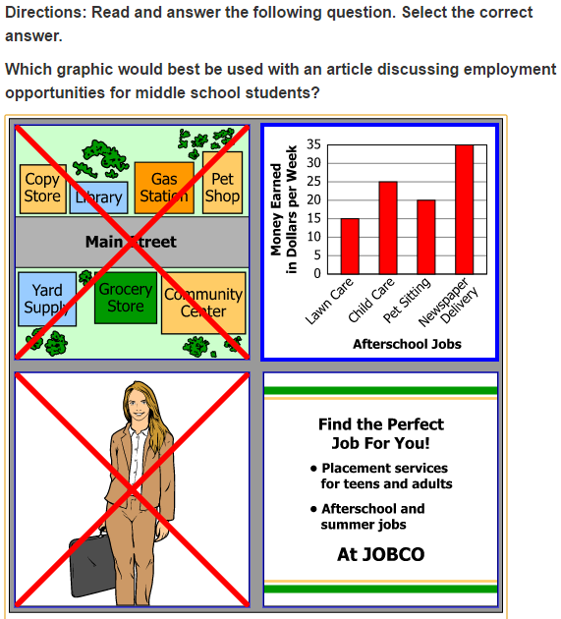
1 | 16 (Cont.) |  |  | This item also specifies the number of answers a student must select (one). If a student tries to select more than the number of answers indicated, a message appears in the top right corner of the screen. This message will remain for approximately five seconds unless the “x” is selected to close the message. Have students try to select an additional answer so that they can see this message appear.  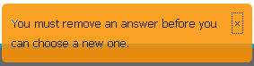
1 | 17 | MC | B
1 | 18 | TEI  Hot Spot | Trunks become smoother with age | This question is a type of hot spot technology enhanced item. The question specifies that there is only one answer. This question will be considered “Answered” when one answer has been selected. The selected answer will be marked with a blue strikethrough line. If a student changes their mind, they must deselect an answer before choosing another.  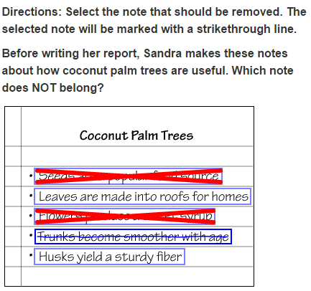  This TEI will allow the use of the eliminator tool. Have students practice using the eliminator tool on this strikethrough item.
1 | Rough Draft:  The Coconut Palm | Informational |  | On a desktop or laptop computer, have students practice using the bar along the right side of the passage to scroll through the passage, as well as the scroll bar on the right side of the screen if necessary. On a touchscreen, use the scroll bar as well as movement of the entire page (shift the page upward with your finger) to scroll through the passage.  Tell students that at the end of the rough draft is a footnote. The footnote defines the word “proverb” from paragraph 1. The footnote is separated from the rough draft by white space and the text is gray.  Remind students that when they get to the first question associated with this passage, the reading passage will be in the location where they left it on this screen.
1 | 19 | MC | B
1 | 20 | MC | D
1 | 21 | TEI  Drag and Drop | A comma should be placed only after the words “water” and “coconut.” | To answer this question, the comma must be placed into the correct place(s) within the sentence. The comma can be used more than one time, and some of the boxes may be left empty. Tell students to only place a comma where it belongs in the sentence.  Remind students that when they select the comma and begin to move it, all of the boxes will shade blue, indicating that they can place the comma in any location they believe to be the correct location.  The question will be considered “Answered” when one comma has been placed in a box. This is so no clue or hint is given as to how many of the boxes need a comma.
1 | 22 | MC | C | Have students practice using the accessibility feature that allows them to change the background and foreground color. Select the user drop-down menu and Change the background and foreground color from the menu.  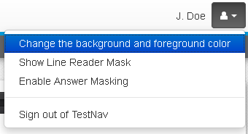  There are six different options other than black on white, which is the default setting. Have students select a contrast setting and then the Continue button to enable this feature. This feature could be used by students who would benefit from the use of color contrasting to make text more distinct.  This setting will remain enabled until turned off. To turn off this setting, select the user drop-down menu, select Change the background and foreground color, and then select the button next to the default setting. Then select the Continue button.
1 | 23 | TEI  Hot Text | become | Have students change the contrast setting to “Black on Light Blue.” (See instructions on the previous item.)  When students answer this hot text item, they will see that the color scheme of the selected state is black with white text, rather than blue with white text (as it is on the default setting).  Before proceeding to the next question, change the contrast settings back to the default.
1 | 24 | MC | C
1 | 25 | MC | D | Information for Teachers:  This is the end of the practice item set. See the Introduction to TestNav 8: Multiple-Choice/Technology-Enhanced Item Tests document for information on closing TestNav.

