Virginia Department of Education

Serving English Learners (ELs) Who Need Additional Reading Support

What Leaders Should Know
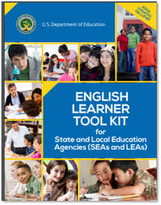
The United States Department of Education requires Local Educational Agencies (LEAs) to:
- provide ELs with appropriate language assistance programs and services,
- offer services until ELs have exited, and
- choose programs that meet civil rights requirements.
The English Learner Toolkit provides additional guidance and support in meeting these requirements.

Language Education Instructional Programs (LIEP) are a civil right.
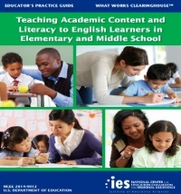
Schools must provide all students with a solid, core classroom instructional program (i.e., a Tier 1 system). Not all currently used interventions in literacy include adequate attention to listening or sophisticated writing and speaking skills, and thus they may need to be augmented for English Learners. For more information, refer to Teaching Academic Content and Literacy to English Learners in Elementary and Middle School p. 59.

LIEP are part of core, Tier 1 instruction.
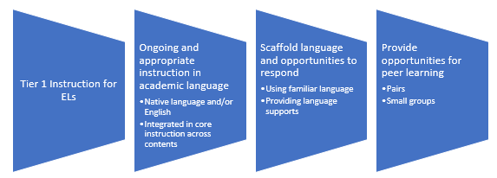
Response to Intervention in Reading for English Language Learners

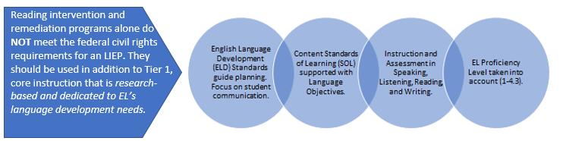
Reading intervention and remediation programs alone do NOT meet the federal civil rights requirements for an LIEP. They should be used in addition to Tier 1, core instruction that is research-based and dedicated to EL’s language development needs.
Sources: U.S. Department of Education, WIDA, Emergent Bilingual Learners Literacy Guide

What Does the Research and Literature “Say?”

“Oral language functions as a foundation
for literacy and as the means of learning in school and out” (Fillmore & Snow, 2002). However, oral language development is often missing from reading and writing programs, leaving teachers to wonder why their students are still struggling or taking longer than expected become proficient speakers and readers.
Source: Grapeseedus.com : The Importance of Oral Language for Literary Success

Because the language arts (reading, writing, listening, and speaking) are so interrelated, children must be given the opportunity to practice the strands of language arts in connected and purposeful ways.

Source: Texas Gateway: Beginning Reading Instruction

The evidence suggests that the students who benefit most from classroom discussion are those who are struggling to comprehend text…

Effect Size of…
- Classroom Discussion .82
- Repeated Reading Programs .67
Source: Visible Learning for Literacy, Grades K-12

Instruction in the key components of reading is necessary—but not sufficient—for teaching language-minority students to read and write proficiently in English. Oral proficiency in English is critical as well—but student performance suggests that it is often overlooked in instruction.
Source: eric.ed.gov: Developing Literacy in Second-Language Learners

Systematic phonics instruction can be very effective in helping ELs…learn to decode words. However, this skill does not facilitate reading comprehension if students’ oral language proficiency is not developed to the level of the texts they are expected to read. For this reason, reading instruction should be combined with intensive development of the oral language needed to understand the text.
Teaching students to decode words they don’t know only reinforces the ideas that “reading” is pronouncing sounds out loud.
Source: Reading Rockets: What Does Research Tell Us About Teaching Reading to English Language Learners?

Children cannot be expected to learn to read a language before they have an understanding of that language as it is spoken. Much of our reading skill depends on how we expect a sentence to flow, or a string of words to make sense. If we do not have an understanding of the language, then we do not have a framework for understanding what we are reading.
Source: Emergent Bilingual Learners Guide
Reading Programs for ELs should include intensive language development as well as instruction in literacy strategies and skills.

