VIRGINIA DEPARTMENT OF EDUCATION

Reading Instruction for English Learners:
Planning and Preparing Literacy Instruction

Make literacy visible
- Establish content and connected language targets to support students in narrating or sequencing stories, comparing texts, justifying conclusions by citing text evidence, etc.
- Use think-alouds to model reading strategies and identify text structures and features within grade-level, complex texts. Have students practice using those strategies together in texts more aligned with their independent reading levels.
- Provide supports for communication of reading strategies, questions, and ideas and reflections about the text (e.g., sentence frames, anchor charts).

Use cooperative learning structures and strategies
- Provide structured opportunities for students to collaborate, communicate ideas, and make meaning of texts (e.g. talk moves, literature circles, or talking chips).
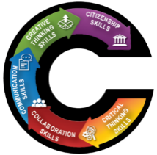
- Have students use partner reading (e.g., whisper reading for beginning ELs) or reader’s theater strategies to build confidence and motivation.
- Use flexible and fluid grouping of students.
- Build written communication skills through shared writing strategies (e.g., write around).

Connect learning to students’ backgrounds and skills
- Use texts that represent students’ cultures, backgrounds, and interests.
- Facilitate opportunities for students to read and discuss literature in their primary language(s).
- Identify cognates and other primary language connections.
- Allow for student choice in topics.

Parse texts
- Preview text for important features and vocabulary central to the theme/concept that should be pre-taught, e.g.:
  - Tier 2 vocabulary (transitional and signal expressions);
  - Tier 3 vocabulary (technical terms); or
  - Figurative or critical colloquial (social) language.
- Frontload (pre-teach) approximately 5 of those in a meaningful way (e.g., common experience)
- Check for new or complex sentence structures or grammatical feature to frontload and reinforce.

Engineer and level texts for independent reading work
- Insert additional subheadings and/or images with captions for conceptual understanding.
- Chunk into smaller, more manageable passages.
  - Leveled reading for shorter articles is available for free from sources such as Readworks, NewsinLevels, and CommonLit.
- Reframe more complex sentence structures into simple sentences.
- Keep wide-margins for notes.
- Use familiar linguistic redundancy instead of pronouns.

Teach foundational skills within meaningful contexts
*Emphasis is on reading for meaning.
- Use words in context/current texts to reinforce phonics and phonemes patterns such as silent letters, blends, word families, and rhymes. Additional texts can include popular song lyrics and video captions.
- Provide additional support and practice with phonemes that do not exist within an EL's primary language.
- Point out different letter combinations that have the same sound, and provide extra practice with them.
- Use strategies to model and practice fluency (e.g., use of intonation within choral and echo reading activities).
High expectations, asset-based thinking, and a growth mindset are key to student success!

VIRGINIA DEPARTMENT OF EDUCATION

Reading Instruction for English Learners:
Pre, During, and After
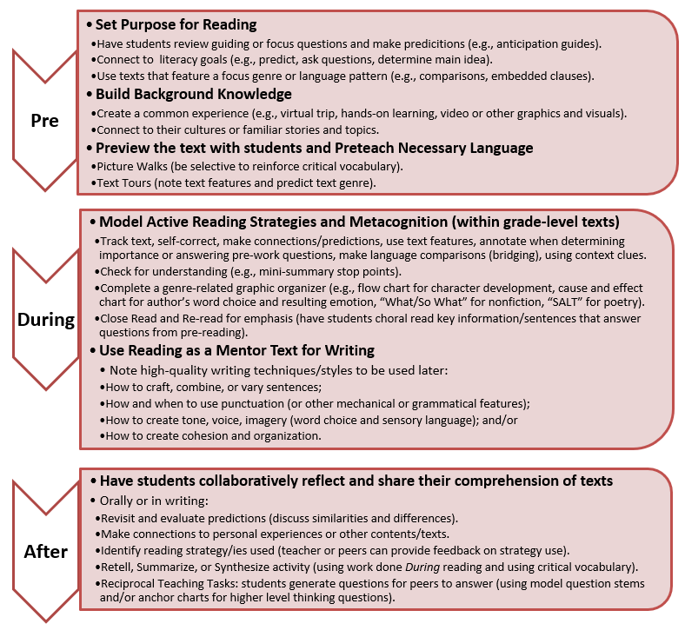
Main Sources: Boosting Achievement (Salva & Matis, 2017), Expediting Comprehension for English Language Learners (ExC-ELL) (Calderón & Associates, 2018), Effective Practices for Developing the Literacy Skills of English Language Learners in the English Language Arts Classroom (Turkan, 2012), EL Excellence Every Day (Ward Singer, 2018), Why Doesn’t Every Teacher Know Research on Reading Instruction (Pimental, 2018), Developing Literacy in Second-Language Learners: Report of the National Literacy Panel on Language-Minority Children and Youth, Executive Summary (2006), Reading 101: English Language Learners (Robertson, retrieved from Colorín Colorado Dec 2019)

