VIRGINIA DEPARTMENT OF EDUCATION

Engaging ELs in the Art of Dance

Make learning visible
- Establish content and connected language targets to support students in comparing styles of dance, describing movement sequences, explaining their personal responses towards dance, evaluating dance performances, etc.
- Draw attention to patterns and relationships in dance performances
- Refer to student-generated word walls to support language development and understanding of dance concepts and choreography
- Complement written word walls and anchor charts with visuals and graphics, e.g., a poster that lists dance elements or forms and techniques with visual cues for memory and language connections

Support the language of dance

All students can learn! High expectations, asset-based thinking, and growth mindsets are key to student success!

- Provide multiple opportunities for students to communicate about their and peers’ dance performances
- Explicitly teach the language of dance arts beyond a focus on vocabulary to support conceptual understanding
- Provide sentence starters to support Dance Arts Standards of Learning (SOL) and communication of their vision as a dancer or choreographer, e.g.,
  - Evaluate works by self and others:
My/Your/the performance can be improved by _____.
When dancing, I/you/the dancer can improve technique by _____.
  - Compare and contrast aspects of musical works:
These two dance pieces are (similar/different) because _____.
The element that makes this style of dance (unique/different) is ____.
  - Articulate personal response to dance:
This style of dance made me feel ______ because _____.
I think this dance is about ______ because _____.
  - Understand historical and cultural influences:
____ was a popular form of dance during (time period) because ____.
____ dance was impacted/influenced by ____.
  - Inquire about dance:
I wonder why the choreographer chose ____?
What dance techniques or movements might be help me express ___?
  - Solve choreographic problems: In order to make the performance more ___, we can try ___. If we change ____, then maybe ___.
Connect learning to ELs’ backgrounds and skills
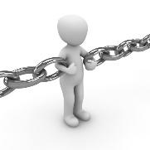
- Make connections between dance as a mode of expression with students’ lives
- Highlight contributions and innovations from a variety of cultures
- Facilitate opportunities for dance choices and responses to be explained in student’s home language
- Model respectful analysis of a variety of perspectives

Use cooperative learning structures and strategies
- Structure opportunities for students to collaborate and communicate ideas when designing dance performances
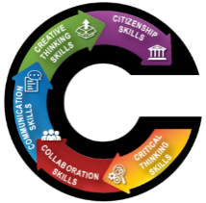
- Use flexible and fluid grouping of students
- Ask students to “Notice” and “Wonder/Inquire” about dance performances and products together
- Teach “talk moves” so students can engage in academic conversations about dance, e.g., I would like to build on your idea. I have a different idea to share. Can you please clarify what you just said?

Reduce cognitive load and allow processing time
- Break tasks and prompts into smaller sections and organize texts using bullet points versus complex paragraphs
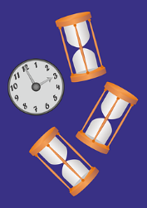
- Read tasks and texts out loud
- Use simple sentences and include only details needed to complete the task within reading texts
- Show and explain model and sample products that meet performance expectations
- Provide adequate thinking and processing time, and flexible time frames for completing tasks
High expectations, asset-based thinking, and a growth mindset are key to student success!
Virginia Department of Education 2020

