VIRGINIA DEPARTMENT OF EDUCATION

Engaging ELs in Music

Make learning visible
- Establish content and connected language targets to support students in comparing musical works, describing music, explaining their personal responses towards music, evaluating musical performances, etc.
- Draw attention to patterns and relationships in musical works
- Refer to student-generated word walls to support language development and understanding of music concepts
- Complement written word walls and anchor charts with visuals and graphics

Support the language of music

All students can learn! High expectations, asset-based thinking, and growth mindsets are key to student success!

- Provide multiple opportunities for students to communicate about their and peers’ music performances and preferences
- Explicitly teach the language of music beyond a focus on vocabulary to support conceptual understanding and for students to communicate like musicians
- Provide sentence starters to support Music Standards of Learning (SOL) and communicate their vision for creating and performing music, e.g.,
  - Evaluate works by self and others:
My/Your/the performance of this music can be improved by _____.
When (singing/playing), I/you/the musician can improve technique by _____.
  - Compare and contrast aspects of musical works:
These two pieces of music are (similar/different) because _____.
The element that makes this style of music (unique/different) is ____.
  - Articulate personal response to music:
This music made me feel ______ because _____.
I think this music is about ______ because _____.
  - Understand historical and cultural influences:
____ was a popular form of music during (time period) because ____.
____ music was impacted/influenced by ____.
  - Inquire about music:
I wonder why the composer chose ____?
Which current technologies would be best for ____?

Connect learning to students’ backgrounds and skills
- Make connections between music as a mode of expression and different styles of music within students’ lives
- Highlight contributions and innovations from a variety of cultures
- Facilitate opportunities for music choices and responses to be explained in student’s home language
- Model respectful analysis of a variety of perspectives

Use cooperative learning structures and strategies
- Structure opportunities for students to collaborate and communicate ideas when rehearsing for musical performances
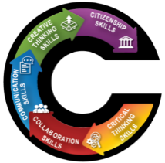
- Use flexible and fluid grouping of students during discussions and rehearsals, where possible
- Ask students to “Notice” and “Wonder/Inquire” about musical works together
- Teach “talk moves” so students can engage in academic conversations about music, e.g., I would like to build on your idea. I have a different idea to share. Can you please clarify what you just said?

Reduce cognitive load and allow processing time
- Break tasks and prompts into smaller sections and organize texts using bullet points versus complex paragraphs
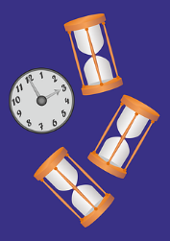
- Read tasks and texts out loud
- Use simple sentences and include only details needed to complete the task
- Show and explain model and sample music that meets composition or performance expectations
- Provide adequate thinking and processing time, and flexible time frames for completing reading and writing tasks
High expectations, asset-based thinking, and a growth mindset are key to student success!
Virginia Department of Education 2020

