Standards of Learning
Introduction to TestNav 8:
Multiple-Choice/Technology-Enhanced Item Tests

For use with Practice Items
in TestNavTM 8
Updated March 2024

Table of Contents
Standards of Learning Introduction to TestNav 8: 1
Table of Contents 2
Introduction 4
Intent of Practice Items 4
Publishing the Practice Item Sets in TestNav 8 4
Opening the Practice Items 6
TestNav 8 System Requirements: 6
Launching the TestNav 8 Application: 7
Accessing the Practice Items through the Application: 8
TestNav 8 Features 11
Starting a Test and Navigation Buttons in TestNav 8 (Traditional Test and CAT): 11
The Forward and Backward Arrows (Traditional Test and CAT): 14
Traditional Test 14
Mathematics CAT 14
Reading CAT 15
Review Button and Bookmark Button (Traditional Test and CAT): 17
Traditional Test 17
Mathematics CAT 19
Reading CAT 20
Standalone Questions (EOC Reading) 21
Submitting Final Answers (Traditional Test): 22
Submitting Final Answers (CAT): 23
Exiting a Test (Traditional Test and CAT): 24
Online Tools Available in TestNav 8 26
Zoom feature: 28
Accessibility Features Available in TestNav 8 28
Change the background and foreground colors: 29
Line Reader Mask: 30
Answer Masking: 32
Enable Magnifier: 33
Audio Player on Audio Versions of the World History to 1500 test, World History from 1500 to the Present test, World Geography test, and all Science tests measuring the 2010 Science Standards of Learning: 33
Audio Tools on 2016 Mathematics Standards of Learning tests, 2017 English Standards of Learning tests, EOC Writing tests, 2015 History and Social Science Standards of Learning tests, and 2018 Science Standards of Learning tests. 36
Selection of Answers for Multiple-Choice Items 37
Technology-Enhanced Item Types 37
Drag and Drop: 37
Hot Spot: 38
• Coordinate Grids 39
• Number Lines: 39
• Hot Text: 40
Bar Graph and Histogram: 40
Fill-in-the-Blank: 41
Equation Editor: 41
Materials Needed for Completing the Practice Items 43
Guided Practice Suggestions 43

Introduction

Intent of Practice Items
Since 2011 the Virginia Department of Education (VDOE) has provided practice items for various Standards of Learning (SOL) tests. The practice item sets provide-
- examples that are representative of content included in the Standards of Learning as they are revised;
- examples that show increased rigor;
- examples of technology-enhanced items (TEI) and opportunities to experience TEI functionality;
- opportunities to practice with new item types as they are introduced;
- opportunities to practice with the online tools and features that are available during online SOL testing;
- opportunities to navigate through and interact with the online testing software.

Please note that the practice items are not intended to be a complete test and are not intended to cover all content for the grade level or course. Furthermore, while the practice items provide examples of some TEI, they are not intended to represent all types of functionality associated with these item types. The practice item sets are in a traditional test format and as such do not provide computer adaptive test (CAT) navigation practice.

Publishing the Practice Item Sets in TestNav 8

Beginning with the fall 2016 test administration, the Virginia Standards of Learning (SOL) tests will be administered using TestNav 8, a new version of the test delivery software with responsive design. Virginia school divisions will gain the flexibility of administering online SOL tests on a wider variety of devices (e.g., Google™ Chromebooks, Apple iPads®, Android™ tablets), including touch-screen devices. The TestNav 8 software allows tests to be administered securely on these additional devices, while continuing to support the use of traditional Microsoft Windows®-based and Mac OS®-based workstations. In Virginia, test content can be accessed using an installable TestNav 8 application on the device or workstation.

In order to help prepare students for the online administration of the tests, the practice item sets are being made available in TestNav 8. The practice item sets can be used to introduce students to the online navigation, online tools, and overall functionality and appearance of the test delivery system. Providing the practice item sets in TestNav 8 will also allow school division staff to experience the technical changes and updated system requirements of TestNav 8 prior to its use during online testing.

All SOL tests will be administered in TestNav 8 beginning with the fall 2016 test administration. This includes all Non-Writing and Writing tests.

Opening the Practice Items

The practice items are non-secure and may be accessed by a web browser on the SOL Practice Items webpage on the Virginia Department of Education website. They may also be accessed via an installable TestNav 8 application that can be used on certain desktops, laptops, and tablets that meet the minimum hardware and software requirements. Before downloading the application, ensure your device meets the minimum requirements for the TestNav 8 installable application.

TestNav 8 System Requirements:
To view the most current TestNav 8 system requirements, go to TestNav System Requirements. From the website, active links are provided to the download location and to the setup instructions for each supported device type.

TestNav 8 will look at the font available on the device being used and will look in the order of: Helvetica Neue, Helvetica, Arial, & Sans Serif. If any of these font types are not available, the default font type available on the device will be used.

All Virginia Standards of Learning tests must be administered using the TestNav 8 app and be in kiosk mode. Kiosk mode prevents students from accessing any other web pages or applications besides TestNav while testing.

Please note that an external keyboard is listed as a hardware requirement for some devices. In Virginia, external keyboards will not be required when administering SOL tests on iOS and Android tablets; however, when determining what devices will be used for SOL testing, school divisions are strongly encouraged to consider the level of student experience and familiarity with the device the student will be assigned to use.

Launching the TestNav 8 Application:

After installing the TestNav 8 application on a supported device, open the application. Then select Virginia.

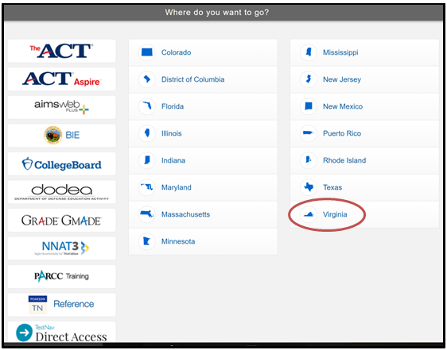

Accessing the Practice Items through the Application:
On an actual SOL test, a username and password are necessary to access a test. Since the practice items are non-secure, a username and password are not necessary. Instead, select the link that says, “SOL Practice Items.” (Please note that the practice items are not representative of a complete test. Please see page 4 for an explanation of the intent of the practice item sets.)

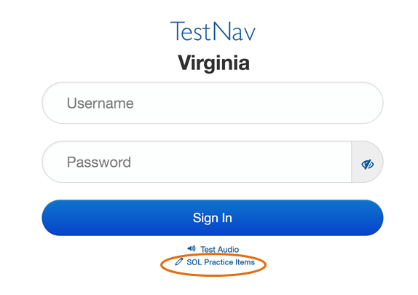
A Standards of Learning Practice Item Sets screen will appear.
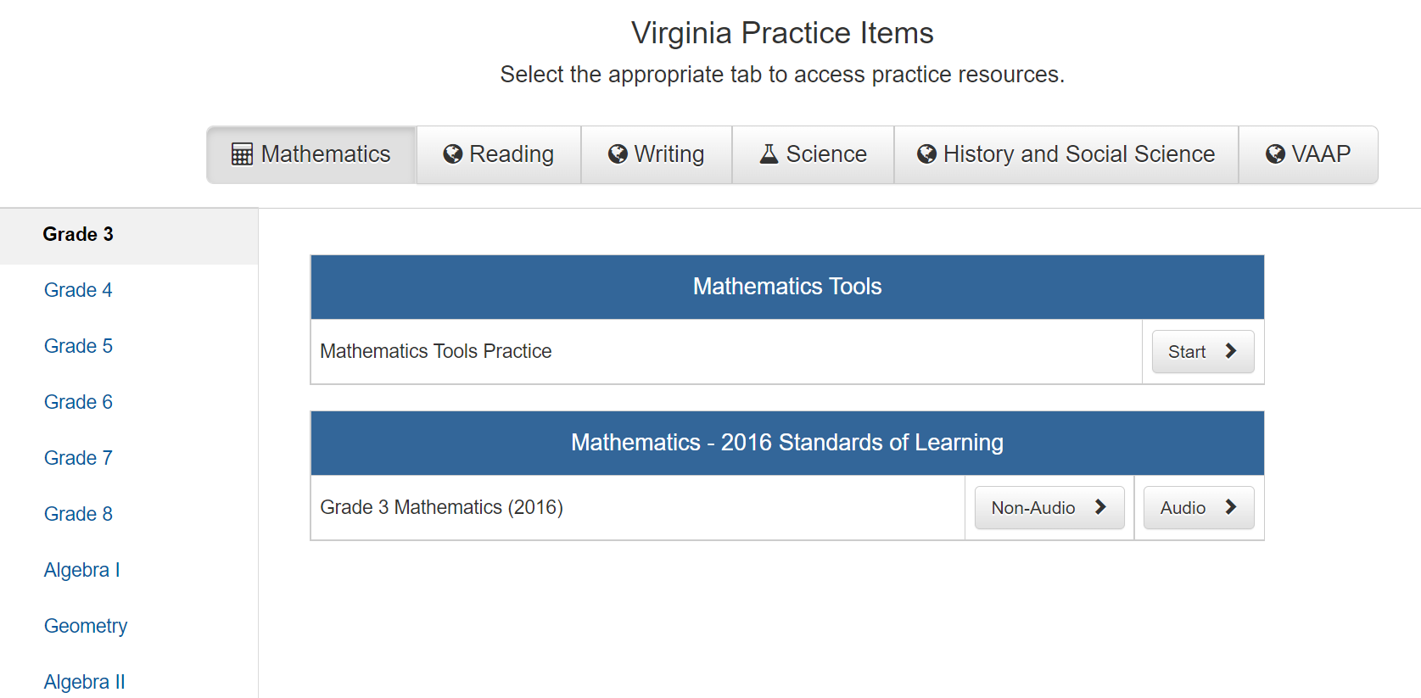

Select a content area to view the associated practice item sets. This screenshot shows the selection of Reading. Then select a grade level or course to begin a practice item set.

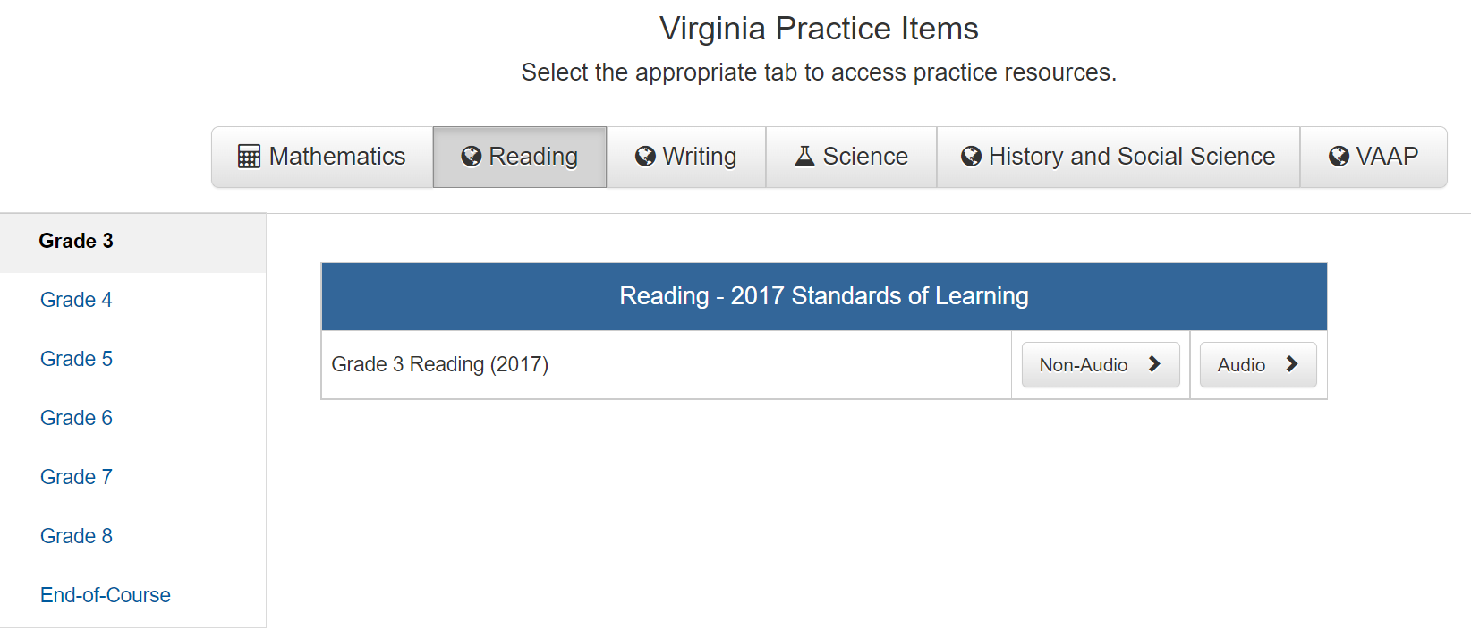

TestNav 8 Features

Starting a Test and Navigation Buttons in TestNav 8 (Traditional Test and CAT):
Before using the practice items with students, teachers should familiarize themselves with TestNav 8 in order to help students navigate through the testing interface.

On an actual Standards of Learning (SOL) test, a username and password will be required to begin a test. If the test being administered is an audio version of the test, the “Test Audio” button can be selected to set the volume of the audio player prior to sign in.

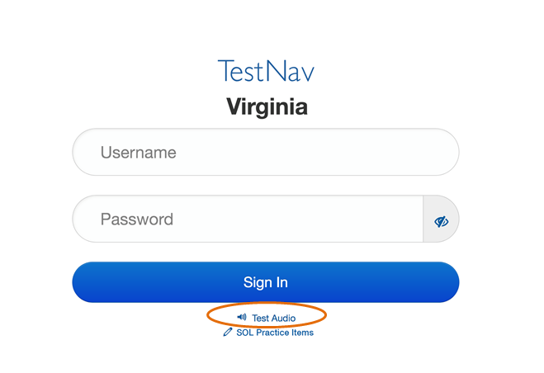

Since the practice items are non-secure, entering Sign In credentials is not necessary. When the practice items are loaded, a welcome screen is shown. To begin the practice items, select the blue Start button. A grade 4 mathematics screenshot is shown.

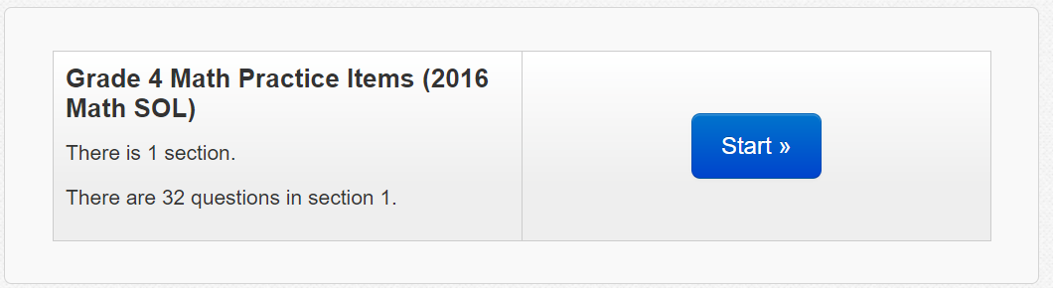

A copyright page will appear on the screen. Agree to the terms of the copyright by checking the box next to the statement, “I agree to the Terms and Conditions.”

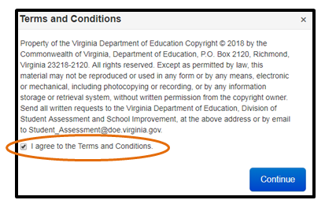

On an actual Standards of Learning (SOL) test, the terms of copyright will appear on the Welcome screen.
Navigation through TestNav 8 occurs at the top of the screen. Included features are forward and backward arrows, most TestNav online tools, accessibility features, and access to a drop-down Review screen and a Bookmark button. On computer adaptive tests (CAT), some of these features (the Review and Bookmark buttons and the backward arrow) are not included.

This image gives a description of the features that may be found at the top of the screen in TestNav 8.

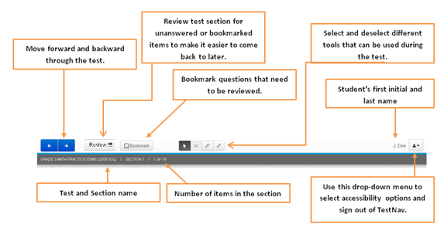

The Forward and Backward Arrows (Traditional Test and CAT):

Traditional Test

The forward and backward arrows can be used to navigate between screens. On a traditional test (and in the practice item sets), students can move forward and backward throughout each section of a test. An arrow button with a blue background indicates a button can be selected.

Mathematics CAT

On an actual mathematics CAT, the left arrow will be gray and the right arrow will be blue. When a student has completely answered the question on the screen, the right arrow will become active, indicating the student may proceed to the next question when ready.

If a student has not completely answered a question, the right arrow will not become active and they will not be able to proceed to the next question. A message will appear on the student’s screen indicating the question has not been fully answered.
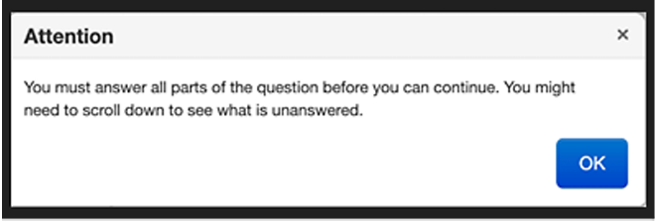
Students are not allowed to navigate to previously answered questions on a mathematics CAT.

Reading CAT

On an actual reading CAT, students can navigate forward and backward only within a passage set (the questions that are associated with a particular passage).
The left arrow remains gray until the student leaves the passage and enters the first test question.
Once a student has progressed to the first test question screen, both the right and left arrows are blue and remain blue for the entire passage set. It is important to note that a student may not naviage forward or backward until an answer is selected. A message will appear on the student’s screen indicating the question has not been fully answered.
After a student has answered a question, he or she may navigate to the next question, or navigate back to any previously answered question within the passage set. Therefore, both arrows will be active.
Students may change their responses to test questions with a passage set. It is important to note that once a student navigates to the next passage, it is not possible to return to a question associated with a previous passage. Students will receive an alert message when they begin or end a passage set.
Beginning of a passage set:
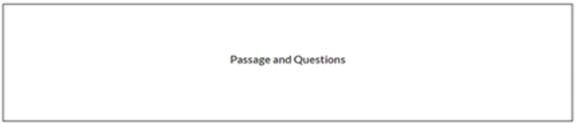
End of a passage set:
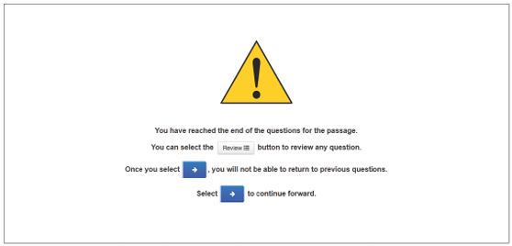

Review Button and Bookmark Button (Traditional Test and CAT):

Traditional Test
Since the practice items are in a traditional test format, students can use the Review button to monitor the status of each item and the Bookmark button to mark an item that they wish to come back to at another time. The statements that follow are for Reviewing and Bookmarking items in the practice item sets and on actual SOL tests that are not computer adaptive:

To bookmark an item, select the Bookmark button. Students can use this button to mark an item that they wish to review at a later time. The button turns dark gray to indicate that the item is selected as bookmarked.
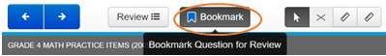

When the Review button is selected, a drop-down menu will appear. All of the questions in the current section will be listed. The question the student is viewing on the screen will be shaded dark gray.
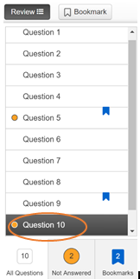
An orange circle to the left of a question indicates the question is Not Answered. A blue tag to the right of the question indicates the question was marked for review. In the example provided above, Question 5 is both unanswered and bookmarked. It may be necessary to use the scrollbar on the right side of the drop-down menu in order to see all of the items in the list.

Along the bottom of the drop-down menu is the total number of questions in the section (All Questions), the total number of Not Answered questions in the section, and Bookmarks in the section. Selecting the Not Answered icon will produce only unanswered questions in the list. Likewise, selecting the Bookmarks icon will produce only bookmarked questions in the list. In the example shown, there are 26 total questions in the section. When the orange circle icon is selected, the 22 questions without an answer will appear in the list. When the blue flag is selected, the 2 questions with a bookmark will appear in the list.

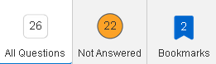

Note that any sample items in a section are not in the total count of test questions because on an actual SOL test, they are not scored as part of the test. Therefore, sample items will never appear as Not Answered questions.

Mathematics CAT

It is very important to note that the Review button and the Bookmark button are not available in an actual mathematics CAT. If the practice item set a teacher is reviewing with students is for a subject that will be assessed with a mathematics CAT, students should be told that those buttons will not be available on the actual test.

Reading CAT
In an actual passage based reading computer adaptive test, the Review and Bookmark features are different than in the practice item sets. If the practice item set a teacher is reviewing with students is for a subject that will be assessed with a reading CAT, students should be informed how to use these features in an actual reading computer adaptive test. On a computer adaptive test, students “must answer to proceed.” This means that a student will have to answer the question before they are able to advance forward or backward within a passage set. Once one passage set has been completed by the student and they leave the passage, they may not revisit the passage.

In an actual reading computer adaptive test, the Review and Bookmark buttons will be grayed out (as well as the navigation arrows) and will not be active until the question on the screen has been answered.

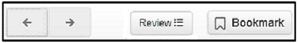
Only the questions in the passage set that the student has visited and answered will be listed in the Review drop-down menu.

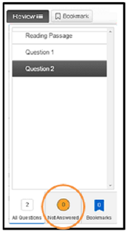

No question will ever show as Not Answered since all questions must be answered before a student can navigate away from the question.

Questions that are bookmarked for review should be reviewed prior to navigating to the next passage. Once a student navigates to the next passage, he or she cannot return to any question in a previous passage.

Standalone Questions (EOC Reading)
If a student will be presented with a standalone question or questions, a screen with this message will appear next.

Submitting Final Answers (Traditional Test):
After answering the last question in the last section, an “End of Section” screen will appear. If there are unanswered questions or bookmarked questions, students can return to the question as described on page 17 of this document. When all questions have been answered, select the green Submit Final Answers button.
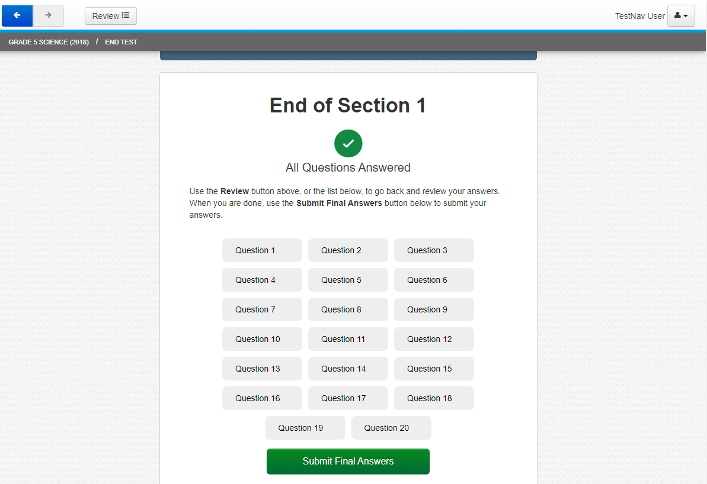
A warning message will pop up that states, “Are you sure you want to submit final answers? You will not be able to return to this test.” Select the green Yes, Submit Final Answers button to submit the answers and sign out of TestNav 8.

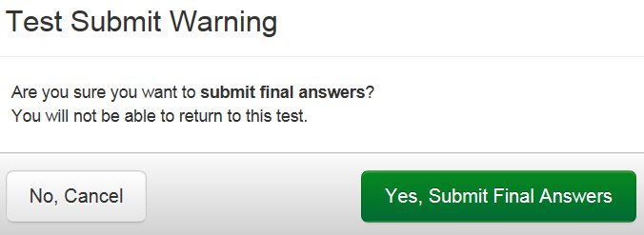

Submitting Final Answers (CAT):
On a CAT, the final screen will be displayed after the student answers the last question (mathematics) or after the student has completed the last passage set (reading). Students should select Submit Final Answers to submit the test. This screen shot shows an example from a Grade 3 mathematics test.

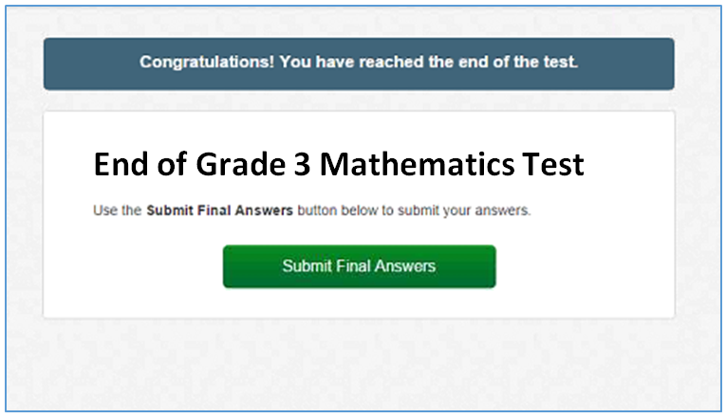
The following screen will then appear:
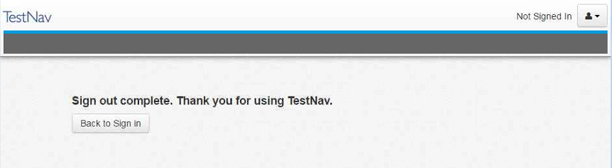

Exiting a Test (Traditional Test and CAT):
In an actual SOL test, there may be a situation that requires a student to exit the test before the test is completed. In these instances, the student will need to exit the test without submitting it to be scored. In order to exit the test, select on the icon next to the student’s name, located near the top of the screen on the right. Select Sign out of TestNav from the drop-down menu.
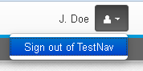

A warning message will pop up on the screen that states, “I want to exit this test and finish later.” Select the blue Save and Return Later button. Note that this method of exiting TestNav will not result in any saved answers while working within the practice items. Saved responses to test questions will only occur during live, secure testing and not within the practice items.

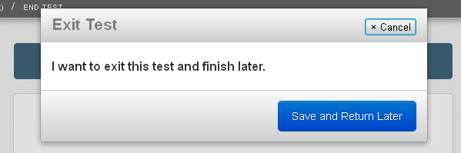

Online Tools Available in TestNav 8

The online tools currently available in TestNav 8 are shown in the table. Not every tool is available on every test. Directions for practicing these tools with students are provided in the Guided Practice Suggestions documents that are available for each practice item set. Teachers should be familiar with these tools prior to using the practice item sets with students.
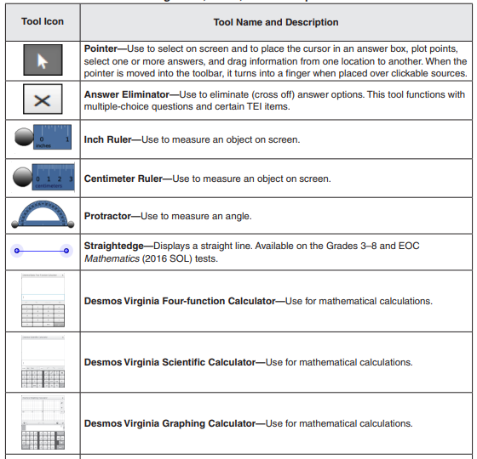
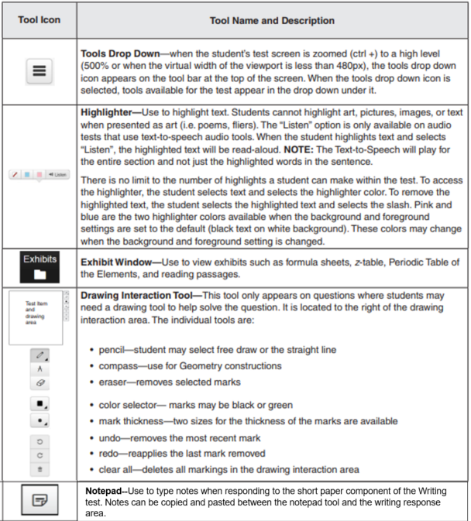

Zoom feature:
Use the zoom feature to change the size of the text and images on the screen.
- On a PC or Chromebook, press the CTRL and + keys at the same time to zoom in. Press the CTRL and – keys at the same time to zoom out. Press the CTRL and 0 (zero) keys at the same time to return to the default screen size.
- On a Mac, press the COMMAND and + keys at the same time to zoom in. Press the CMD and – keys at the same time to zoom out. Press the COMMAND and 0 (zero) keys at the same time to return to the default screen size.
- On a touch screen, touch two points on the screen, and then move your fingers away from each other to zoom in. Touch two points on the screen, and then move your fingers toward each other to zoom out.

Accessibility Features Available in TestNav 8

These are three accessibility features available in TestNav 8 for Standards of Learning tests. These features are available on all tests for all students. Accessibility features are available from the drop-down menu on the upper right corner of the screen. To access a feature, select it from the drop-down list. To remove the feature once selected, select the feature again.
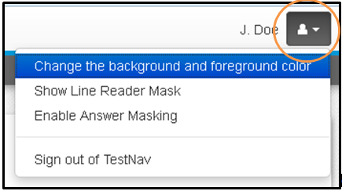

Change the background and foreground colors:
In addition to the standard black text with a white background, there are six other color contrast settings available. Select the button next to the desired contrast setting and then select the blue “Continue” button. The contrast setting will remain until another contrast setting is selected. Selecting a contrast setting other than the default setting may change the default color of some of the tools and accessibility features. The color of art will not change when the contrast setting is changed.

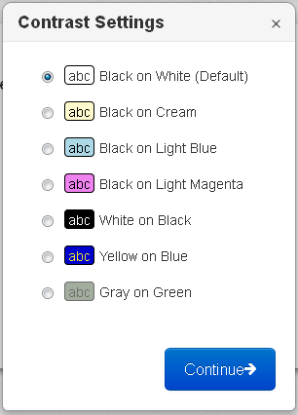

Line Reader Mask:
The Line Reader Mask can be used to show only parts of text or a question at a time. Dragging the diagonal lines at the lower right corner of the outside box resizes the area on the screen covered by the line reader.
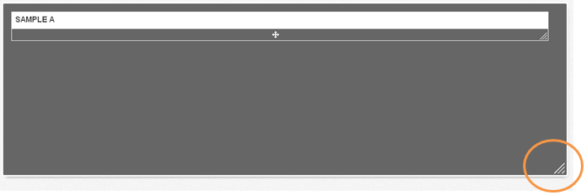
This image shows the line reader tool as gray, which is its color when the contrast settings are set to the default (Black on White). If the contrast settings are changed, the color of the line reader changes as well.

Dragging the diagonal lines at the lower right corner of the inside box resizes the window in which the screen content can be seen.
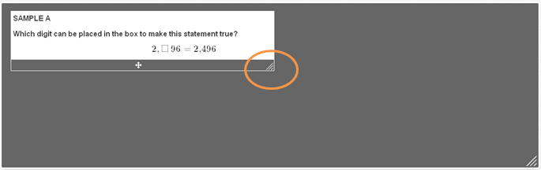
Dragging the cross in the middle of the window moves the window on the screen.
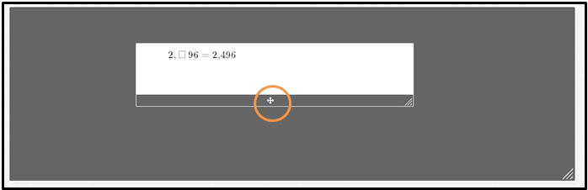

Answer Masking:
Answer masking places a “mask” over multiple-choice answer options so that students can only look at one (or more) answer options at a time. Each mask can be removed by selecting the elliptical icon (the “eye”) to the right of the answer option.

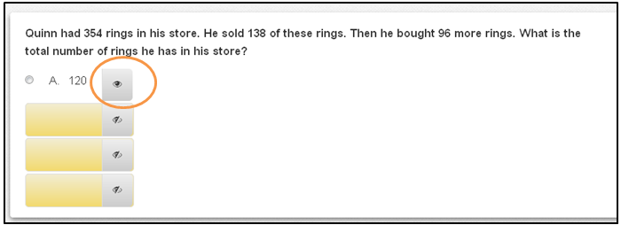
Directions for practicing these accessibility features with students will be explained in the Guided Practice Suggestions for each practice item set. Teachers should be familiar with these tools prior to using the practice item sets with students.

Enable Magnifier:
This tool is available on mathematics and science tests. Use this tool to magnify an area. When selected, a square box appears on the screen that can be moved anywhere to magnify the text/art within the box. The Magnifier retains the previously magnified value until the magnifier is moved again. This tool needs to be selected for each test item as needed. To remove the tool from the screen, select Disable Magnifier in the user dropdown menu. The magnifier will appear on the screen as shown below.

Audio Player on Audio Versions of the World History to 1500 test, World History from 1500 to the Present test, World Geography test, and all Science tests measuring the 2010 Science Standards of Learning:
Some students have an audio accommodation as the most appropriate delivery method for online testing, as indicated in their Individualized Education Program (IEP), English Learner (EL) Student Assessment Participation Plan, or 504 Plan. On audio versions of the test, the audio player will be available at the top of the screen. Please note that the gear symbol allows students to adjust the speed. While students can speed up or slow down the speed, the default for the audio reader is “Normal.”

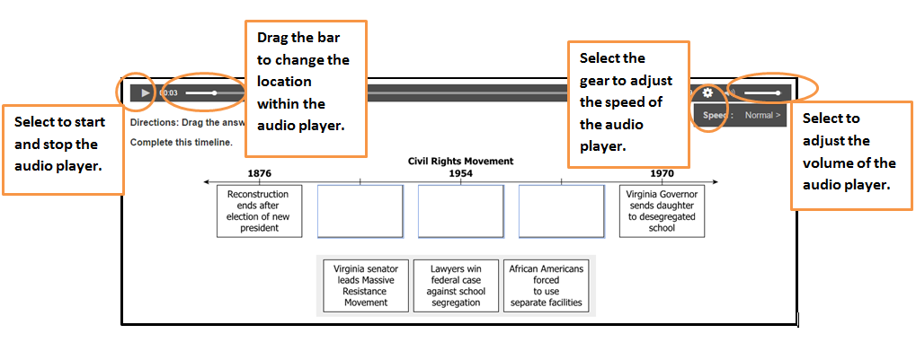
On audio versions of the writing tests and writing practice item sets, there will be two audio players on the screen when there is a reading passage on the left side of the screen and an associated question on the right side of the screen. Students should stop one player before they start the other.
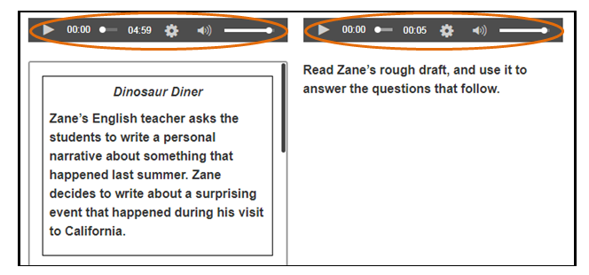

Audio Tools on 2016 Mathematics Standards of Learning tests, 2017 English Standards of Learning tests, EOC Writing tests, 2015 History and Social Science Standards of Learning tests, and 2018 Science Standards of Learning tests.

Students, who are assigned these “audio” tests, will see the audio tools for the text-to-speech reader on the right side of the screen.
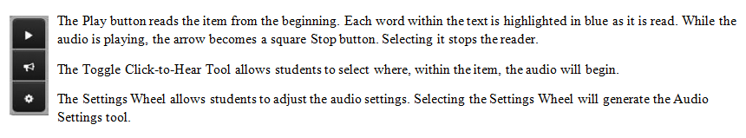
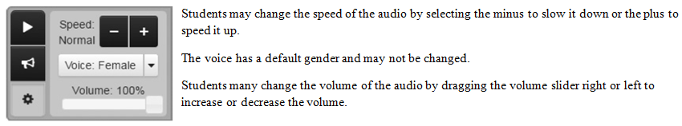
In addition to highlighting the words as they are read, the text-to-speech tool with automatically scroll as needed while reading.

Selection of Answers for Multiple-Choice Items

Multiple-choice items must be answered in TestNav 8 by selecting the letter of the answer option or the option itself using the mouse, keypad, or touch screen. On multiple-choice items, once an answer is selected, the item cannot be returned to an unanswered state (no answer selected) unless the student uses the eliminator tool to place an “X” over the selected answer and then deselects the “X”.

Technology-Enhanced Item Types

There are different types of technology-enhanced items. Some examples include:

- drag and drop,
- hot spot (which includes some number line items, coordinate plane items, and hot text items),
- bar graph or histogram, and
- fill-in-the-blank.

A brief description of some technology-enhanced item (TEI) types is provided below. Included is information on when a technology-enhanced item will be considered answered.

Drag and Drop:
Drag and drop items contain draggers and bays.

- Draggers are the answer options that are moved to bays in response to the question.
- Bays are areas of an item where draggers will remain once moved there. Drag and drop items require a student to respond by moving one or more draggers from one place on the screen into a bay(s) elsewhere on the screen.
If using a mouse or keypad, select on the dragger and keep the button down while moving the dragger to the desired bay. Once the button is released, the dragger will be in the new location. A dragger can be moved back to its original location in the same manner. When using a touch screen, select the dragger with a finger and move the dragger to the desired bay. The dragger is released when the finger is removed from the screen. When a dragger is selected and moved from its position, any bay that will accept a specific dragger becomes shaded.

Drag and drop items contain answer receptacles called “bays” and “draggers” that the student moves into the bays to answer the question. There are many types of drag and drop items, and each item is evaluated individually so that the student is given the most detailed information without providing hints as to the correct answer. For items with a specified number of bays, the item will be considered answered once the student uses that number of draggers. For example, if there are three bays and it is intended for a dragger to be placed into each bay, then the item will be considered answered once three draggers have been input by the student. Additionally, if the directions or question indicate that all draggers need to be used to answer the item, then the item will be considered answered only when all draggers have been used. If the number of draggers necessary to answer the question is not indicated, such as an item that requires the use of a dragger to complete a model or pictograph, then the item will be considered answered once the student places one dragger in a bay.

Drag and drop items may be used in reading, writing, mathematics, science, and history assessments.

Hot Spot:
Hot spot items contain hot spot zones which represent student answer options.

- Hot spot zones are answer options which may be part of a graphic, art, numbers, or text, that are selected in response to a question.
- Unlike a traditional multiple-choice item where only one answer option is correct, hot spot items may require the student to select one or more hot spot zones (answer options) in order to answer the item correctly.
- Number line and coordinate plane items require students to respond by selecting a location on a number line or coordinate plane to plot one or more points. In these items, the points themselves are the hot spot zones.

Students choose a hot spot by selecting it with a mouse or keypad or by selecting it with a finger on a touch screen. After the hot spot is selected, there will always be an indication that the zone has been marked as an answer, such as the hot spot being outlined in blue, the hot spot being shaded, an asterisk being placed on the hot spot, or a blue point being plotted on the number line or coordinate plane. If the points plotted on a coordinate plane are connected by line segments or have a line extend through them, the lines will be blue as well.
For most hot spot items, when the number of correct responses is indicated in the directions or in the item itself, the item will be considered answered only after the student has selected that number of hot spots. For example, if the student is directed to select three answers, then the item will be considered unanswered if the student selects one or two answers and will only show as answered once the student has selected three answers. If the number of correct responses is not indicated in the directions or in the question itself, then the item will be considered answered after the student selects one answer. For example, if the student is required to “Select all correct answers,” the item will be considered answered once the student selects one answer option. In this case, it is assumed that the student thought there was only one correct answer. This practice avoids providing information as to how many correct answers there are in the “select all” hot spot items.
- Coordinate Grids: Plot a point on the grid by selecting a location with the pointer tool or by selecting a location on a touchscreen. A blue point will appear that has a light blue halo. In order to deselect a point, select it again. In some items as students plot the points, a blue line segment will connect them. Some coordinate grid items will require students to plot one or more points as the response. Sometimes the number of points necessary to answer the item is indicated in the item. Students must make sure to read the question carefully to determine the number of answers necessary to completely answer the question.

- Number Lines: Many number line items are hot spot items and require the student to plot one or more points as the response. When the number of points necessary to answer the item is indicated in the directions or the item itself, the item will be considered answered only when the specified number of points has been plotted. When the directions or the item do not specify the number of points to plot, the item will be considered answered after the student plots one point.

- Hot Text: Hot text is a type of hot spot item. In a hot text item, the answer options are outlined in light blue, and a selected
answer is shaded a darker blue.* A hot text item will show as answered after one answer is selected. Students must make
sure to read the question carefully to determine the number of answers necessary to completely answer the question.
A hot text item is a type of the hot spot item type. In a hot text item, the answer options are outlined in light blue, and a selected answer is shaded a darker blue.*
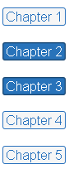

*When the background and foreground colors are set to the default setting, the selected answers will shade darker blue with white text. The color scheme of the selected answers will change when the background and foreground color settings are changed.
Hot spot items may be used in reading, writing, mathematics, science, and history assessments.

Bar Graph and Histogram:
Bar graph and histogram items require students to graph data by indicating the height (if the bars are vertical) or length (if the bars are horizontal) of one or more bars or intervals. The bar height or length is graphed by dragging the bar to the desired location.
For all bar graph and histogram items, once any bar is moved, the item will be considered answered.

Bar graph and histogram items may be used in mathematics and science assessments.

Fill-in-the-Blank:
Fill-in-the-blank items require students to input characters from the keyboard (numbers, letters, or symbols) to answer the question. For this item type, the student responds to a question by typing into a blank box provided in the item.

- Some response boxes may limit the characters that can be entered. For instance, if the response is expected to be numeric, the student will not be able to enter letters. Students will receive an error message if they enter a character that is not allowed on that item.
- Students should carefully follow directions in fill-in-the-blank items, such as providing an answer in simplest form, rounding a number as indicated, or using significant digits.
- Currently, no fill-in-the-blank item requires students to correctly spell a word; however, alphabetic characters or symbols may be used in an answer in some items.
For all fill-in-the-blank items, when a student enters any character into the response box, the item will be considered answered. If a student enters an answer, and then completely removes that answer from the fill-in-the-blank box, the item will be considered unanswered.

Fill-in-the-blank items are currently used in mathematics and science assessments.

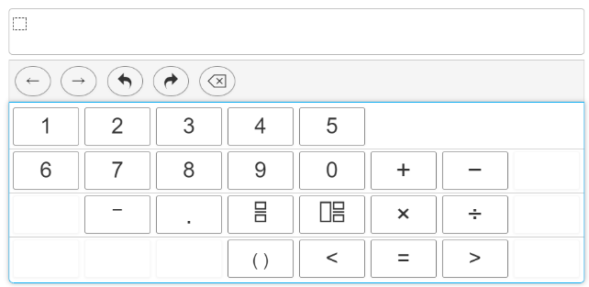
Equation Editor:
Equation editor items require students to enter answers in a box like the one shown. The buttons and math symbols that appear on the palette below the box may be used to enter an answer. The computer keyboard may also be used to enter numbers, letters, and some math symbols. Not all math symbols will be on the computer keyboard.

Students should become familiar with the math symbols that may appear on the palette. It is important they know how to use the structure box for a fraction or mixed number.
These buttons, below the entry box and above the palette, are useful for changing an answer.
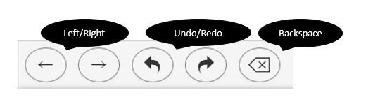

The arrow keys on the computer keyboard may be used to move around an equation, expression, and in and out of parentheses or other mathematical symbols. Students may also use their mouse or tap with their finger (on a touch-screen) to move around an equation or expression. 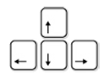
If there is information in an answer box, students will need to fill in all of the blanks to complete the answer.
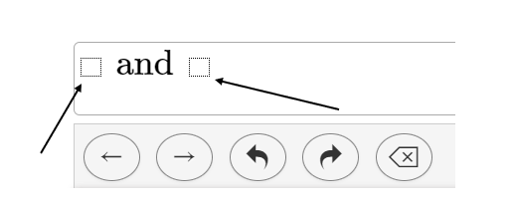

Materials Needed for Completing the Practice Items

Materials needed include scratch paper, pencil, and state approved ancillary materials. Virginia has an online Desmos calculator which appears in math and science practice item sets when applicable.

Guided Practice Suggestions

Prior to working with students on the practice item sets, it is important for teachers to familiarize themselves with the navigation, tools, and accessibility features in TestNav 8. Teachers should also be familiar with how to answer multiple-choice and technology-enhanced item (TEI) types.

Teachers and other adults should use the important information found in this document in conjunction with the information found in the Guided Practice Suggestions that are available for each practice item set. The Guided Practice Suggestions documents provide specific item information for each question in the practice item sets, and provide specific information for teachers as they guide students through the practice items. Following the suggestions in these guides will ensure that students are exposed to the different tools within TestNav 8, the different functionality features of TEI, and common messages that may appear as students complete their tests.

