Standards of Learning
Guided Practice Suggestions
For use with the End of Course Writing
Practice Items in TestNavTM 8

Table of
Contents

Change Log 2
Introduction to TestNavTM 8: MC/TEI Document 3
Guided Practice Suggestions 3
End of Course Writing Practice Item Information and Recommended Guided Practice Suggestions 4

Change Log

Updates to this document will be reflected in the table.
Change Log
Version | Date | Description
V.5 | 4/27/2020 | General information updated.
V.4 | 12/30/2016 | Update information on strikethrough and eliminator tool functions.
V.3 | 10/21/2016 | General information updated.
V.2 | 09/02/2016 | Updated available tools.
V.1 | 07/08/2016 | Original Document Posted.

Introduction to TestNavTM 8: MC/TEI Document
The Introduction to TestNav 8: Multiple-Choice/Technology-Enhanced Item Tests document located on the Virginia Department of Education SOL Practice Items webpage serves as an introduction to the online navigation, tools, accessibility features, and overall functionality and appearance of TestNav 8. It is highly recommended that teachers (or other adults) read the Introduction to TestNav 8: Multiple-Choice/Technology-Enhanced Item Tests document prior to reading this guide, the Guided Practice Suggestions for the End of Course (EOC) Writing practice item set.

Reading the Introduction to TestNav 8: Multiple-Choice/Technology-Enhanced Item Tests document will give teachers an understanding of the features of TestNav 8 prior to working with students. In part, the document provides information on:

- Opening the practice item sets within the required TestNav 8 Application.
- Navigating through the practice item sets.
- Answering technology-enhanced items (TEI) and multiple-choice (MC) items.
- Using the online tools.
- Using the accessibility features available in TestNav 8.

This important information should be used in conjunction with the information found in this guide.

Guided Practice Suggestions
This guide provides specific item information (item type and answer) for each question in the EOC Writing practice item set in table format. Along with the item information in the table, there is a column titled “Guided Practice Suggestions.” This column contains information for teachers as they guide students through the practice items. For instance, guided practice suggestions can state, “Use the eliminator tool to place a red ‛X’ on the answers that are not correct,” or, “Make sure students know how to select draggers and place them in the empty boxes using their mouse, keypad, or touchscreen.” Following the suggestions in the table will ensure that students are exposed to all of the different tools within TestNav 8, the different functionality features of TEI, and the common messages that may appear as students complete TEI.

End of Course Writing Practice Item Information and Recommended Guided Practice Suggestions

Question | Item Type | Answer Key | Guided Practice Suggestions
Rough Draft: Robo Games | Essay |  | If a passage is longer than one page, it will scroll. On a desktop or laptop computer, have students practice using the bar along the right side of the reading passage to scroll through the passage, as well as the scroll bar on the right side of the screen if necessary. On a touchscreen, use the scroll bar as well as movement of the entire page (shift the page upward with a finger) to scroll through the passage.  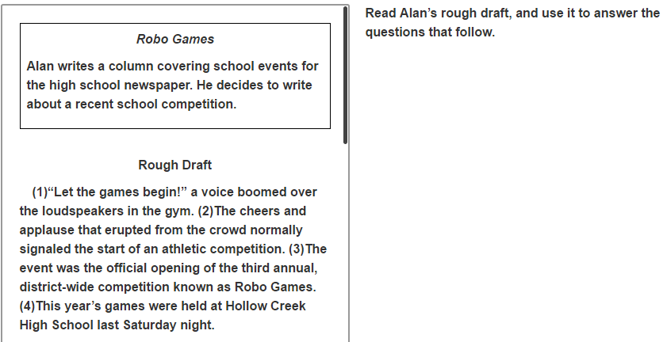  Throughout the practice item set, move to the next or previous screen by selecting an arrow in the top left corner of the screen. An arrow with a blue background indicates the button is active and can be selected.
1 | TEI  Drag and Drop | This answer should be placed in the box: This time, however, the roar was for a math and science event. | This question asks about sentences in the first paragraph. Tell students that the passage on the left is scrolled to the location where the student left the passage before moving to this screen. It may be necessary to scroll up to look at the first paragraph.  Have students select a dragger and place it in the empty box using the mouse, keypad, or touchscreen.  As soon as a dragger is selected and moved, the receptacle box turns blue and is outlined by a dotted line.  Selecting a dragger and moving it to the empty box may cause the remaining draggers to shift location in the answer option area.  On this item, the gray box will decrease in size when a dragger is removed. However, the gray box will expand to accept the dragger if the dragger is placed back over it.  Have students practice moving draggers back to the gray box. Draggers will go back to their original location when returned to the gray box.  This item will not be considered “Answered” until the box has an answer in it.
2 | MC | B | When a tool in the toolbar is active, it will be dark gray. In the picture below, the pointer is active because it is dark gray.  Have students select the eliminator tool located in the toolbar and then place a red “X” on the answers that are not correct. In the picture above, the eliminator tool is circled.  To remove an “X” keep the eliminator tool active and select the “X” to remove it. Have students practice removing an “X.”  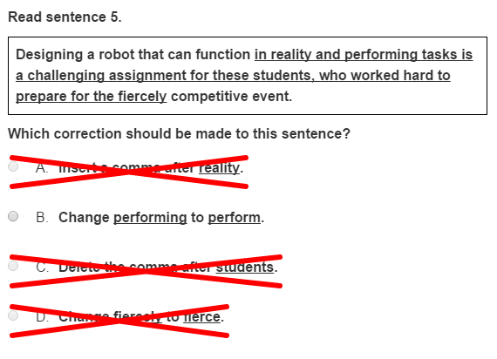  Tell students:  Multiple-choice items must be answered in TestNav 8 by selecting the letter of the answer option or the option itself using the mouse, keypad, or touchscreen. On multiple-choice items, once an answer is selected, the item cannot be returned to an unanswered state (no answer selected) unless the student uses the eliminator tool to place an “X” over the selected answer and then selects the “X” again to remove it.  Remind students that placing an “X” on the incorrect answer choices does not complete the item. A selection must be made with the pointer tool in order for the item to be considered “Answered.”
3 | TEI  Drag and Drop | The sentence should read: The following five teams, each consisting of five members, were represented COLON Lakeview COMMA MacArthur COMMA Greenwood COMMA Taft, and Hollow Creek.  The first shaded area, located after the word “following” in the sentence, should have been left empty. | This is a type of drag and drop technology-enhanced item. Have students select and drag the punctuation marks to the correct locations. Each punctuation mark can be used more than one time. Some boxes in the sentence may remain empty.  As soon as one punctuation mark is selected and moved, all of the boxes in the sentence shade blue. This indicates that the punctuation mark can be placed in any box.  If a student changes their mind and wishes to remove a punctuation mark, the student should select it and drag it back to the gray box.  This item will be considered “Answered,” once one punctuation mark is placed into the sentence. This is so no clue or hint is given as to how many punctuation marks should be in the sentence.
4 | MC | C | Tell students that the passage on the left is scrolled to the location where the student left the passage before moving to this screen. It may be necessary to scroll to look at sentence 13 in the passage.  Have students use the highlighter tool to highlight sentence 13 in the passage.  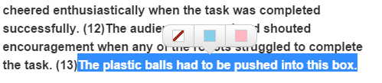  To highlight using a keyboard, place the cursor tool next to the  first word after (13), left click, hold down, and drag the cursor over the sentence. Then select the highlighter color.* To remove the highlight, left click, hold down, and drag over the sentence. Then select the white box on the left with the red line.  On a touchscreen, hold down on the sentence with a finger, and adjust the area to be highlighted with the blue anchors. Then select the highlighter color.* To remove the highlight, hold down on the text with a finger, adjust the anchors so that they are at the ends of the highlighted sentence, then select the white box on the left with the red line.
4 (Cont.) |  |  | On a touchscreen, the following option message may appear when students highlight text.  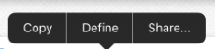  In the practice items, selecting one of the options listed will open a new window and direct students to the internet. This will not occur in the actual testing environment; selecting an option will not direct the students to another screen.  Tell students that the highlighter tool will only work on text. It will not work on art (images/pictures).  *Pink and blue are the two highlighter colors available when the foreground and background settings are set to the default (black text on white background). These colors may change when the foreground and background setting is changed.
5 | MC | A | As students navigate to this question, point out that the highlighting they did on the rough draft when they completed question 4 will remain on the rough draft unless they choose to remove it.  Have students practice using the Line Reader Mask accessibility feature with this item. Select the user drop-down menu in the top right corner of the screen and select Show Line Reader Mask from the menu.  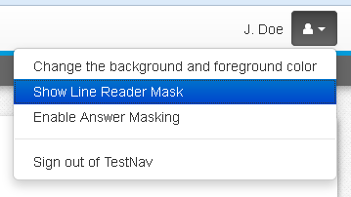  The Line Reader Mask will first appear on the left side of the screen. Have students move the tool over to the right side of the screen, over the question.  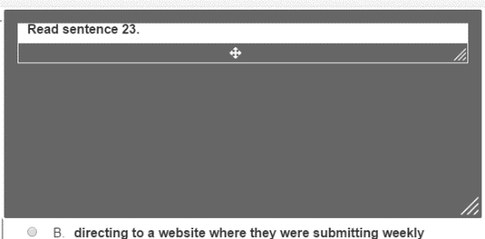
5 (Cont.) |  |  | Have students use the corner diagonal line areas to practice resizing the area covered by the line reader and the window through which content can be seen. Have students use the cross to move just the window through which content can be seen. Hold down on any part of the gray area and drag the tool to move the entire tool.  Have students practice moving the line reader to the left side of the screen and practice using it on the reading passage.  To turn off the Line Reader Mask, select the drop-down menu and select Hide Line Reader Mask. If the student does not turn off the Line Reader Mask, it will automatically turn off when the student navigates away from the item.
6 | MC | C | Have students practice using the Answer Masking accessibility feature with this item. Select the user drop-down menu in the top right corner of the screen and select Enable Answer Masking from the menu.  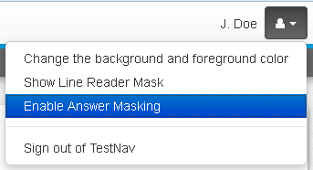  The answer options on multiple-choice items will now be masked as shown in the screenshot.  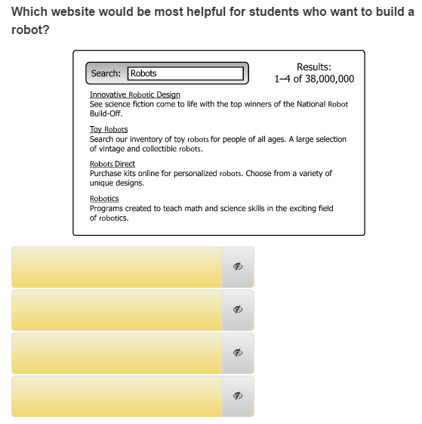
6 (Cont.) |  |  | Students may show or hide each option by selecting the “eye.”  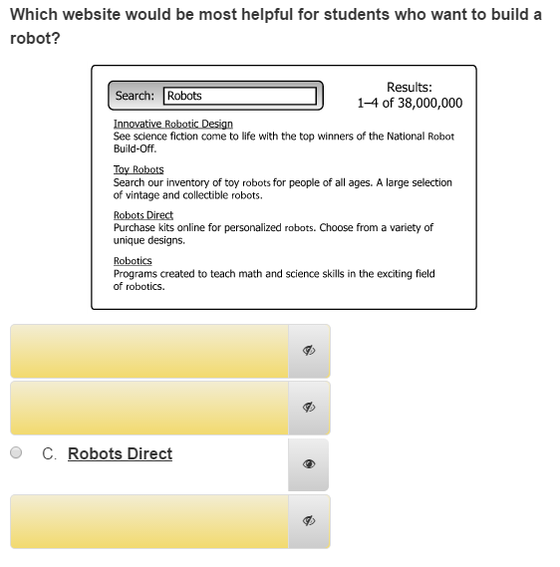  Answer Masking will remain on in each multiple-choice item until it is turned off. To turn off Answer Masking, select the user drop-down menu and select Disable Answer Masking.
7 | TEI  Hot Spot | To organize related information | This is a hot spot technology-enhanced item. To answer this question correctly, the correct answer in the gray box must be selected. A blue box outlines the answer choice when it is selected, indicating a student has chosen that response as an answer.  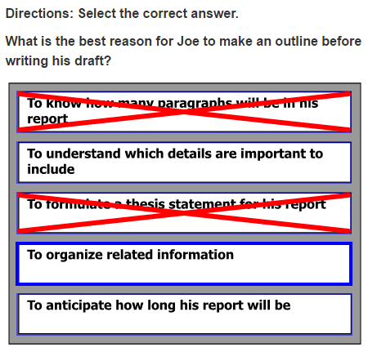  In order to deselect an answer and remove the blue box, the answer choice must be selected again. Have students practice selecting and deselecting an answer.  This TEI will allow the use of the eliminator tool. Have students practice using the eliminator tool on this hot spot item.
7 (Cont.) |  |  | This item also specifies the number of answers a student must select (one). If a student tries to select more than the number of answers indicated, a message appears in the top right corner of the screen.  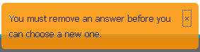  This message will remain for approximately five seconds unless the “x” is selected to close the message. Have students try to select an additional answer so that they can see this message appear.
Rough Draft: Not Your Average Historic Site | Informational |  | On a desktop or laptop computer, have students practice using the bar along the right side of the passage to scroll through the passage, as well as the scroll bar on the right side of the screen if necessary. On a touchscreen, use the scroll bar by the passage or move the entire passage with a finger to scroll through it.  Remind students that when they get to the first question associated with this passage, the reading passage will be in the location where it was left on this screen.
8 | MC | C | Have students select the Bookmark button and tell the students that when it is selected, the Bookmark button will turn dark gray. This button would be used to mark a question for review at a later time.  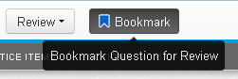  Then have students select the Review button. A drop-down menu will appear. All of the questions in the current section will be listed. The question that the student is viewing on the screen will be shaded dark gray. This question has an orange circle next to it because it has not yet been answered. This question will also have a blue flag next to it because it was just bookmarked.  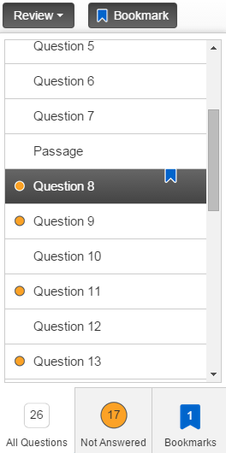
8 (Cont.) |  |  | Have students practice using the scroll bar to see the status of each question in the drop-down menu.  Have students close the Review drop-down menu and deselect the Bookmark button. Then, direct students to select the Review drop-down menu again to see that the question no longer has a blue flag.
9 | MC | D
10 | TEI  Hot Text | parks: | This is a type of hot spot technology-enhanced item called a hot text item. In a hot text item, the answer options are outlined in light blue, and a selected answer is shaded a darker blue with white text.*  *When the background and foreground colors are set to the default setting, the selected answers will shade darker blue with white text. The color scheme of the selected answers may change when the background and foreground color settings are changed. Guided practice with changing the background and foreground colors will be covered with a question further along in this practice item set.
11 | MC | A
12 | TEI  Drag and Drop | The sentence should read: Riverside COMMA the last stop on the commuter train that ran from Chicago to the surrounding areas COMMA quickly became a popular choice.  The second, third and fourth shaded areas should be left blank. | This is a type of drag and drop technology-enhanced item. Have students select and drag the comma to the correct location(s). The comma can be used more than one time. Some boxes in the sentence may remain empty.  As soon as one comma is selected and moved, all of the boxes in the sentence shade blue. This indicates that the comma can be placed in any box.  If a student changes their mind and wishes to remove a comma, the student should select it and drag it back to the gray box. (If a student decides to remove the comma, the student should select the comma and drag it back to the gray box.)  This item will be considered “Answered,” once one comma is placed into the sentence. This is so no clue or hint is given as to how many commas should be in the sentence.
13 | TEI  Hot Spot | The 2nd and 6th boxes from the top: What is the process for acquiring a National Historic Landmark status? and What characteristics must a site have to be considered a National Historic Landmark? | To answer this question correctly, the two correct answers in the gray box must be selected. A blue box outlines an answer choice when it is selected, indicating a student has chosen that response as an answer.  If a student tries to select more than the number of answers indicated, a message appears in the top right corner of the screen.  This message will remain for approximately five seconds unless the “x” is selected to close the message. Have students try to select an additional answer so that they can see this message appear.  This question will be considered “Answered” only when two answer choices have been selected.
14 | MC | D | This is a standalone question because it not part of a series of questions related to a reading passage. For this type of item, students may still be required to read text to answer the question, but they are not required to read a full passage.  Have students practice zooming in to look at the question on the screen, and then have them zoom out.  On a PC or Chromebook, press the CTRL and + keys at the same time to zoom in. Press the CTRL and – keys at the same time to zoom out. Press the CTRL and 0 (zero) keys at the same time to return to the default screen size.  On a Mac, press the COMMAND and + keys at the same time to zoom in. Press the COMMAND and – keys at the same time to zoom out. Press the COMMAND and 0 (zero) keys at the same time to return to the default screen setting.  On a touchscreen, have students touch two points on the screen and then move their fingers away from each other to zoom in. Touch two points on the screen and then move their fingers toward each other to zoom out.  As students are practicing how to zoom in and out, make sure they are doing so within reason. If students zoom in too far, they may not be able to see all of the information necessary to answer the question. If students zoom out too far, they may not be able to clearly see details of the question on the screen. It should also be noted that zooming in and out on the screen may cause the text wrapping to change. Remind students that they should only use this feature when necessary.  Before students go to the next question, make sure they return to the default screen.
15 | TEI  Hot Spot | The 2nd and 5th notes from the top: Finding a job can be challenging, so use the local newspaper and search online, and Contact local banks and credit unions for currency exchange rates and current interest rates on personal loans. | This question is a type of hot spot technology-enhanced item. The selected answers will be marked with a blue strikethrough line. To make changes, the student must deselect a note to remove the blue strikethrough line.  Tell students that when there are an unspecified number of answers, as in this question, the question will be considered “Answered” when one answer has been selected. This is so no clue or hint is given as to how many answers are correct.  This TEI will allow the use of the eliminator tool. Have students practice using the eliminator tool on this strikethrough item.  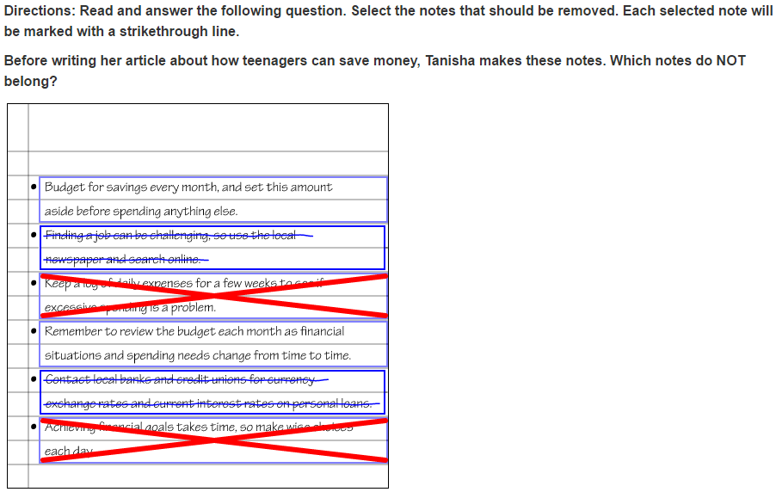
16 | TEI  Hot Text | The 4th box from the top: Valley of Moving Rocks | Have students practice with the accessibility feature that allows change to the background and foreground color. Select the user drop-down menu and Change the background and foreground color from the menu.  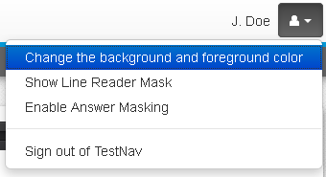  There are six different options other than black on white, which is the default setting. Have students select the setting “Black on Light Blue.” Then select the Continue button to enable this feature. This feature could be used by students who would benefit from the use of color contrasting to make text more distinct.  When the background and foreground colors are set to the default setting, the selected answers will shade darker blue with white text. The color scheme of the selected answers may change when the background and foreground color settings are changed. Since students have selected the “Black on Light Blue” setting, the selected answers will be black with light blue writing.  This setting will remain enabled until turned off. Have students turn this setting off. To turn this setting off, select the user drop-down menu, select Change the background and foreground color, and then select the button next to the default setting. Then select the Continue button.  The question will be considered “Answered” once one answer has been selected.
17 | MC | D
Rough Draft:  Traveling Rocks | Informational |  | On a desktop or laptop computer, have students practice using the bar along the right side of the passage to scroll through the passage, as well as the scroll bar on the right side of the screen if necessary. On a touchscreen, use the scroll bar as well as movement of the entire page (shift the page upward with their finger) to scroll through the passage.
18 | MC | B
19 | TEI  Drag and Drop | The punctuation marks should be placed after the following words: Racetrack COMMA, fast COMMA, lakebed SEMICOLON, and instead COMMA The first, fourth, and seventh boxes should be left empty. | Have students select and drag the punctuation marks to the correct location(s). Each punctuation mark can be used more than one time. Some boxes in the sentence may remain empty.  As soon as one punctuation mark is selected and moved, all of the boxes in the sentence shade blue. This indicates that the punctuation mark can be placed in any box the student chooses as the correct location.  If a student changes their mind and wishes to remove a punctuation mark, the student should select it and drag it back to the gray box. If a student decides to remove the punctuation mark, the student should select the punctuation mark and drag it back to the gray box.  This item will be considered “Answered,” once one punctuation mark is placed into the sentence. This is so no clue or hint is given as to how many punctuation marks should be in the sentence.
20 | TEI  Drag and Drop | From the top: NO in the first box, YES in the second box, YES in the third box, NO in the fourth box, YES in the fifth box and NO in the last box. | As soon as a dragger is selected and moved, each receptacle box turns blue and is outlined by a dotted line. This indicates that the dragger can be placed in any box—whichever location the student chooses as the correct location.  Have students try to place one dragger “over” another dragger, to show how the draggers will return to the gray box. If a student wishes to change an answer, the initial dragger must be moved back to the gray box and another dragger must be selected and moved into the response box.  Remind students that the words “Yes” and “No” should be used more than one time since this question will not show as “Answered” until each box has an answer.
21 | MC | C
22 | MC | A
23 | TEI  Hot Text | had seemed | Students should select the word or phrase that is NOT correct. A selected answer will shade dark blue with write writing (in the default setting).
24 | MC | B
25 | MC | D
26 | MC | C | Information for Teachers:  This is the end of the practice item set. See the Introduction to TestNav 8: MC/TEI document for information on closing TestNav.

