Standards of Learning
Guided Practice Suggestions

For use with the Chemistry
Practice Items in TestNavTM 8
January 2023

Table of
Contents

Change Log 2
Introduction to TestNavTM 8: MC/TEI Document 3
Guided Practice Suggestions 3
Chemistry Practice Item Information and Recommended Guided Practice Suggestions 4

Change Log

Updates to this document will be reflected in the table.
Change Log
Version | Date | Description
V.4 | 1/2023 | General information updated.
V.3 | 9/2022 | General information updated.
V.2 | 10/21/2016 | General information updated.
V.1 | 09/02/2016 | Original Document Posted.

Introduction to TestNavTM 8: MC/TEI Document
The Introduction to TestNav 8: MC/TEI document located on the Virginia Department of Education SOL Practice Items webpage serves as an introduction to the new online navigation, tools, accessibility features, and overall functionality and appearance of TestNav 8. It is highly recommended that teachers (or other adults) read the Introduction to TestNav 8: MC/TEI document prior to reading this guide, the Guided Practice Suggestions for the Chemistry practice item set.

Reading the Introduction to TestNav 8: MC/TEI document will give teachers an understanding of the features of TestNav 8 prior to working with students. In part, the document provides information on:

- opening the practice item sets within the required TestNav 8 Application,
- navigating through the practice item sets,
- answering technology-enhanced items (TEI) and multiple-choice (MC) items,
- using the online tools, and
- using the accessibility features available in TestNav 8.

This important information should be used in conjunction with the information found in this guide.

Guided Practice Suggestions
This guide provides specific item information for each question in the Chemistry practice item set in table format. Along with the item information in the table, there is a column titled “Guided Practice Suggestions.” This column contains information for teachers as they guide students through the practice items. For instance, guided practice suggestions can state, “Use the eliminator tool to place a red ‛X’ on the answers that are not correct,” or, “Make sure students know how to select draggers and place them in the empty boxes using their mouse, keypad, or touchscreen.” Following the suggestions in the table will ensure that students are exposed to all of the different tools within TestNav 8, the different functionality features of TEI, and the common messages that may appear as students complete TEI.

Chemistry Practice Item Information and Recommended Guided Practice Suggestions
Question | Item Type | Answer Key | Guided Practice Suggestions
1 | MC | C | Throughout the practice item set, move to the next or previous screen in a section by selecting an arrow in the top left corner of the screen. An arrow with a blue background indicates the button is active and can be selected.  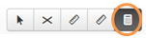  Have students practice using the online calculator by selecting the calculator icon.  Once selected, the calculator will appear on the screen. Students can move the calculator on the screen by holding down inside the top of the calculator and dragging it to a new location. Make sure students familiarize themselves with knowing how to select and use the calculator if needed. Have students enter the calculations for this particular question on the calculator to help them determine the answer.  Selecting the calculator icon again will put the tool away; or, select the pointer tool to put the calculator away.
2 | MC | D | Have students select the eliminator tool located in the toolbar. Then have them place a red “X” on the answers that are not correct.  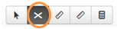  When a tool in the toolbar is active, it will be dark gray. In the picture above, the eliminator tool is active.  To remove an “X,” keep the eliminator tool active and select the “X” to remove it. Have students practice removing an “X.”  Multiple-choice items must be answered in TestNav 8 by selecting the letter of the answer option or the option itself using the mouse, keypad, or touchscreen. On multiple-choice items, once an answer is selected, the item cannot be returned to an unanswered state (no answer selected) unless the student uses the eliminator tool to place an “X” over the selected answer and then selects the “X” again to remove it.  Remind students that placing an “X” on the incorrect answer choices does not complete the item. A selection must be made with the pointer tool in order for the item to be considered “Answered.”
3 | TEI  FIB | 10.1 | Tell students that the answer does not need to be as long as the response box.  If a student tries to enter too many numbers, this message will appear:  A question may specify that the answer must be given in a particular format. Remind students to read the question carefully so they know how to answer the question.
4 | MC | A | Students may want to use a Periodic Table when answering this question. In order to access the online periodic table, students can click on the black Exhibits icon that is located on the far right of the screen.  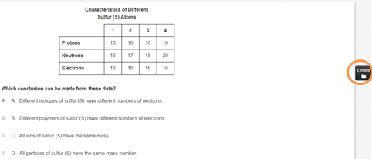  When the icon is selected, the periodic table will appear on the screen.  Some devices may have a scroll bar for the exhibit. If so, have students practice scrolling to the bottom of the periodic table and back up to the top. On a desktop or laptop, scroll by using the scroll bar on the right side of the Exhibits window. On a touchscreen device, use a finger to hold down on the white part of the periodic table to drag it up and down.  Have students practice moving the Exhibits window around the screen. To move the Exhibits window on a desktop or laptop, place the pointer tool on the gray bar across the top of the Exhibits window and drag it to a new location on the screen. To drag the Exhibits window on a touchscreen device, use a finger to hold down on the gray bar across the top of the Exhibits window, and drag the window to a new location within the item window.  To close the Exhibits window, select the “X” in the upper right corner.
5 | MC | A | Have students select the Bookmark button and tell them that when they select the Bookmark button, it will turn dark gray. This button would be used to mark a question for review at a later time.  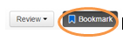  Then have students select the Review button. A drop-down menu will appear. All of the questions in the current section will be listed. The question that the student is viewing on the screen will be shaded dark gray.  This question has an orange circle next to it because it has not yet been answered. This question will also have a blue flag next to it because it was just bookmarked.  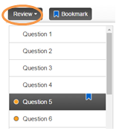  Have students practice using the scroll bar to see the status of each question in the drop-down menu.  Have students close the Review drop-down menu and deselect the Bookmark button. Then, tell them to look at the Review drop-down menu again to see that the question no longer has a blue flag.
6 | TEI  Drag and Drop | The blue boxes for 1s, 2s, and 3s should have an up arrow on the left and a down arrow on the right. All three of the yellow 2p boxes should have an up arrow on the left and a down arrow on the right. The first two 3p boxes should have one up arrow each, and the last 3p box should be empty. | Have students select draggers and place them in the empty boxes using the mouse, keypad, or touchscreen.  As soon as a dragger is selected and moved, each receptacle box turns blue and is outlined by a dotted line. This indicates that the dragger can be placed in that box. Some items have multiple receptacle boxes and sometimes a restriction is placed on where a dragger can be placed. A selected dragger, once selected and moved, can only be placed in the boxes that shade light blue.  Notice that the directions state that each arrow may be used more than one time.
7 | TEI  Drag and Drop | From left to right, the boxes should contain: 2, 2, 6, 2, 6, and the last box on the right should be blank. | Have students practice moving draggers back to the gray box. Draggers will go back to their original location when returned to the gray box.  Tell students that when there are an unspecified number of answers, the question will be considered “Answered” when one answer has been selected. This is so no clue or hint is given as to how many answers are correct.
8 | TEI  FIB | -1 or 1- | A question may specify that the answer must be given in a particular format. This question specifies that the answer indicate a positive or negative electrical charge. Make sure you remind students to read the question carefully so they know how to answer the question.  Information for teachers:  Answers with leading zeros would be scored as correct (e.g., 010, 0010, 00010, or 000010).  Tell students that if and answer has four or more digits, it will be scored as correct with or without the use of commas. If a comma is used, it must be in the correct location within the number.
9 | TEI  FIB | 36 | This question has the Drawing Interaction Tool. The Drawing Interaction Tool is a boxed area that exists on certain science questions. The pencil may be used to make marks, notations, straight lines, or dots on or around artwork or graphs inside the Drawing Interaction area. The student selects the specific tool he/she wants to use and uses it to help answer the question.  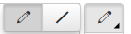  The top tool is the pencil or straight line tool. The arrow in the bottom right corner expands the tool so a student may select free draw or the straight line.  A dot may be placed if a student uses his mouse, keypad, or touchscreen. The student would select free draw and use his mouse or keypad to click and release to place a point. If using a touchscreen, the student would use his finger to place a point.  The second tool is used to erase selected lines, markings, or writing.  The third tool allows the markings to be black or green. The arrow in the bottom right corner expands the tool so a student may select the color.  The fourth tool allows the students to select the thickness of the markings. The arrow in the bottom right corner expands the tool so a student may select the size.  The fifth and sixth tools are used to Undo or Redo the most recent markings.  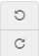
9  (Cont.) |  |  | The last tool allows all markings to be eliminated at the same time.  Have students practice marking on the figures and removing the marks made to help answer the question.
10 | MC | B | Have students practice using the Answer Masking accessibility feature with this item. Select the user drop-down menu in the top right corner of the screen and select Enable Answer Masking from the menu.  The answer options on multiple-choice items will now be masked as shown in the screenshot.  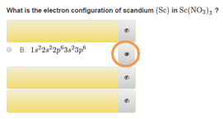  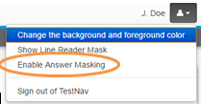  Students may show or hide each option by selecting the “eye.”
11 | TEI  Hot Spot | Column 4 | The eliminator tool works on some TEI items as well as Multiple-Choice items. Have students select the eliminator tool located in the toolbar and then place a red “X” on the answers that are not correct.  A blue box outlines the answer choice when it is selected, indicating a student has chosen that response as an answer.  In order to deselect an answer and remove the blue box, the answer choice must be selected again. Have students practice selecting and deselecting an answer.  Some items will specify the number of answers to select. If a student tries to select more than the number of answers indicated, a message appears in the top right corner of the screen.  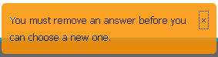  This message will remain for approximately five seconds unless the “X” is selected to close the message. Have students try to select an additional answer so that they can see this message appear.
12 | TEI  Drag and Drop | In this order:  lead (IV) and oxide | Have students practice moving draggers back to the gray box. Draggers will go back to their original location when returned to the gray box.  This item will not be considered “Answered” until each box has an answer in it. The images must be in the correct order.  Have students try to place one dragger “over” another dragger, to show how the draggers will return to the gray box. If a student wishes to change an answer, the dragger must be moved back to the gray box and another option must be selected and moved into the response box.
13 | TEI  Drag and Drop | From left to right, the correct coefficients are 2, 1, 1, and 2. | Have students practice using the Line Reader Mask accessibility feature with this item. Select the user drop-down menu and Show Line Reader Mask from the menu.  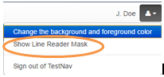  The Line Reader Mask will appear over the item. Have students use the diagonal line areas to practice resizing the area covered by the line reader and the window through which content can be seen. Have students use the cross to move just the window through which content can be seen. Hold down on any part of the gray area and drag the tool to move the entire tool.  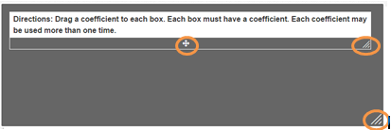  To turn off the Line Reader Mask, select the drop-down menu and select Hide Line Reader Mask. If the student does not turn off the Line Reader Mask, it will automatically turn off when the student navigates away from the item.
14 | MC | B | Notice that the Answer Masking tool will remain on in each multiple-choice item until it is turned off. To turn off Answer Masking, select the user drop-down menu and select Disable Answer Masking.
15 | TEI  Hot Spot | Concentration, Pressure, Volume, and Temperature | Tell students that when there are an unspecified number of answers, the question will be considered “Answered” when one answer has been selected. This is so no clue or hint is given as to how many answers are correct.
16 | MC | B | Have students practice using the accessibility feature that allows them to change the background and foreground color. Select the user drop-down menu and Change the background and foreground color from the menu.  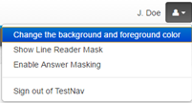  There are six different options other than black on white, which is the default setting. Have students select a contrast setting and then the Continue button to enable this feature. This feature could be used by students who would benefit from the use of color contrasting to make text more distinct.  This setting will remain enabled until turned off. To turn off this setting, select the user drop-down menu, select Change the background and foreground color, and then select the button next to the default setting. Then select the Continue button.
17 | MC | B
18 | MC | C | To highlight using a keyboard, have students place the cursor next to the direction sentence, left click, hold down, and drag the cursor over the sentences. Then have students select the highlighter color from the pop-up box.*  To remove the highlight, left click, hold down, and drag over the sentences. Then select the white box with the red line on the left side of the pop-up box.  On a touchscreen, have students hold down on the sentences with a finger, and adjust the area to be highlighted with the blue anchors. Then have students select the highlighter color from the pop-up box.* To remove the highlight, hold down on the text with a finger, adjust the anchors so that they are at the ends of the highlighted sentences, then select the white box with the red line on the left side of the pop-up box.  Tell students that the highlighter tool will only work on text. It will not work on art (images/pictures).  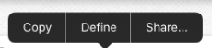  On a touchscreen, the following message may appear when students highlight text.  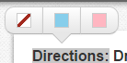  In the practice items, selecting one of the options listed will open a new window and direct students to the internet. This will not occur in the actual testing environment; selecting an option will not direct the students to another screen.  *Pink and blue are the two highlighter colors available when the foreground and background settings are set to the default (black text on white background). These colors may change when the foreground and background setting is changed.
19 | MC | B | Practice using the ruler tool as a straight edge to familiarize students with this tool.  There are two ruler tools on the top of the screen ( ). The icon on the left should be used to access the eighth inch ruler and the icon on the right should be used to access the centimeter ruler. Students should select the appropriate ruler for each measurement question.  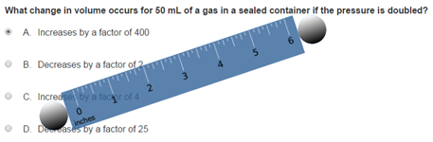  To move the ruler, select and drag the ruler over to the object to be measured. To rotate the ruler, select and drag an end with the circle. Have students practice moving and rotating the ruler. Selecting the ruler tool icon again will put the ruler tool away; or, select the pointer tool to put it away.
20 | TEI  Hot Spot | (0.5, 12) and  (0.7 and 15) | The graph is a type of Hot Spot technology enhanced item. Have students plot a point on the grid by selecting a location with the pointer tool or by selecting a location with a finger (on a touchscreen). A blue point will appear that has a light blue halo. As students plot the points, a blue line segment will connect them.  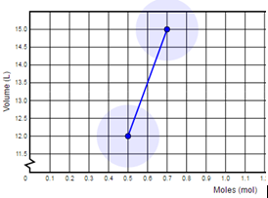  In order to deselect a point, select it again.  This item will be considered “Answered” when one point is plotted so that no clue or hint is given as to how to graph the data in the table.
21 | MC | C | Have students practice zooming in to look at the question on the screen, and then have them zoom out.  Use the Zoom-In and Zoom-Out feature to enlarge or shrink text or images on the screen. Selecting “+” increases the zoom. Selecting “–” decreases the zoom. Other methods can activate Zoom depending on the device (keyboard shortcuts, pinch to zoom, etc.). Once zoom is set, this setting applies to all test items until it is changed. This feature appears in the user dropdown menu only when using the TestNav8 app on a laptop or desktop. It will not appear in the browser version of the practice items and it will not appear on an iPad in the TestNav8 app.  The shortcut keys may also be used to zoom.
22 | TEI  Hot Spot | Box 1, Box 3, and Box 4 | To answer this question correctly, all the correct answers in the gray box must be selected.
23 | MC | C | Have students practice with the Enable Magnifier. This feature will magnify an area. The Magnifier retains the previously magnified value until the magnifier is moved again. When selected, a square box appears on the screen that can be moved anywhere to magnify the text/art within the box. This tool can be selected for each test item as needed. To remove the tool from the screen, select Disable Magnifier in the user dropdown menu.
24 | MC | C
25 | TEI  Hot Spot | From left to right, any three of the following carbon atoms: the second, third, fourth, fifth, seventh, or eighth atoms | To answer this question correctly, all the correct answers must be selected.
26 | TEI  Hot Spot | Protein and DNA | This question will be considered “Answered” when one answer has been selected. This is so no clue or hint is given as to how many answers are correct.
27 | MC | A | Information for Teachers:  This is the end of the practice item set. See the Introduction to TestNav 8: MC/TEI document for information on closing TestNav.

