Standards of Learning
Guided Practice Suggestions
For use with the 2015 History
Practice Items in TestNavTM 8
September 2019

Table of Contents
Standards of Learning Guided Practice Suggestions 1
Introduction to TestNavTM 8: MULTIPLE-CHOICE/TEI Document 3
Guided Practice Suggestions 3
Online Tools, Features, Icons, and Descriptions of Function 4
Pointer 4
Answer Eliminator 4
Highlighter 4
Zoom-In and Zoom-Out Feature 4
User Dropdown Menu 5
Audio Tools 6
Virginia Studies 8
Civics and Economics 11
Virginia & U.S. History 14
End of Course History 17

Introduction to TestNavTM 8: MULTIPLE-CHOICE/TEI Document
The Introduction to TestNav 8: Multiple-Choice/Technology-Enhanced Item Tests document located on the Virginia Department of Education SOL Practice Items webpage serves as an introduction to the online navigation, tools, accessibility features, and overall functionality and appearance of TestNav 8. It is highly recommended that teachers (or other adults) read the Introduction to TestNav 8: MC/TEI document prior to reading this guide, the Guided Practice Suggestions, for the History practice item sets.

Reading the Introduction to TestNav 8: MC/TEI document will give teachers an understanding of the features of TestNav 8 prior to working with students. In part, the document provides information on:

- opening the practice item sets within the required TestNav 8 Application,
- navigating through the practice item sets,
- answering technology-enhanced items (TEI) and multiple-choice items,
- using the online tools, and
- using the accessibility features available in TestNav 8.

This important information should be used in conjunction with the information found in this guide.

Guided Practice Suggestions
This guide provides specific item information for each question in the History practice items. Along with the item information, there are guided practice suggestions in the Functionality Description column of the table. This column contains information for teachers as they guide students through the practice items. For instance, guided practice suggestions can state, “Use the eliminator tool to place a red ‛X’ on the answers that are not correct,” or, “Make sure students know how to select draggers and place them in the empty boxes using their mouse, keypad, or touchscreen.” Following the suggestions in the table will ensure that students are exposed to all of the different tools within TestNav 8, the different functionality features of TEI, and the common messages that may appear as students complete TEI.

Online Tools, Features, Icons, and Descriptions of Function
Pointer
Use to select an answer on screen and to place the cursor in an answer box, plot points, select one or more answers, and drag information from one location to another.
Answer Eliminator
Use to eliminate (cross off) answer options. This tool functions with multiple-choice questions and certain technology-enhanced items.
Highlighter
Use to highlight text. Students cannot highlight art, pictures, images, or text when presented as art.
There is no limit to the number of highlights a student can make within the test. To access the highlighter, the student selects text and selects the highlighter color. To remove the highlighted text, the student selects the highlighted text and selects the slash. Pink and blue are the two highlighter colors available when the background and foreground settings are set to the default (black text on white background). These colors may change when the background and foreground setting is changed.

Zoom-In and Zoom-Out Feature

On a PC or Chromebook:
Zoom in—press the CTRL and + keys at the same time.
Zoom out—press the CTRL and – keys at the same.
Return to default screen size—press the CTRL and 0 keys at the same time.

On a Mac:
Zoom in—press the CMD and + keys at the same time.
Zoom out—press the CMD and – keys at the same time.
Return to default screen size—press the CMD and 0 keys at the same time.

On a touchscreen device:
Zoom in—touch two points on the screen, and then move your fingers away from each other.
Zoom out—touch two points on the screen, and then move your fingers toward each other.
User Dropdown Menu 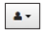

Change the Background and Foreground Colors
Selecting this permits students to choose the background and foreground colors of their test. The list of background and foreground colors is shown in the screen shot below:

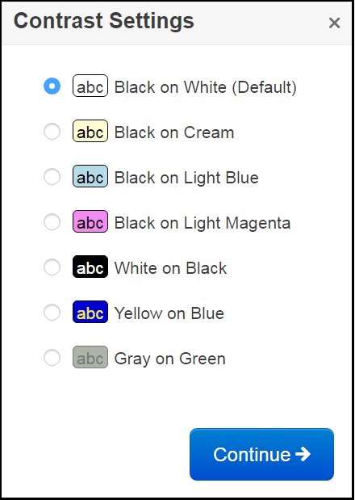

To return the background and foreground color to the default, the student selects Black on White (Default).

Show Line Reader Mask
Selecting this will place a mask on the screen that the student may place over text or test questions. The line reader mask has a window, which shows only one line of text. The student must drag the window down over the text in order to read it. The student can resize the mask and the window. This mask must be selected for each passage or question after the student moves backward or forward in the test. To remove the line reader mask, in the dropdown the student selects Hide Line Reader Mask. The line reader mask screen shot is below:

Enable Answer Masking
Selecting this will place a mask over each multiple-choice answer option (this is not available on TEI questions). The student may uncover an answer choice by selecting the gray box with the image of an eye. Once enabled, the answer mask will be present on all multiple-choice questions. To stop the answer choice masking, the student opens the dropdown menu and selects Disable Answer Masking. The answer masking screen shot is below:
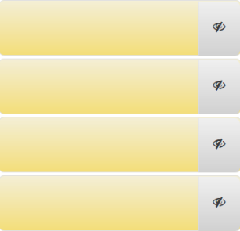

Sign out of TestNav
Selecting this will bring up the Exit Test screen. The Exit Test screen permits the student to Exit the Test, or to Cancel the selection and return to the test.
TestNav tools cannot be used to indicate answers to online test items. The Pointer must be used to:
- select multiple-choice answers;
- place the cursor in a box in order to type an answer;
- plot points on a line, graph, or graphic;
- select one or more answers; or
- drag answers from one location to another.

If the student uses a tool other than the Pointer to indicate the student’s answer, the Review dropdown will show that question as Not Answered. If the student feels that the student did answer the question, instruct the student to go back to the test item to make sure that the Pointer was used to indicate the answer.
A Help menu for the TestNav tools is not available.

Audio Tools
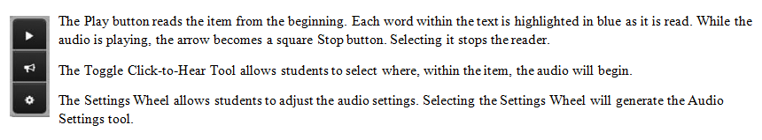
Students who are assigned an “audio” test in Spring 2020 for the 2015 History and Social Science Standards of Learning (Virginia Studies, Civics and Economics, Virginia and U.S. History) will see the audio tools for the text-to-speech reader on the right side of the screen.

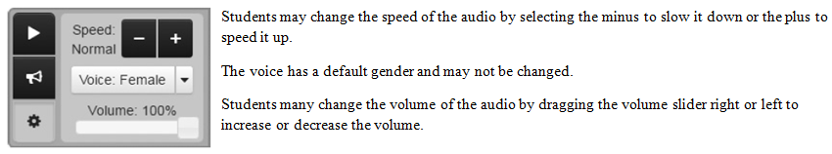
Students who are assigned an “audio” test in Spring 2020 for the 2008 History and Social Science Standards of Learning (World History to 1500 test, World History from 1500 to the Present test, World Geography test) will see the audio tools at the top of the screen. Please note that the gear symbol allows students to adjust the speed. While students can speed up or slow down the speed, the default for the audio reader is “Normal.”

Virginia Studies
Question Number | Item Type | Correct Answer | Functionality Description
1 | Multiple Choice | B | The eliminator tool works on some technology-enhanced items as well as multiple-choice items. Have students practice using the eliminator tool. A student must remove the X using the eliminator tool before using the pointer tool to select an option.  The pointer tool must be used to select the answer option for the item to show as “Answered.”
2 | TEI  Hot Spot | Both of these answers must be selected:  Mineral  Ashland | A blue box outlines the answer choice when it is selected, indicating a student has chosen that response as an answer. In order to deselect an answer and remove the blue box, the answer choice must be selected again. If a student tries to select more than the number of answers indicated, a message appears in the top right corner of the screen. This message will remain for approximately five seconds unless the “X” is selected to close the message. Have students practice selecting and deselecting an answer.
3 | TEI | These three phrases must be selected:  people should be allowed to practice any religion  freedom of the press would be protected  individual rights would be protected | This is a type of hot spot item called a hot text item. In a hot text item, the answer options are outlined in light blue, and a selected answer is shaded a darker blue when the background and foreground colors are set to the default setting.
4 | Multiple Choice | C | The highlighter tool can be used in a textbox as well as a question. Students should be familiar with how to use the highlighter tool on the device that will be used during testing.  Have students practice using the highlighter tool to highlight information in the textbox.
5 | TEI  Drag and Drop | In the left box:  Factories  Growth of Industry  In the right box:  Plantations  Expansion of Slavery  Answers must be placed in the correct location. | As soon as a dragger is selected and moved, each receptacle box turns blue and is outlined by a dotted line. This indicates that the dragger can be placed in any box—whichever location the student chooses as the correct location. However, sometimes a restriction is placed on where a dragger can be placed. A dragger, once selected and moved, can only be placed in the boxes that shade blue. Selecting a dragger and moving it to the empty box may cause the remaining draggers to shift location in the answer option area.  This item will not be considered “Answered” until each box has an answer in it.
6 | TEI  Drag and Drop | From left to right in this order:  African Americans forced to use separate facilities;  Lawyers win federal case against school segregation;  Virginia senator leads Massive Resistance Movement  Answers must be placed in the correct location. | This item will not be considered “Answered” until each box has an answer in it.
7 | TEI  Drag and Drop | In the Oliver W. Hill, Sr. circle: Defended rights of African Americans in court  In the overlapping of the circles: Promoted racial equality  In the A. Linwood Holton, Jr. circle: Appointed African Americans to government positions  Answers must be placed in the correct location. | In this question the draggers may go in any box, but the student must place the options in a specific order to answer the question correctly. When a student selects a dragger, all of the boxes will highlight with a blue shade. This indicates the dragger can be placed in any of the highlighted boxes.  This item will not be considered “Answered” until each box has an answer in it.

Civics and Economics
Question Number | Item Type | Correct Answer | Functionality Description
1 | Multiple Choice | C | The highlighter tool can be used in a textbox as well as a question. Students should be familiar with how to use the highlighter tool on the device that will be used during testing.  Have students practice using the highlighter tool to highlight the words in the textbox.
2 | TEI  Drag and Drop | In the Declaration of Independence box:  Stated grievances against the King of Great Britain  Preserved the rights of the colonists  In the Articles of Confederation box:  Assigned major powers to the states  Created a weak central government  Answers must be placed in the correct location, but may be in any order in the correct location. | As soon as a dragger is selected and moved, each receptacle box turns blue and is outlined by a dotted line. This indicates that the dragger can be placed in any box—whichever location the student chooses as the correct location. However, sometimes a restriction is placed on where a dragger can be placed. A dragger, once selected and moved, can only be placed in the boxes that shade blue. Selecting a dragger and moving it to the empty box may cause the remaining draggers to shift location in the answer option area.  This item will not be considered “Answered” until each box has two answers in it.
3 | TEI  Drag and Drop | Answers in order from left to right:  Commander-in-Chief  Chief Legislator  Chief Citizen  Answers must be placed in the correct location. | This item will not be considered “Answered” until each box has an answer in it.
4 | Multiple Choice | C | The eliminator tool works on some technology-enhanced items as well as multiple-choice items. Have students practice using the eliminator tool. A student must remove the X using the eliminator tool before using the pointer tool to select an option.  The pointer tool must be used to select the answer option for the item to show as “Answered.”
5 | TEI  Hot Spot | The following points must be plotted on the graph:  (2,12), (3.9), (5,6), (7,3) | This coordinate grid is a type of hot spot technology-enhanced item.  Information for teachers: once two points have been plotted a line will connect the two points.
6 | TEI  Hot Spot | These three good and services must be selected:  Police  Post Office  Public Library | A blue box outlines the answer choice when it is selected, indicating a student has chosen that response as an answer. In order to deselect an answer and remove the blue box, the answer choice must be selected again. If a student tries to select more than the number of answers indicated, a message appears in the top right corner of the screen. This message will remain for approximately five seconds unless the “X” is selected to close the message. Have students practice selecting and deselecting an answer.
7 | TEI  Hot Spot | In the County Political Party column:  Organize Fundraisers for Campaigns  Educate Voters on the Issues  In the National Political Party column:  Recruit Candidates for President  Organize Fundraisers for Campaigns  Educate Voters on the Issues  All correct answers in each column must be selected. | This item will be considered “Answered” when one box has a check in it.

Virginia & U.S. History
Question Number | Item Type | Correct Answer | Functionality Description
1 | Multiple Choice | B | The highlighter tool can be used to highlight words in a question. Students should be familiar with how to use the highlighter tool on the device that will be used during testing.  Have students practice using the highlighter tool to highlight the word “British.”
2 | TEI  Drag and Drop | Answers in order from left to right:  Missouri Compromise  California admitted as a free state  Popular sovereignty allowed in Kansas  Abraham Lincoln elected president  Answers must be placed in the correct location. | As soon as a dragger is selected and moved, each receptacle box turns blue and is outlined by a dotted line. This indicates that the dragger can be placed in any box—whichever location the student chooses as the correct location. However, sometimes a restriction is placed on where a dragger can be placed. A dragger, once selected and moved, can only be placed in the boxes that shade blue. Selecting a dragger and moving it to the empty box may cause the remaining draggers to shift location in the answer option area.  This item will not be considered “Answered” until each box has an answer in it.
3 | Multiple Choice | B | The eliminator tool works on some technology-enhanced items as well as multiple-choice items. Have students practice using the eliminator tool. A student must remove the X using the eliminator tool before using the pointer tool to select an option.  The pointer tool must be used to select the answer option for the item to show as “Answered.”
4 | TEI  Hot Spot | These three conditions must be selected:  recognize the independence of new nations  allow its territories to become mandates  accept blame for the war | A blue box outlines the answer choice when it is selected, indicating a student has chosen that response as an answer. In order to deselect an answer and remove the blue box, the answer choice must be selected again. If a student tries to select more than the number of answers indicated, a message appears in the top right corner of the screen. This message will remain for approximately five seconds unless the “X” is selected to close the message. Have students practice selecting and deselecting an answer.
5 | TEI  Hot Spot | These three headlines must be selected:  Flappers Practice “The Charleston” on the Boardwalk  Opening Day of Scopes Trial Brings World Notice to Dayton  Women Vote in Elections for the First Time in Virginia | None
6 | TEI  Hot Spot | These two sources must be selected:  “The Political Consequences of Baltic Nationalism” (educational website)  “Perestroika and the Soviet Economy: A Report,” at the Wilson Center (national archive) | None
7 | TEI  Drag and Drop | In the Significant Question column:  Is separate but equal constitutional?  In the Major Participants column:  Thurgood Marshall  Oliver Hill  The answer options in this column may appear in either order. | This item has a restriction placed on where a dragger can be placed. A dragger, once selected and moved, can only be placed in the boxes that shade blue. Selecting a dragger and moving it to the empty box may cause the remaining draggers to shift location in the answer option area.  This item will not be considered “Answered” until each box has an answer in it.
8 | TEI  Hot Spot | These three locations must be selected:  1, 3, 4 | The answers for this item must be selected from the numbers in the gray box located below the map. Students should practice selecting the answers that correspond to the numbered locations.

End of Course History
Tests Based on the 2008 History and Social Science Standards of Learning

The end-of-course World History to 1500, World History from 1500 to the Present, and World Geography tests will continue to be based on the 2008 History and Social Science Standards of Learning.
Question Number | Item Type | Correct Answer | Functionality Description
1 | TEI  Drag and Drop | These images should be placed in the boxes:  Porcelain  Spices  Silk  The images may appear in any order. | As soon as a dragger is selected and moved, each receptacle box turns blue and is outlined by a dotted line. This indicates that the dragger can be placed in any box—whichever location the student chooses as the correct location. However, sometimes a restriction is placed on where a dragger can be placed. A dragger, once selected and moved, can only be placed in the boxes that shade blue. Selecting a dragger and moving it to the empty box may cause the remaining draggers to shift location in the answer option area.  This item will not be considered “Answered” until each box has an answer in it.
2 | TEI  Hot Spot | These three areas must be selected:  2, 3, 4 | A blue box outlines the answer choice when it is selected, indicating a student has chosen that response as an answer. In order to deselect an answer and remove the blue box, the answer choice must be selected again. If a student tries to select more than the number of answers indicated, a message appears in the top right corner of the screen. This message will remain for approximately five seconds unless the “X” is selected to close the message. Have students practice selecting and deselecting an answer.
3 | Multiple Choice | D | The highlighter tool can be used to highlight words in a question. Students should be familiar with how to use the highlighter tool on the device that will be used during testing.  Have students practice using the highlighter tool to highlight the word “Mexico.”
4 | TEI  Hot Spot | These two characteristics should be selected:  High infant mortality rate  Low life expectancy | The eliminator tool works on some technology-enhanced items as well as multiple-choice items. Have students practice using the eliminator tool. A student must remove the X using the eliminator tool before using the pointer tool to select an option.  The pointer tool must be used to select the answer option for the item to show as “Answered.”
5 | TEI  Drag and Drop | Answers from left to right:  Building of Mohenjo-Daro  Spread of Buddhism  Golden Age of classical culture  Answers must be placed in the correct location. | None
6 | TEI  Hot Spot | These three images and phrases should be selected:  Safe travel on roads  Renewed emphasis on family  Greatest territorial conquests | None
7 | TEI  Drag and Drop | Answers from top to bottom:  Mayan  Aztec  Incan  Answers must be placed in the correct location. | None

