Skill | Expert  Wow, Awesome!  Exceeds the standard  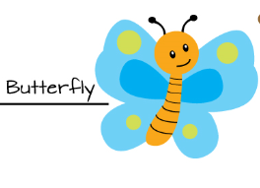 | Practitioner  Got it!  Meets the standard  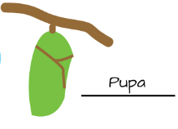 | Apprentice  Almost.  Has some understanding  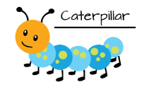 | Novice  Getting started.  No or little understanding  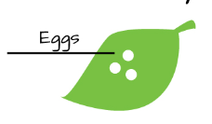
Questioning | I asked a question related to the topic that can be investigated and I know what data needs to be collected.  I predicted an outcome to a question and I based my prediction on my observations or prior experiences. | I asked a question related to the topic that can be investigated.  I predicted an outcome related to the question. | I asked a question related to the topic but it cannot be investigated.  I predicted an outcome but it was not related to the question. | I was unable to ask a question related to the topic.  I could not predict an outcome.
Investigating | I worked with my team to determine the steps in the experiment and used my science tools when following the steps in the experiment. | I used my science tools and followed all the steps in the experiment. | I followed most of the steps in the experiment.  I tried to use my science tools. | I mixed up my steps.  I did not use my science tools.
Recording and Interpreting Data | My data is complete, I recorded the data correctly in tables and graphs, and I was able to interpret my data when asked. | My data is complete and I recorded it in the correct tables and graphs. | My data is started but is not in right place on the tables or graphs. | I have no data.
Explaining | I recorded and shared my ideas, related them to what we have learned in class, and can suggest how these ideas can fit in to other science content. | I recorded and shared my ideas using science terms and relate it to what we have learned in class. | I started to record and share my ideas but I am not sure how it fits in to what we are learning. | I did not record or share my ideas.
Communicating | I am able to use science words when I communicate my observations and data using simple graphs, drawings, numbers, speech, and/or writing. | I am able to communicate my observations and data using simple graphs, drawings, numbers, speech, and/or writing. | I am able to communicate my observations or data using only one or two types of communication (simple graphs, drawings, numbers, speech, and/or writing). | I have a difficult time communicating my observations or data to others.

