VDOE Sample Science Performance Assessment

Topic: Stoichiometry
Course: Chemistry

Content Standards:

Science (2018)
CH.3 The student will investigate and understand that atoms are conserved in chemical reactions. Knowledge of chemical properties of the elements can be used to describe and predict chemical interactions. Key ideas include
- balanced chemical equations model rearrangement of atoms in chemical reactions;
- reaction types can be predicted and classified.

CH.4 The student will investigate and understand that molar relationships compare and predict chemical quantities. Key ideas include
- Avogadro’s principle is the basis for molar relationships; and
- stoichiometry mathematically describes quantities in chemical composition and in chemical reactions.

Connections to Mathematics
A.4 The student will solve
  - multistep linear equations in one variable algebraically;
- practical problems involving equations and systems of equations.

Connections to Profile of a Virginia Graduate
- Critical & Creative Thinking
- Communication
- Collaboration

Essential Science Skills and Processes:
CH.1 The student will demonstrate an understanding of scientific and engineering practices by
- planning and carrying out investigations
  - individually and collaboratively plan and conduct observational and experimental investigations
- plan and conduct investigations or test design solutions in a safe manner, including planning for response to emergency situations
- select and use appropriate tools and technology to collect, record, analyze, and evaluate data
- interpreting, analyzing and evaluating data
- record and present data in an organized format that communicates relationships and quantities in appropriate mathematical or algebraic forms
- solve problems using mathematical manipulations including the International System of Units (SI), scientific notation, derived units, significant digits, and dimensional analysis
- differentiate between accuracy and precision of measurements
- consider limitations of data analysis when analyzing and interpreting data
- obtaining, evaluating, and communicating information
- communicate scientific and/or technical information about phenomena and/or a design process in multiple formats

Performance Assessment:
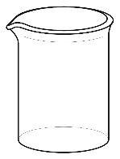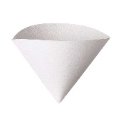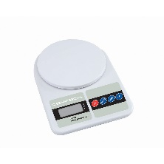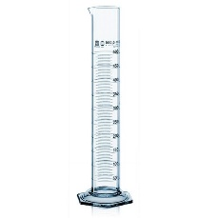
Beaker Funnel Filter Paper Scale Graduated Cylinder

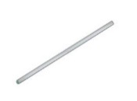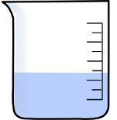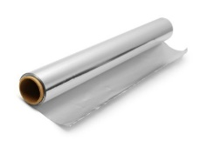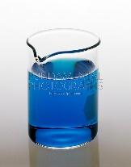
Stirring Rod H₂O Aluminum foil (Al) CuCl₂

An experiment is to be performed to produce 1.7g of copper using aluminum foil and copper (II) chloride as reactants. The equipment shown above is available for the experiment.
a) Write the balanced formula for the chemical reaction.
b) Briefly list the steps needed to carry out this experiment.
c) Determine how much aluminum foil is needed to produce 1.7g of Cu metal when reacted with excess copper (II) chloride solution. Show all work.
d) Indicate two sources of error that would lead to a percent yield being greater than 100%.

Common Rubric Categories:
- Asking Questions and Defining Problems
- Planning and Carrying Out Investigations
- Interpreting, Analyzing, and Evaluating Data
- Constructing and Critiquing Conclusions and Explanations
- Obtaining, Evaluating, and Communicating Information

Lesson Overview and Preparation:
Implementation
BEFORE:  Preparing students for the task  Resources needed for each group:  - student direction page  - experimental design pages  - 1.0 M CuCl₂  - Al foil  - Beaker  - Digital scale  - Filter  - Filter paper  - Graduated Cylinder  Safety:  Safety rules should be reinforced prior and during each laboratory experience.  Please refer to the Safety Data Sheet (SDS) for any chemicals used in chemical experiments. | Students should have background knowledge and be able to:  - Balance chemical reactions;  - Use stoichiometry to determine quantities of products or reactants in a chemical reaction; and  - Engage in multiple laboratory experiences (performance tasks) that reflects the practices and calculations needed to complete the performance task. The laboratory task may reflect different levels of inquiry based on the student efficacy in the laboratory setting.  - Materials are listed to reflect those needed to complete the experiment that informs the performance assessment. Students should engage in the actual experiment in groups prior to completing the individual written performance assessment.  ** Teachers may use common rubric section on “Planning and Carrying Out Investigations” to assess students as they engage in laboratory experiences.
DURING: | Students are to work individually when completing the performance assessment. The assessment may be used as a standalone assessment or as part of a unit or chapter assessment.
AFTER:  Reflecting with students after the task | Reflection questions to consider and discuss:  - What errors did the groups encounter in the experiment? How would these errors affect the percent yield in the experiment?  - If the student obtained 1.9g of Cu at the conclusion of the experiment, what was his percent yield?  - Could another metal be substituted for Al in the experiment?  - Why was aluminum foil chosen to be the limiting reagent?

Accessibility:
Accommodations/Modifications
- Provide students with step by step directions in the laboratory that mimic the steps in the performance assessment.
- Conduct calculations as a class prior to experimentation.
- Demonstrate laboratory procedures to class prior to lab experience.
- Use a simulation prior to experimentation to prepare students for laboratory experiences.
- Engage in laboratory simulation after the lab activity to review procedures and calculations with students.
- Give students strips of paper that indicate each step of procedures and have students place them in the appropriate order.
- Students complete second student assessment, which has been modified, to complete performance assessment.

Extensions:
- Give students the molarity of the copper solution and have them determine the volume needed to react as an alternative to using an excess quantity of the solution. Students will need prior instruction on the concept and calculations of molarity.

Stoichiometry Performance Assessment Name________________________

Beaker Funnel Filter Paper Scale Graduated Cylinder

Stirring Rod H₂O Aluminum foil (Al) CuCl₂

An experiment is to be performed to produce 1.7g of copper using aluminum foil and copper (II) chloride as reactants. The equipment shown above is available for the experiment.
a) Write the balanced formula for the chemical reaction.

b) Briefly list the steps needed to carry out this experiment.

c) Determine how much aluminum foil is needed to produce 1.7g of Cu metal when reacted with excess copper (II) chloride solution. Show all work.

d) Indicate two sources of error that would lead to a percent yield being greater than 100%.

Stoichiometry Performance Assessment Name________________________
Modified Version
Beaker Funnel Filter Paper Scale Graduated Cylinder

Stirring Rod H₂O Aluminum foil (Al) CuCl₂

An experiment is to be performed to produce 1.7g of copper using aluminum foil and copper (II) chloride as reactants. The equipment shown above is available for the experiment.
a) Balance the equation for the reaction below.
______Al + ____CuCl₂ _____AlCl₃ + _____ Cu
b) In the space provided, indicate the order of the procedures to complete the experiment.
_______ Rinse the copper precipitate with water.
_______ Use graduated cylinder to measure 100mL of CuCl_{2.}
_______ After the reaction occurs, pour the products into funnel and filter paper to filter out solid copper.
_______ Use the digital scale to determine mass of filter paper.
_______ Weigh aluminum using digital scale.
_______ Calculate the number of grams of aluminum needed to produce 1.7 grams of Cu.
_______ Use scale to determine the mass of the copper and the filter paper. Subtract mass of filter paper to find total mass of copper produced.
_______ Use stirring rod to stir aluminum and CuCl₂ until all of the aluminum reacts.
_______ Add aluminum to CuCl₂ solution.
_______ Dry copper overnight.
3. Indicate errors that would cause the final mass to be greater than expected.
_______ Used more than 100 mL of CuCl₂.
_______ Did not rinse Cu precipitate.
_______ Used less Al then the amount calculated.
_______ Product not dried completely.

