Using the Science 3rd Grade Performance Task Rubric
Genre: Laboratory Investigation
Asking Questions and Defining Problems
- Does the student ask a question that can be answered using data (empirical evidence) obtained using an investigation?
- Does a student support a prediction using scientific concepts?
- Is the student’s prediction related to the initial question?
Planning and Carrying Out Investigations
- Is the student able to follow procedures and use tools correctly when conducting an investigation?
- Can students (either individually or as a team) develop procedures that may be used to answer a scientific question?
  - In third grade, teachers should model how procedures are developed and scaffold activities that allow students the opportunity to take ownership in developing their own procedures. This scaffolding should occur so that by the end of fifth grade, students should be able to generate their own procedures to follow in an investigation.
  - Details such as tools used to collect data and any measurements needed to conduct the investigation should be included in student procedures.
Interpret, Analyze, and Evaluate Data
- Is the student able to record data accurately using a table?
- Is the student able to construct a graph that reflects the data collected in an experiment?
  - In third grade, students should be able to label the axes of the graph, graph the data points appropriately, and title the graph.
  - Sample graph:

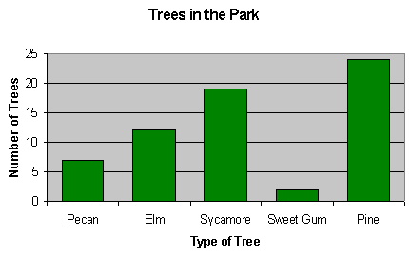

  - Students in third grade are expected to use bar graphs or pictographs. In fourth grade students begin to use line graphs to represent data.
  - By the end of fifth grade, students should be able to analyze patterns in data. Prior to fifth grade, teachers should help students to develop this skill and guide students in the recognition of any existing patterns in data.
- Given a completed graph, is a student able to interpret data, determine a trend in data, or make a conclusion about the data?
Construct and Critique Conclusions and Explanations
- Does the explanation provided by the student relate to the question posed at the beginning of the investigation?
- Does the student use evidence obtained in an investigation and scientific understanding to support an explanation or answer a question?
Develop and Use Models
- Is the student able to create a model (drawing, diagram, or physical representation) to explain a process or describe a system?
- Is the student able to explain the model he/she created orally or in writing?
- Does the student use related scientific terminology when labeling or explaining his/her model?
Obtain, Evaluate, and Communicate Information
- Is the student able to communicate clearly when constructing an explanation of an investigation or when describing a model?
- Does the student use appropriate science concepts and terminology in his communication?

