VDOE Sample Science Performance Assessment

Topic: Solutions
Course: Third Grade Science

Content Standards:

Science (2018)
3.3 The student will investigate and understand how materials interact with water. Key ideas include
- many solids dissolve more easily in hot water than in cold water.

Mathematics
3.10 The student will read temperature to the nearest degree.

3.15 The student will
- collect, organize, and represent data in pictographs or bar graphs; and
- read and interpret data represented in pictographs and bar graphs.

Computer Science
3.1 The student will construct sets of step-by-step instructions (algorithms), both independently and collaboratively
a) using sequencing;
c) using events.

English
3.8 The student will write in a variety of forms to include narrative, descriptive, opinion, and expository.
a) Engage in writing as a process.
f) Elaborate writing by including supporting details.

Connections to Profile of a Virginia Graduate
- Critical & Creative Thinking
- Communication
- Collaboration

Essential Science Skills and Processes:
3.1 The student will demonstrate an understanding of scientific and engineering practices by
- asking questions and defining problems
- ask questions that can be investigated and predict reasonable outcomes
- ask questions about what would happen if a variable is changed
- planning and carrying out investigations
- with guidance, plan and conduct investigations
- use appropriate methods and/or tools for collecting data
- measure length, mass, volume, and temperature in metric and U.S. Customary units using proper tools
- measure elapsed time
- interpreting, analyzing, and evaluating data
- organize and represent data in pictographs or bar graphs
- read, interpret, and analyze data represented in pictographs and bar graphs
- constructing and critiquing conclusions and explanations
- use evidence (measurements, observations, patterns) to construct or support an explanation
- obtaining, evaluating, and communicating information
- read and comprehend reading-level appropriate texts and/or other reliable media
- communicate scientific information, design ideas, and/or solutions with others

Performance Task:
Background: You and your friends decide to open a lemonade stand in order to raise money for a new swing set for your school playground. You think a large number of people will show up to buy your lemonade and you want to be able to make lemonade quickly. Your friend says that the temperature of the water does not matter when mixing lemonade; however, you want to determine if the temperature of the water can help the solid lemonade mix dissolve faster.
Challenge: Design and conduct an investigation that will test the ability of a lemonade mixture to dissolve in cold and warm water. You will need to prepare a written report explaining your investigation plan. You need to write in complete sentences and use scientific terms where appropriate.

Common Rubric Categories:
- Asking Questions and Defining Problems
- Planning and Carrying Out Investigations
- Interpreting, Analyzing, and Evaluating Data
- Constructing and Critiquing Conclusions and Explanations
- Obtaining, Evaluating, and Communicating Information

Lesson Overview and Preparation:

Safety and Preparation | Lesson Information
BEFORE:  Preparing students for the task  Resources needed:  - student direction page  - experimental design pages  - room temperature water  - ice water  - warm water  - cups  - lemonade mix (solid)  - stopwatch  - scale/scoop  - liquid measuring cup/beaker | Students should have background knowledge and be able to:  The performance assessment should be conducted in groups with each student filling in their own sheet. Before completing this task, the teacher should have modeled experimental design and students should have had opportunities for guided and independent practice in designing scientific investigations.  Students should be aware that not all substances mix with water. In order to align with the wording of the standard, the teacher should emphasize that some solids and liquids mix with water in different ways  Students need to know the following scientific terminology: question, prediction, procedure, observations, and conclusion.  Depending on student readiness, you might also consider teaching variable and constant although these terms are not required.  Pre-teaching suggestions:  - Distribute a task description to each student. Read the task description together.  - Have students read a book about solutions.  - Have students use what they have learned in class about how materials interact with water to predict how temperature effects the dissolving of a substance in water.
DURING:  Supporting students with the task  You may need to answer  questions students have about the prompt to ensure that each student understands what s/he is being tasked to do.  Anticipated timeline: 1-2 class periods (25 minutes each)  Laboratory Tips:  - Small pitchers should be placed at each table in order to reduce classroom traffic.  - Water can be heated by the teacher using an electric kettle/pot. Do not use boiling water. Water should only be hot to the touch but not boiling.  - Students should not use more lemonade mix than is recommended on the label.  - To measure the water (and make the lemonade), use a cup with markings, such as a beaker or a liquid measuring cup.  - To the measure the lemonade mix, use a balance or a scoop. | Questions to explore with students before experimentation (whole group):  - What happens to solids when they dissolve in water?  - Does the temperature of the water impact how fast a solid dissolves in water?  - What data can be collected to determine if the temperature of water affects how a solid dissolves in water?  - What are you going to change in your experiment?  - What are you going to keep the same in your experiment?  - What measurements will you take?  Teacher actions:  - Review the components of experimental design: question, prediction, procedures, observations (data).  - Review science safety rules.  - Display the available materials they can use for the experiment.  - Ask each group to generate their question and prediction.  - Ask each group to create procedures to test their prediction. Whole group scaffolding may be needed to facilitate the development of student-generated procedures.  - Upon teacher approval of the procedures, each group will use the materials indicated in their procedures to carry out the investigation.  - Students will collect data and record their data on the student sheet  - Teacher will facilitate a group discussion of data.
AFTER:  Reflecting with students after the task | Reflection questions to consider and discuss:  Students revisit the essential questions:  - Why is it important that materials interact with water? (bigger understanding)  - How does temperature affect the way that some solids dissolve in water?  - What other solids would we like to test to see if they behave the same way?

Accessibility:
Accommodations/Modifications
- Give students strips of paper that indicate each step of the procedures and have students place them in the appropriate order. Teacher checks order before student glues them on the paper.
- Give students sentence stems to help complete their student sheet.
- Have students complete second set of student sheets, which has been modified, to design investigation. An additional modification would include using pictures that match the equipment available in your classroom.

Extensions:
- Students create a Plus-Minus-Interesting chart for the different water temperatures mixtures and results.
- Students investigate how other materials interact with water.

Lemonade Investigation

Background:
You and your friends decide to open a lemonade stand in order to raise money for a new swing set for your school playground. You think a large number of people will show up to buy your lemonade and you want to be able to make lemonade quickly. Your friend says that the temperature of the water does not matter when mixing lemonade; however, you want to determine if the temperature of the water can help the solid lemonade mix dissolve faster.

Challenge:

Design and conduct an investigation that will test the ability of a lemonade mixture to dissolve in cold and warm water. You need to write in complete sentences and use scientific terms where appropriate.

Lemonade Investigation

What question are you trying to answer?
____________________________________________________________________________________________________________
What do you think will happen?
If lemonade mix is put in __________water then the lemonade mix
will dissolve________________ than in ________ water.

What steps will you take to complete your experiment?
You may add more numbers, and you may include a labeled sketch/diagram of your set-up.
1
2
3
4
5

Diagram or sketch your experiment

My Data
Observations:_______________________________________________________________________________________________________________________________________________________Data Table:
Temperature of Water | Time to Dissolve Lemonade
What does the data show about lemonade mix dissolving in different temperatures of water?
______________________________________________________________________________________________________________________________________________________________________________________________________________________________________________________________________________

What temperature would you recommend that your team use when making large amounts of lemonade? Support your recommendation with evidence from your investigation.
______________________________________________________________________________________________________________________________________________________________________________________________________________________________________________________________________________

Lemonade Investigation (modified)
Which temperature of water will cause the lemonade to dissolve faster? Circle the temperature you think would be best.
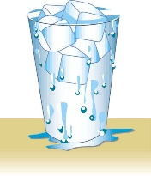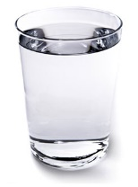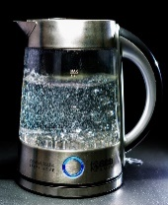
Cold Warm Hot
What do you think will happen? If lemonade mix is put in __________water then the lemonade mix will dissolve ________________ than in ________ water.
Planning the investigation:
What will you measure? __________________________________________________________________________________________________________________________________________________________________What tools will you use?
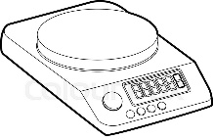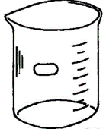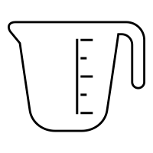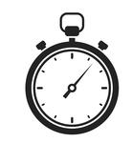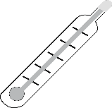
What steps will you take to complete your experiment?
You may include a labeled sketch/diagram of your set-up below.

1
2
3
4
5

Diagram or sketch your experiment

My Data
Observations:_________________________________________________________________________________________________________________________________________________________________________________________________________
Data Table:
Temperature of Water | Time to Dissolve Lemonade

What does the data show about how the temperature of the water affects how lemonade mix dissolves?
____________________________________________________________________________________________________________________________________________________________________________________________________________________

What temperature would you recommend that your team use when making large amounts of lemonade? Support your recommendation with evidence from your investigation.
_________________________________________________________________________________________________________________________________________________________________________________________________________________________________________________________________________

