Keep it Cool

Question:
Which type of container keep water the coldest?

Background:
You are planning to spend the day at the park with your friends. Since it is a hot day, you want to serve drinks that will stay cool. You have three types of containers you can bring. You have paper cups, Styrofoam cups, and metal cans. You are not sure which one to choose, so you decide to test which type of container will keep liquid the coldest for 15 minutes.

Materials:
- 3 thermometers
- 1 measuring cup
- 1 metal can
- 1 Styrofoam cup
- 1 paper cup
- 1 container of ice water
- 1 strainer or funnel
- 1 clock

Prediction:
Which container do you think will keep the water coldest for fifteen minutes?
I think
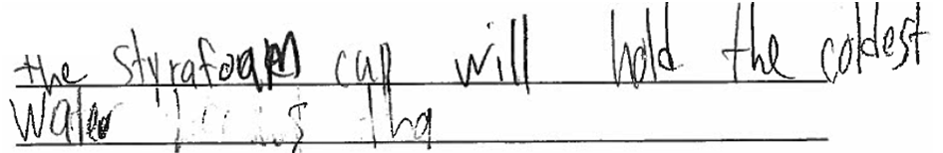

because
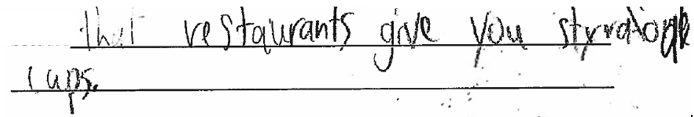

Procedure:
- Set out the three types of containers and put a thermometer in each one.
- Using the measuring cup, put equal amounts of ice water in each container. This amount should be enough to fill each container at least three-quarter full.
- In the data table below, record the temperature of the water in each container after 30 seconds.
- After 15 minutes have passed, record the temperature of the water in each container.
- Subtract the beginning temperature from the temperature that was taken after 15 minutes. Record the difference. This is the amount that the temperature changed.

Data Table:
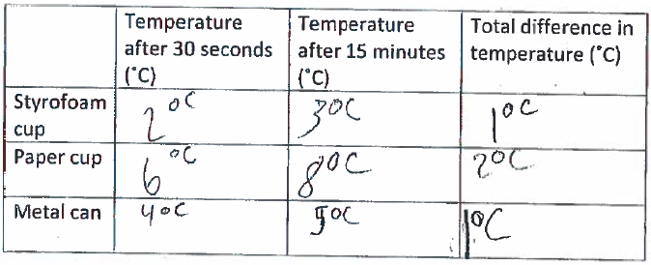

Data Analysis:
- Use the data from your data table to create a bar graph of the change in temperature for each container. Label and title your graph.

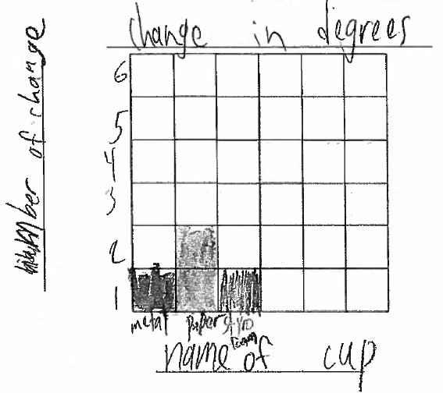

Questions:
- Describe what happened to the water temperature in all three containers. Did the temperature change? If so, describe the change.
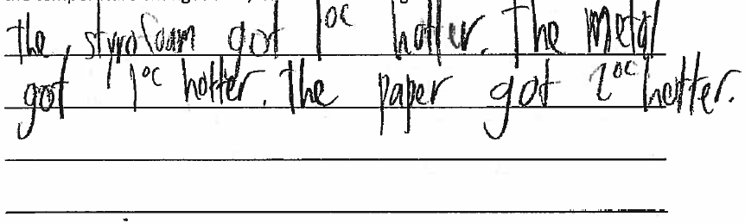

- Which container was best at keeping the water cold? Use your data (table and graph) to explain your answer. 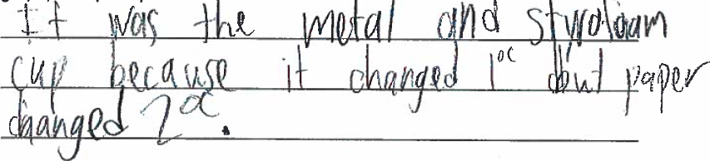

- Was your prediction correct? Use data from your investigation to explain why your prediction wasd correct or incorrect.
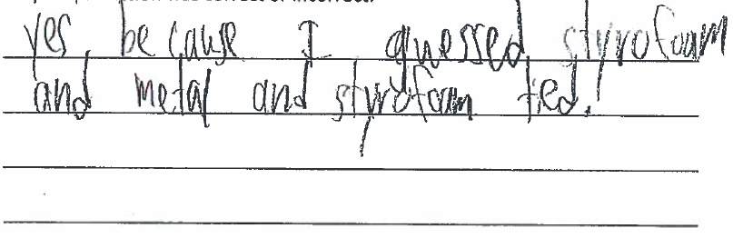
- Suppose you are going on a picnic and will be serving soft drinks in cups. What kind of cup would you use to keep the drinks cold? Explain why you would choose that kind of cup. 