Virginia Department of Education
Explanation of Testing Accommodations for Students with Disabilities
Math Aids – Accommodation Code 19
Revised January 27, 2020

Accommodations provided to students with disabilities as part of the instructional and assessment process should allow equal opportunity to access the assessments in the Virginia Assessment Program. Accommodations based solely on the potential to enhance performance beyond providing equal access are not allowed.
Accommodations used on the state assessments must be documented in the student’s Individualized Education Program (IEP) or 504 Plan and used in daily instruction. Using new or unfamiliar accommodations on a state assessment is inappropriate. The IEP team or 504 committee should consider the need for each student to use each accommodation separately.
This document contains examples of math aids which are either allowed or not allowed for use by a student with a disability participating in the Virginia Assessment Program. The allowed items pictured in this document are examples of acceptable math aids that may provide some students with disabilities equal access to a state mathematics test.
A math aid does not have to be identical in appearance to the pictured example in order to be used as an accommodation. The math aid should be identical in concept and purpose to the approved math aid included in this document, but the specific attributes of a math aid may vary. For example, the number of rows of beads on an abacus or other counting tool may differ and the number of factors or fractions represented on a multiplication chart or a fraction chart may extend beyond the pictured examples.
Math aids may be laminated. If a student will write on a laminated math aid, the Additional Markers, Highlighters, Colored Pens, and/or Pencils accommodation must be documented in the IEP or 504 Plan.
Note: Math aids may not be held up to the screen of the testing device.
Examples of allowed math aids that may provide equal access to mathematics assessments for some students with disabilities | Explanation of the allowed math aid accommodations
Arithmetic Tools  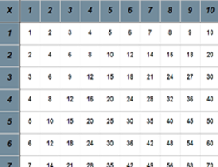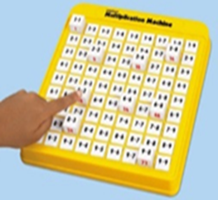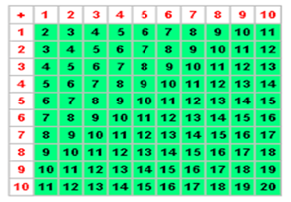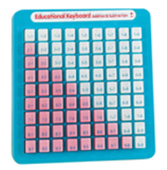 | Arithmetic Tools are defined as arithmetic tables/charts, or machines, which serve the same, function as a four-function calculator. The range of addition, subtraction, multiplication or division factors represented on an arithmetic table/chart, or machine may vary.  The Calculator Accommodation Criteria Form, effective beginning in 2017-2018, must be used to find a student eligible to use a calculator, arithmetic charts/table(s), and/or machine(s).
Hundreds Chart  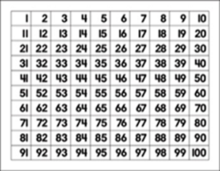 | A hundreds chart math aid must be limited to 100. Students may not use expanded charts, which include numbers beyond 100.
Number Lines  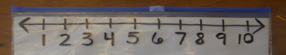  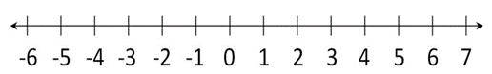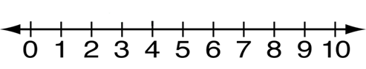 | The number line should be a graduated straight line with arrowheads on both ends of the line to indicate that real numbers continue indefinitely in the positive and negative directions. There may be multiple number lines on a single page. A number line may be blank or printed with whole numbers.  A number line may have a slider to mark the student’s place on the number line.
Counting Strips  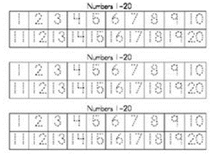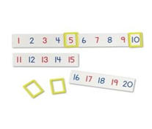 | A student may use a single counting strip of whole numbers or multiple counting strips may be printed on a page.
Number Alignment Aids  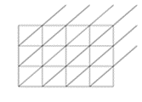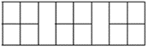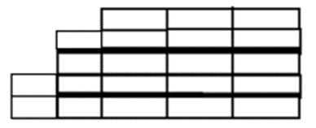 | Number alignment aids may only be used to assist students in correctly lining up numbers when writing a math problem. Number alignment aids may not contain text, mathematical signs, shaded or colored areas.
Graph Paper  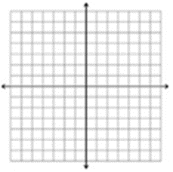 | Graph paper with or without a coordinate plane may be used.
Fraction Circles and Bars  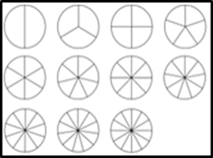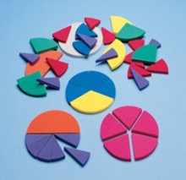  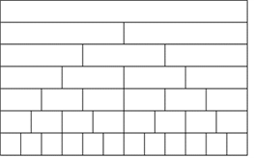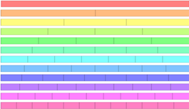 | Fraction circles must be blank without text. Each piece of a fraction circle must be one solid color. Fraction circles may be cut apart or on a whole page.  Fraction bars must be blank without text. Each piece of a fraction bar must be one solid color. Fraction bars may be cut apart or on a whole page.
Cuisenaire Rods  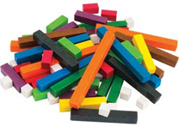 | Cuisenaire rods are blank three-dimensional manipulatives of varying lengths and colors, which may be used for counting and calculation.
Representation Units  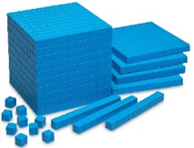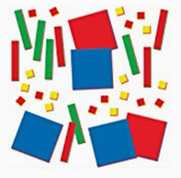 | Representation units are manipulatives composed of various sized units used for counting or calculating.  Base 10 blocks provide a visual presentation of base 10 and must be blank other than the scoring used to indicate the various units.  Algebra Tiles offer a visual presentation of variables and constants. Algebra Tiles must be blank and no accompanying materials may be provided.
Counting Tools  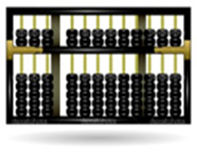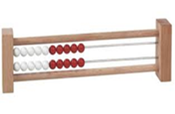  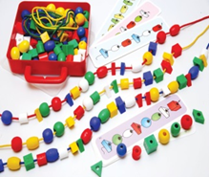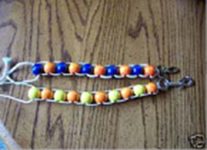 | Abacus, Golf Beads, and Rekenrek math aids are examples of manual aids for counting or calculating that consist of beads or disks that can be moved up or down on a string or stick.
Colored Shapes  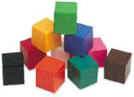 | Colored shapes are blank and may be two- or three-dimensional.
Blank Clocks  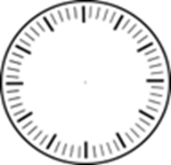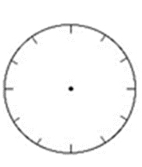 | Blank clock math aids may have tick marks but may not have hands or numbers.
Money  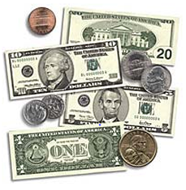 | A student may use coins and bills as a manipulative for calculating money amounts. Play money that does not resemble US currency may not be used.

Place Value Chart  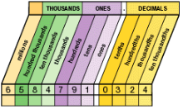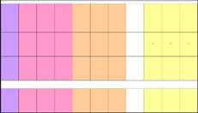 | Fraction Chart  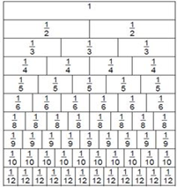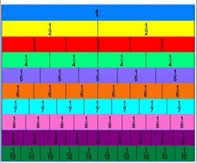
Table of Measures  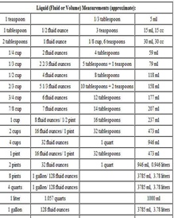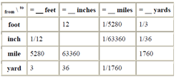 | Measurement Conversion Charts  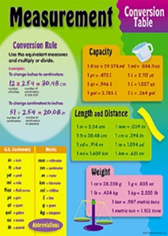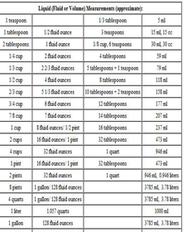
Temperature Conversion Charts  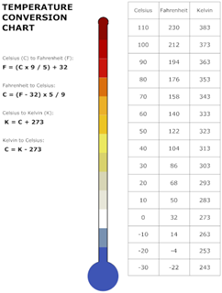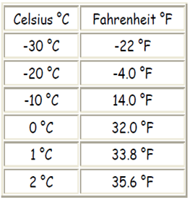 | Rounding Charts  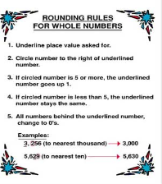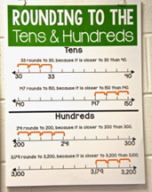  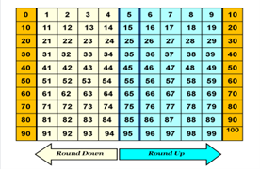

Money Equivalency Charts  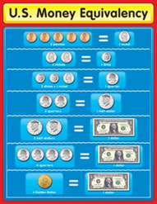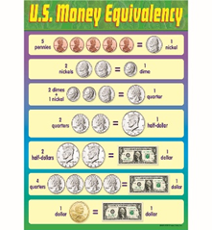 | Vocabulary Charts  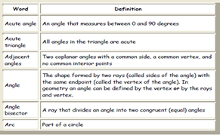  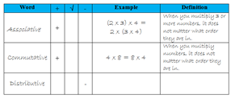
Time Conversion or Equivalency Charts  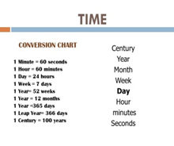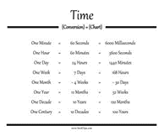 | Charts of formulas and/or symbols  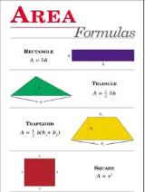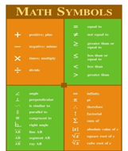
Shape Charts  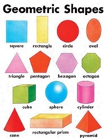 | Tally Mark Chart  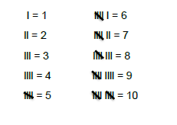

Problem Solving Charts ( Key Words)  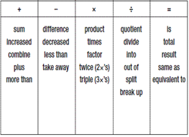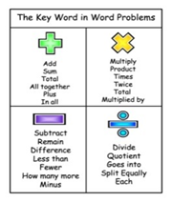 | Problem Solving Charts  (Steps to Solve a Mathematics Problem)  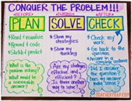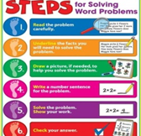
Elapsed Time Ruler  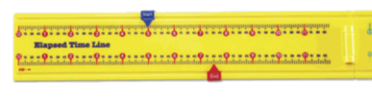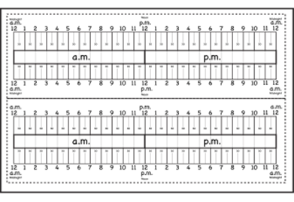 | Multi-Layer Rulers  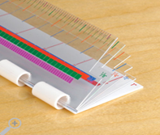  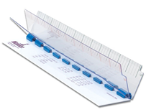
Clocks  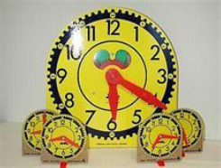 | Gallon Man  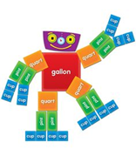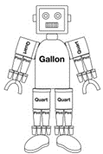
Scissors  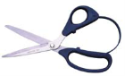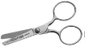 | Set of Weights  