WIDA Secure Portal Accounts for VIRGINIA Educators

How do I access the WIDA Secure Portal?
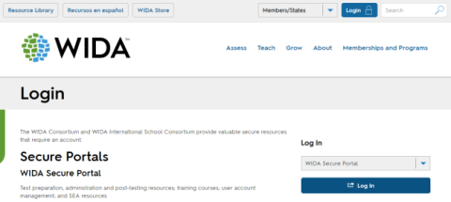
I need to create an account (1st time user) | I already have an account. I am having password trouble.
Contact your Title III Coordinator. Unsure of who that is? Consult Virginia’s Title III Coordinator List, which is updated periodically. If that contact information does not work, email the English Learner Instruction Specialist at the Virginia Department of Education.  Be sure to use your work email to sign up. | Go to WIDA’s password reset page. Requested a password reset, but still having trouble logging in? Contact the WIDA Client Services Center at help@wida.us or (866) 2767735 for WIDA Secure Portal account support.

What can I access on the WIDA Secure Portal?

Self-Paced eWorkshops (Additions made annually)
- Complete the eWorkshops individually or expand your learning with your local professional learning community
- Take advantage of interactive and engaging learning
- Enjoy relevant, practical content that you can put into action immediately!
- Includes a variety of topics: Doing and Talking STEM, Engaging Newcomers, Leading for Equity, and more

Professional Learning Modules
Interactive Modules:
Engaging ELLs: Teaching to Student Strengths
Video: What does it mean to be an English Learner?

Recorded Webinars:
Academic Language of Math
Score Reports Overview

Resources for Teaching and Learning
- Lesson Videos
- Can Do Philosophy
- Essential Actions Handbook
- Creating a Welcoming Classroom Ideas
- Family Engagement Information and Ideas
- Principles of Language Development
- Response to Instruction and Intervention Handbook (RTI²)
- Focus Bulletins on Scaffolding, Using Technology, Dually Identified ELs, SLIFE students, Writing, STEM, and more!
- Research reports on STEM, Long Term ELs, American Indian Education, Implementing WIDA ELD Standards and more!

