Sample Breakfast Menus and Recipes
In order to promote nutritious breakfast practices across Virginia, the VDOE-SNP created the Breakfast Club, a group of stakeholders charged with advocating and promoting healthier breakfast menus and foods. This sample menu provides ideas from programs across Virginia that emphasize the Club’s best practices for serving nutrient-dense breakfasts. This menu may be used by new and seasoned directors alike for breakfast ideas. A select number of featured recipes are also included. Use the USDA School Breakfast Program meal pattern to ensure compliance with federal regulations.

VDOE-SNP Breakfast Club
Collaboration from the Club provides guidance and resources for Virginia school divisions to offer nutrient-dense, quality breakfasts. To learn more about the quarterly Breakfast Club meetings or to highlight a smart breakfast choice in your school, please contact Laura Burns, VDOE-SNP Wellness Policy Specialist, via email at Laura.Burns@doe.virginia.gov.
Last updated on 08/04/2021

Table of Contents
USDA School Breakfast Program Meal Pattern 3
Grab and Go Breakfast Menu – Week 1 5
Grab and Go Breakfast Menu – Week 2 6
Recipe: Peaches and Cream Overnight Oats 7
Recipe: Egg and Cheese Burrito 8
Recipe: Egg and Avocado Toast 9
Recipe: Chicken Sausage and Cheese Croissant 11
Recipe: Blueberry Breakfast Parfait 12

USDA School Breakfast Program Meal Pattern
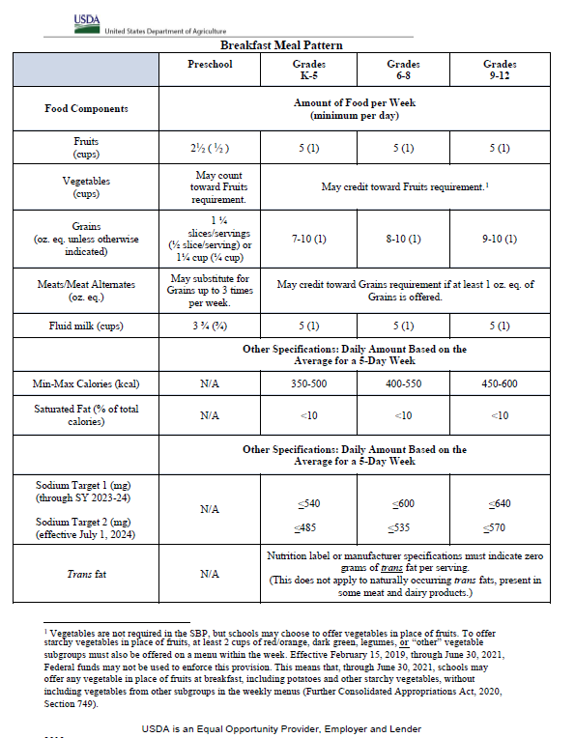

Grab and Go Breakfast Menu – Week 1
Monday | Tuesday | Wednesday | Thursday | Friday
Entrée 1:  - Hard-boiled egg pops (Arlington City Public Schools. Recipe from the American Egg Board Association)  Entrée 2:  - Blueberry parfait (Waynesboro City Public Schools)  Fruit:  - Sliced strawberries*  - Blueberries*  Vegetable:  - Sweet potato hash*  Milk:  - Skim milk  - 1% milk | Entrée 1:  - Blueberry yogurt smoothie with granola (Newport News City Public Schools)  Entrée 2:  - Breakfast chicken on a whole grain biscuit (Richmond City Public Schools)  Fruit:  - Sliced Virginia apple*  - Sliced cantaloupe*  Milk:  - Skim milk  - 1% milk | Entrée 1:  - Scrambled egg and cheese on a whole grain croissant (Danville City Public Schools)  Entrée 2:  - Whole grain bagel with cream cheese and sliced tomatoes* (Cumberland County Public Schools)  Fruit:  - Sliced peaches*  - Blackberries*  Milk:  - Skim milk  - 1% milk | Entrée 1:  - Peaches and cream overnight oats (Chesterfield County Public Schools)  Entrée 2:  - Fun fruit breakfast pizza (Child Nutrition Recipe Box)  Fruit:  - Asian pear*  - Sliced strawberries*  Milk:  - Skim milk  - 1% milk | Entrée 1:  - Egg and cheese breakfast burrito (Middlesex County Public Schools)  Entrée 2:  - Sunflower seeds with a whole grain muffin (Harrisonburg City Public Schools)  Fruit:  - Sliced cantaloupe*  - Watermelon cubes*  Vegetable:  - Red pepper strips*  Milk:  - Skim milk  - 1% milk
*Indicates a food item that may be produced in Virginia

Grab and Go Breakfast Menu – Week 2
Monday | Tuesday | Wednesday | Thursday | Friday
Entrée 1:  - Breakfast wrap (Virginia Department of Justice)  Entrée 2:  - Turkey sausage, boiled egg, & toast (Virginia School for the Deaf and Blind)  Fruit:  - Blueberries*  - Sliced cantaloupe*  Vegetable:  - Red pepper strips*  Milk:  - Skim milk  - 1% milk | Entrée 1:  - Chicken sausage and cheese croissant (Henrico County Public Schools)  Entrée 2:  - Breakfast basket (National Dairy Council)  Fruit:  - Watermelon cubes*  - Asian pear*  Milk:  - Skim milk  - 1% milk | Entrée 1:  - Fruit & yogurt parfait with granola (Powhatan County Public Schools)  Entrée 2:  - Bacon & egg biscuit (Pulaski County Public Schools)  Fruit:  - Sliced peaches*  - Sliced strawberries*  Vegetable:  - Sweet potato hash*  Milk:  - Skim milk  - 1% milk | Entrée 1:  - Cheddar omelet with hash browns (Salem City Public Schools)  Entrée 2:  - Banana and nut butter breakfast sushi (Humane Society)  Fruit:  - Sliced cantaloupe*  - Sliced Virginia apple*  Milk:  - Skim milk  - 1% milk | Entrée 1:  - Egg and avocado toast (Staunton City Public Schools)  Entrée 2:  - Choice of low-sugar cereals with seasonal fruit (PHILLIPS School)  Fruit:  - Blackberries*  - Sliced strawberries*  Milk:  - Skim milk  - 1% milk
*Indicates a food item that may be produced in Virginia

Sample Recipes from Virginia Schools

Recipe: Peaches and Cream Overnight Oats
Source: Chesterfield County Public Schools
Group: Breakfast
Number of Portions: 1
Size of Portion: 1 each
Serving tool: 10 oz. spoodle
Meal Component Contribution: 1 oz. equiv. whole grain, 1 oz. equiv. meat/meat alternate, ½ cup fruit
HACCP Process: Process #1 – No cook
Ingredient | Quantity | Directions
Yogurt, vanilla, low fat | 4 oz. | Wash your hands. Put on disposable gloves.
Oats, rolled, whole grain, quick cooking | ¼ cup | In a large bowl, combine dry oats, yogurt, and milk.
Milk, 1%, white | 1 oz. | Intentionally left blank
Peaches, diced and drained | ½ cup | Stir in drained, diced peaches.
Intentionally left blank | Intentionally left blank | Measure 10 oz. with a spoodle into a 12 oz. parfait cup. Place lids on cups and refrigerate overnight.  - CCP: Hold at 41℉ or below.
Notes:
When available, fresh, local peaches may be used in place of canned peaches. Substitute ½ cup of ripe peaches for ½ cup of canned peaches. ½ cup of any seasonal fruit may be used in place of ½ cup of peaches.
HACCP Standard Operating Procedure – Use hand washing procedures before starting recipe.
HACCP Standard Operating Procedure – Wash all produce before starting this recipe.

Recipe: Egg and Cheese Burrito
Source: Middlesex County Public Schools
Group: Breakfast
Number of Portions: 25
Size of Portion: 1 wrap
Meal Component Contribution: 1 oz. equiv. whole grain, 3 oz. equiv. meat/meat alternate
HACCP Process: Process #2 – Same Day Service
Ingredient | Quantity | Directions
Egg Patty | 1 each (1 oz.) | - Wash your hands. Put on disposable gloves.
Intentionally left blank | Intentionally left blank | - Heat egg patty in 350℉ oven to internal temp of 165℉  - CCP: Cook to 165℉
Flour tortilla, whole grain, 6 inch | 1 each (1.1 oz.) | - Place two cooked egg patties in tortilla.
Cheese, American yellow, slice | 1 slice (½ oz.) | - Top egg patty with one slice of cheese.
Intentionally left blank | Intentionally left blank | - Fold tortilla into wrap.
Intentionally left blank | Intentionally left blank | - Wrap in foil sheet.  - CCP: Hold at minimum of 155℉
Notes:
Diced red pepper may be added to the burrito for additional flavor and texture.
HACCP Standard Operating Procedure – Use hand washing procedures before starting recipe.
HACCP Standard Operating Procedure – Wash all produce before starting this recipe.

Recipe: Egg and Avocado Toast
Source: Staunton City Public Schools
Group: Breakfast
Number of Portions: 12
Size of Portion: 1 sandwich
Meal Component Contribution: 2 oz. equiv. whole grain, 3 oz. equiv. meat/meat alternate, ¼ cup vegetable (vegetable category: other)
HACCP Process: Process #2 – Same Day Service
Ingredient | Quantity | Directions
Intentionally left blank | Intentionally left blank | - Wash your hands. Put on disposable gloves.
Intentionally left blank | Intentionally left blank | - Preheat the oven to 350°F.
English muffin, whole grain | 12 each | - Line a baking sheet with parchment paper, lay opened faced each English muffin onto lined sheet.
Olive oil | 6 Tbsp. | - Evenly spread ½ tsp. of olive oil on each muffin half.
Intentionally left blank | Intentionally left blank | - Slow-toast the English muffins on the middle rack of the oven for 10 minutes, turning over at 5 minutes.
Avocado, whole, large, ripe | 3 each | - Cut the avocado in half. Using a chef’s knife, slice through the avocado lengthwise until you feel the pit. Separate avocado into two even halves. Remove the pit. Slice 6 even lengthwise cuts through avocado, being careful not to cut through the peel. Scoop out the slices with a tablespoon.
Boiled egg, cooked, medium | 12 each | - Slice each boiled egg in 4 even coin shapes.
Intentionally left blank | Intentionally left blank | - Remove the toasted muffins from the oven. Add 4 egg slices and 3-4 slices of avocado on each muffin.
Intentionally left blank | Intentionally left blank | - Serve in a grab and go service container.  - CCP: Hold for cold service at 41°F or below.

Notes:
HACCP Standard Operating Procedure – Use hand washing procedures before starting recipe.
HACCP Standard Operating Procedure – Wash all produce before starting this recipe.

Recipe: Chicken Sausage and Cheese Croissant
Source: Henrico County Public Schools
Group: Breakfast
Number of Portions: 100
Size of Portion: 1 sandwich
Meal Component Contribution: 1 oz. equiv. whole grain, 1.5 oz. equiv. meat/meat alternate
HACCP Process: Process #2 – Same Day Service
Ingredient | Quantity | Directions
Intentionally left blank | Intentionally left blank | - Wash your hands. Put on disposable gloves.
Chicken sausage patty, cooked, thawed | 100 each | - Preheat oven to 325°F. Spray a sheet pan with non-stick spray. Place sausage patties in a single layer on sheet pan.
Intentionally left blank | Intentionally left blank | - Cook sausage patties in 325°F oven for approximately 7-9 minutes if thawed. (If sausage patties are frozen, cook for 9-11 minutes)  - CCP: Heat sausage patties to 165°F or higher for at least 15 seconds.
Croissant, whole grain | 100 each | - Slice each croissant in half.
Cheese, American, slice | 100 slices | - Assemble 1 sausage patty and 1 slice of cheese inside the sliced croissant. Serve warm.  - CCP: Hold for hot service at 140°F or higher.
Notes:
HACCP Standard Operating Procedure – Use hand washing procedures before starting recipe.
HACCP Standard Operating Procedure – Wash all produce before starting this recipe.

Recipe: Blueberry Breakfast Parfait
Source: Waynesboro City Public Schools
Group: Breakfast
Number of Portions: 1
Size of Portion: 1 Parfait
Meal Component Contribution: 1.75 oz. equiv. whole grain, 1 oz. equiv. meat/meat alternate, 1 cup fruit
HACCP Process: Process #1 – No cook
Ingredient | Quantity | Directions
Intentionally left blank | Intentionally left blank | - Wash your hands. Put on disposable gloves.
Yogurt, vanilla, low-fat | 4 oz. | - In a 9 oz. parfait cup, layer ingredients in the following order:  - 2 oz. yogurt  - ½ cup blueberries  - 2 oz. yogurt
Granola | ½ cup | - Pour ½ cup of granola in parfait cup lid insert.
Blueberries, fresh or frozen | ½ cup | - Seal lid and hold in a cooler at 41°F or below for service.  - CCP: Hold for cold service at 41°F or below.
Notes:
½ cup of seasonal fruit may be used in place of ½ cup of blueberries.
HACCP Standard Operating Procedure – Use hand washing procedures before starting recipe.
HACCP Standard Operating Procedure – Wash all produce before starting this recipe.

