2022 Virginia School Survey of Climate and Working Conditions
Read-aloud Administration Manual

Thank you for assisting in the administration of the 2022 Virginia School Survey of Climate and Working Conditions (2022 Virginia School Survey) to your students. This survey gives schools information that can help maintain a safe, inviting, and supportive learning environment.
The administration of the survey is important to engaging students and obtaining valid results. Please communicate to students that this survey is an effort to include their views and opinions to improve their school.
The purpose of this document is to provide you with the tools you need to conduct a read-aloud administration of the 2022 Virginia School Survey. Below are a series of questions and answers that can help you to prepare to administer the survey to any students requiring this accommodation. Following this section is the read-aloud protocol that you should use to administer the survey.
Questions or concerns regarding the Virginia School Survey of Climate and Working Conditions should be directed to Dr. Nikki Wilcox at nikki.wilcox@dcjs.virginia.gov (804) 786-3923. You may also contact Jess Marcon Zabecki at jessica.marconzabecki@doe.virginia.gov or (804) 225-2963.

Administration Questions and Answers
What is the procedure for students to complete the survey? The survey should be administered in a quiet space where students can be monitored – remotely or in person.
In-person: The survey should be administered in a quiet space where students can be monitored and have access to an individual computer or device. The staff member administering the survey should encourage students to complete the survey to the best of their ability and inform students that they should not discuss or talk with one another while taking the survey. The staff member should inform the students the survey takes 25-30 minutes to complete.
Remotely: Students taking the survey remotely are encouraged to find a quiet space where they can complete the survey free from distractions and have access to an individual computer or device. The staff member administering the survey should encourage students to complete the survey to the best of their ability and inform students that they should not discuss or talk with one another while taking the survey. The staff member should inform the students the survey takes 25-30 minutes to complete.
How do I prepare for and administer the survey? We recommend that you prepare the information that students need ahead of time, including the survey link, the school’s access code, and the school and division information.
Your school’s survey link and access code will be emailed to the school point-of-contact one week prior to the survey window opening. Students must enter this access code to complete the survey. All students in your school will use the same access code. Students will be asked to confirm the name of their school and division, to verify their responses are collected correctly.
Be sure to review the following instructions with all students. These instructions also appear on the welcome page of the survey.
What kind of help can I give to students in taking the survey? You are free to help students who do not understand survey instructions or who need clarification of a term or phrase used in the survey. Encourage students to express their own views and to answer all of the questions. If students attempt to skip a question, the survey will not permit them to continue to the next page. They will remain on the same page until they have answered each question, students should be instructed to answer to their best ability.
Is the survey the same for all students? Almost all of the questions are the same for all students in the same grade. In a few cases, a student who answers one question in a certain way will be asked a follow-up question that will not be asked if a student gives a different answer.
What if students ask about the race and ethnicity questions? Following standard practice, there is a question asking students whether they are of Hispanic or Latino ethnic background (Hispanic and Latino are intended to be interchangeable terms). Some students are unfamiliar with this distinction, and may be concerned that there is a separate question about being Hispanic. It is appropriate to explain to students that these questions are following federal guidelines to recognize that people of different races can be Hispanic. Subsequently, they will be asked a question that allows them to report their race.
What if students ask about the gender question? The question that asks students to report their gender provides students with more flexibility in their response to this question. Encourage the students to select the option that best describes their gender.

Read-Aloud Protocol
Below is the read-aloud protocol. The text in bold is the narrative you should read aloud as students begin the survey. The text in italics provide instructions to the reader and those should not be read aloud to the students. The narrative corresponds to the survey text from the 2022 Virginia School Survey.

SAY: This survey is being given to Virginia public school students in grades 9-12. The survey asks how you feel about your school and how students get along with one another and their teachers. We want to know your opinion in order to learn ways to improve your school.
Your individual answers to the survey are anonymous, which means that no one will know how you answered them. Student answers will be summarized in a report to the school that does not include anyone's name.
There are several screens of questions and it should take about 25-30 minutes to complete the survey.
Use the Next and Previous buttons at the bottom of the screen to go to the next or previous page.
Be careful! Do not use the back button of your browser to go back to the previous page. If you use the browser button, your results may be lost and you will need to start the survey again.
Please proceed to the link provided.
Students should see the following screen.
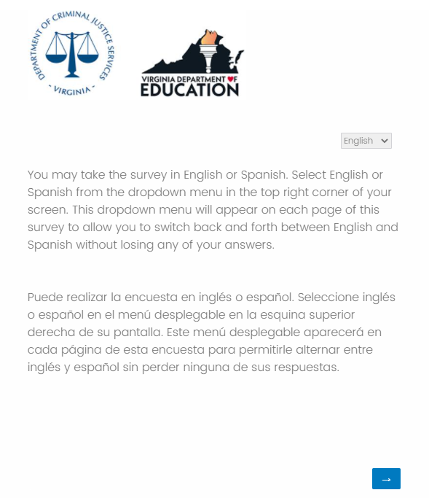
SAY: You may take the survey in English or Spanish. Select English or Spanish from the dropdown menu in the top right coroner of your screen. This dropdown menu will appear on each page of this survey to allow you to switch back and forth between English and Spanish without losing any of your answers. (Pause) Now select the blue arrow in the bottom right corner. Take a moment to read the information on the screen as I read it to you.
Below, please enter your Access Code for taking this survey. Your teacher should have this number for you. Many students will have the same number, so you will not be identified by this number.
Students should see the following screen.
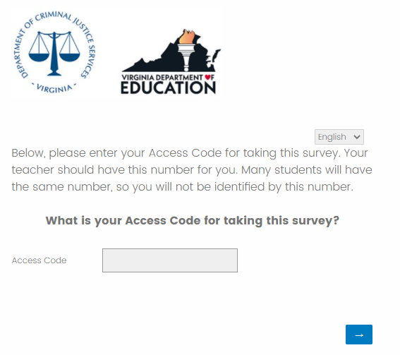
SAY: The access code is _ _ _ _ _S then select the blue forward arrow.
Please write the access code given to you somewhere the students can easily see it. Students should see the following screen.
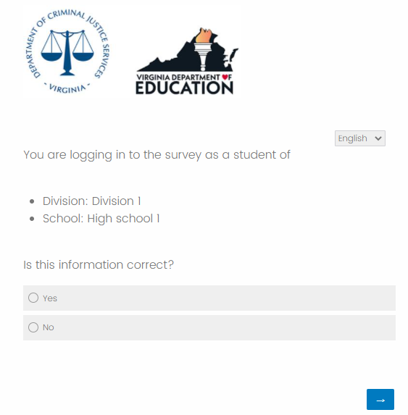
SAY: You should see our division and school name. If the division and school name are not correct please raise your hand. (pause) If this information is correct please select ‘Yes’ and then the forward arrow.
If the division and/or school name are not correct have the student select ‘No,’ and assist them with selecting the correct information.

SAY: I will read each question aloud to you. Based on some of your answers you may or may not see every question. If you do not see the question I am reading, sit quietly until the rest of the class catches up. We will now begin the survey, remember to answer each question to the best of your ability.

SAY: First question. What grade are you in this year? Mark one. 9th, 10th, 11th, or 12th grade.
(Pause)

SAY: Next question. How many years (including this year) have you been a student at this school? Mark one.
This is my first year at this school.
This is my second year at this school.
This is my third year at this school.
This is my fourth (or more) year at this school.
(Pause)

SAY: Next question. How have you attended classes this school year? Mark one.
I have only attended classes remotely (e.g., at home).
I have attended classes in-person and remotely (e.g., at home).
I have only attended classes in-person.
(Pause)

SAY: Next question. How strongly do you agree or disagree with the following statements? Mark one response per line.
 | Strongly Disagree | Disagree | Slightly Disagree | Slightly Agree | Agree | Strongly Agree
I like this school.
I am proud to be a student at this school.
I feel like I belong at this school.
I want to learn as much as I can at school.
I feel interested when I am in class.
I regularly attend school-sponsored events, such as school dances, sporting events, student performance, or other school activities.
I regularly participate in extracurricular activities, such as school clubs or organizations, musical groups, sports teams, student government, or any other extracurricular activities.
(Pause)

SAY: Next question. Please indicate if and why you have a difficult time participating in academic or extracurricular activities. Mark all that apply.
I do not have a difficult time participating.
The activities I am interested in were not offered this year because of COVID-19.
I chose not to participate because of COVID-19.
I chose not to participate because I worry that I will be not fit in or will not be welcomed.
(Pause)

SAY: Next question. What makes you feel that you will not fit in or will not be welcomed? (Asked only if answered “I chose not to participate because I worry that I will not fit in or will not be welcomed”)
My race or ethnicity
My academic abilities
My physical appearance
My having too little or too much money
My gender or gender identity
My sexual orientation
My disability
Another reason.
If you selected ‘another reason,’ type your reason in the box.
(Pause)

SAY: Next question. How strongly do you agree or disagree with the following statements? Mark one response per line.
 | Strongly Disagree | Disagree | Slightly Disagree | Slightly Agree | Agree | Strongly Agree
I get along well with other students at this school.
I care about other students at this school.
I feel that other students at this school care about me.
(Pause)

SAY: Next question. How strongly do you agree or disagree with the following statements? Mark one response per line.
 | Strongly Disagree | Disagree | Slightly Disagree | Slightly Agree | Agree | Strongly Agree
I stop and think before doing anything when I get angry.
I work out disagreements with other students by talking with them.
I can disagree with others without starting an argument or a fight.
I know how to decide right from wrong.
I can control myself when I am upset.
(Pause)

SAY: Next question. How strongly do you agree or disagree with the following statements about this school? Mark one response per line.
 | Strongly Disagree | Disagree | Slightly Disagree | Slightly Agree | Agree | Strongly Agree
Adults at this school care about me.
Adults at this school treat me with respect.
Adults at this school want me to do well.
Adults at this school listen to what I have to say.
I respect the adults at this school.
If I am absent, there is a teacher or some other adult at school that will notice my absence.
(Pause)

SAY: Next question. Do you have positive relationships with any of these adults in your schools? Yes or No, mark one response per line.
The principal or assistant principal
A teacher
My counselor
The School Resource Officer (SRO)
The School Security Officer (SSO)
An adult that shares my racial, ethnic, or cultural background
An adult that does not shares my racial, ethnic, or cultural background
I do not have a positive relationship with any adult at this school.
(Pause)

SAY: Next question. How strongly do you agree or disagree with the following statements about this school? Mark one response per line.
 | Strongly Disagree | Disagree | Slightly Disagree | Slightly Agree | Agree | Strongly Agree
Teachers at this school expect me to use facts and evidence to support my ideas.
Teachers at this school want me to think about different ways to solve problems.
Teachers at this school encourage me to provide constructive feedback to other students.
Teachers at this school encourage me to value and search for a diversity of opinions, perspectives, and abilities.
Teachers at this school often connect what I am learning to life outside the classroom.
The things I learn at this school reflect multiple cultural backgrounds, ethnicities, and identities.
(Pause)

SAY: Next question. How strongly do you agree or disagree with the following statements about this school? Mark one response per line.
 | Strongly Disagree | Disagree | Slightly Disagree | Slightly Agree | Agree | Strongly Agree
The school rules are fair.
I know the consequences if I break a school rule.
When students are accused of doing something wrong, they get a chance to explain.
Adults at this school are good at acknowledging positive behavior.
Adults at this school are good at addressing bullying.
Adults at this school are good at addressing racially motivated behaviors.
The consequences for breaking school rules are the same for all students.
(Pause)

SAY: Next question. What do you believe causes differences in the consequences for breaking school rules? Mark all that apply.
(Asked only if answered “Strongly Disagree”, “Disagree”, or “Slightly Disagree” to “The consequences for breaking school rules are the same for all students.”)
The student’s race or ethnicity
The student’s academic abilities
The student’s physical appearance
The student having too little or too much money
The student’s gender or gender identity
The student’s sexual orientation
The student’s disability
Another reason:
I do not know
None of the above
If you selected ‘another reason,’ type your reason in the box.
(Pause)

SAY: Next question. How strongly do you agree or disagree with the following statements? Mark one response per line. (This question only asked if attended classes’ in-person this year.)
 | Strongly Disagree | Disagree | Slightly Disagree | Slightly Agree | Agree | Strongly Agree
I feel safe traveling between my home and the school.
I feel safe outside on the grounds of the school.
I feel safe in the hallways and bathrooms of the school.
I feel safe in my classes.
(Pause)

SAY: Next question. During the past 30 days, on how many days did you not go to school because you felt you would be unsafe at school or on your way to or from school? Mark one. (This question is asked only if they have attended classes in-person.)
Never
1-2 Days
3-5 Days
6-10 Days
More than 10 Days
(Pause)

SAY: Next question. How strongly do you agree or disagree with the following statements? Mark one response per line.
 | Strongly Disagree | Disagree | Slightly Disagree | Slightly Agree | Agree | Strongly Agree
I know what to do if there is an emergency, natural disaster (such as a tornado or a flood), or a dangerous situation (such as a violent person on campus) during the school day.
If I heard about a threat to school or students’ safety, I would report it to someone in authority.
If other students hear about a threat to the school or students’ safety, they would report it to someone in authority.
(Pause)

SAY: Next question. Has anyone offered, sold, or given you alcohol or drugs while at school, at a school-sponsored event, on a school bus, or on your way to or from school this year? Mark one, Yes or No. (This question is asked only if they have attended classes in-person.)
(Pause)

SAY: Next question. Are you aware if your school uses a team approach to respond to threats of violence from students or other individuals? Mark one, Yes or No.
(Pause)

SAY: Use this definition of bullying when answering the questions below.
- Bullying is when someone is repeatedly being hurt either by words or actions on purpose.
- Bullying is the repeated use of one’s strength or popularity to injure, threaten, or embarrass another person on purpose.
- Bullying makes the person being bullied feel intimidated or humiliated.
- Bullying happens repeatedly over time.
- Bullying can be physical, verbal, or social and includes cyber bullying.
- Bullying does not include teasing or horseplay. It is not bullying when two students who have the same strength or popularity have a fight or an argument.
(Pause)

SAY: How strongly do you agree or disagree with the following statements about this school? Mark one response per line.
 | Strongly Disagree | Disagree | Slightly Disagree | Slightly Agree | Agree | Strongly Agree
Bullying is a problem at this school.
Students at this school are bullied about their race or ethnicity.
Students at this school are bullied about their sexual orientation.
Students at this school are bullied about their physical appearance.
Students at this school are bullied for having too little or too much money.
Students at this school are bullied about their disability.
(Pause)

SAY: Next question. Have you been bullied this school year? Mark one, Yes or No.
(Pause)

SAY: Next question. What do you believe motivated the bullying? Mark all that apply. (This question is only asked if they answered “Yes” to question above.)
My race or ethnicity
My academic abilities
My physical appearance
My having too little or too much money
My gender or gender identity
My sexual orientation
My disability
Another reason:
I do not know
None of the above
If you selected ‘another reason,’ type your reason in the box.
(Pause)

SAY: Next question. Have you participated in bullying another student this school year? Mark one, Yes or No.
(Pause)

SAY: For the next set of questions, select Yes or No, mark one response per line.
Has another student spread rumors or lies about you online or on social media this school year?
Have you spread rumors or lies about another student online or on social media this school year?
Has another student at your school made unwelcome sexual comments, jokes, or gestures that made you feel uncomfortable this school year?
Do adults at this school take action to solve the problem when students report bullying?
Do any adults at this school bully students?
Have you been bullied by an adult at this school this year?
(Pause)

SAY: Next question. How often do you worry about violence at your school? Sometimes, Often, Always, Rarely, or Never. (This question is only asked only if they have attended classes in-person.)
(Pause)

SAY: Next question. How often do students get into physical fights at your school? Sometimes, Often, Always, Rarely, or Never
(Pause)

SAY: Next question. Have any of the following happened to you personally at school this year? Mark one response per line.
 | Never | One Time | More than Once | Many Times
A student threatened to harm me.
A student physically attacked, pushed, or hit me. (This question is asked only if they have attended classes in-person.)

I was in a physical fight on school property. (This question is asked only if they have attended classes in-person.)

A student stole or damaged my personal property. (This question is asked only if they have attended classes in-person.)

(Pause)

SAY: Next question. What do you believe motivated these actions? Check all that apply. (This question is asked only if answered something other than “Never” to any of the four questions above.)
My race or ethnicity
My academic abilities
My physical appearance
My having too little or too much money
My gender or gender identity
My sexual orientation
My disability
None of the above
I do not know
(Pause)

SAY: Next question. Are there gangs at your school? Mark one, Yes, No, or Do not know. (This question is asked only if they have attended classes in-person.)
(Pause)

SAY: Next question. Have gangs caused problems at your school this year (e.g., fights, sale of drugs)? Mark one, Yes, No, or Do not know. (This question is asked only if they answered “Yes” to question above.)
(Pause)

SAY: Next question. Have you considered joining a gang this year? Mark one, Yes or No. (This question is asked only if they answered “Yes” to question about gangs in school.)
(Pause)

SAY: Use these definitions of a School Resource Officer and School Security Officer when answering the questions below.
- A School Resource Officer (SRO) is employed by the Police Department and is assigned to the school to assist with matters related to safety, security, and the law.
- A School Security Officer (SSO) is employed by the school division for the purpose of enforcing the school’s Code of Conduct by maintaining order and discipline, preventing crimes, and investigating violations of school board policies and school rules.
(Pause)

- SAY: Does your school have a School Resource Officer (SRO)? Mark one, Yes, No, Do not know. Remember a School Resource Officer (SRO) is employed by the Police Department and is assigned to the school to assist with matters related to safety, security, and the law.
(Pause)

SAY: Next question. Did your school have a School Resource Officer (SRO) in previous years? Mark one, Yes, No, or Do not know. (This question is asked only if they answered, “No” or “Do not know” to having an SRO.)
(Pause)

SAY: Next question. Would you feel safer if your school had an SRO? Mark one Yes, No, or Do not know. (This question is asked only if they answered, “No” or “Do not know” to having an SRO.)
(Pause)

SAY: Next question. How strongly do you agree or disagree with the following statements about this school? Mark one response per line. (This question is asked only if they answered “Yes” to having an SRO.)
 | Strongly Disagree | Disagree | Slightly Disagree | Slightly Agree | Agree | Strongly Agree
The School Resource Officer (SRO) makes me feel safe at this school.
The School Resource Officer (SRO) makes a positive contribution to our school.
(Pause)

SAY: Next question. Does your school have a School Security Officer (SSO)? Mark one, Yes, No or Do not know. Remember a School Security Officer (SSO) is employed by the school division for the purpose of enforcing the school’s Code of Conduct by maintaining order and discipline, preventing crimes, and investigating violations of school board policies and school rules.
(Pause)

SAY: Next question. Did your school have a School Security Officer (SSO) in previous years? Mark one, Yes, No, or Do not know. (This question is asked only if they answered, “No” or “Do not know” to having an SSO.)
(Pause)

SAY: Next question. Would you feel safer if your school had an SSO? Mark one, Yes, No, or Do not know. (This question is asked only if they answered, “No” or “Do not know” to having an SSO.)
(Pause)

SAY: Next question. How strongly do you agree or disagree with the following statements about this school? Mark one response per line. (This question is asked only if they answered “Yes” to having an SSO.)
 | Strongly Disagree | Disagree | Slightly Disagree | Slightly Agree | Agree | Strongly Agree
The School Security Officer (SSO) makes me feel safe at this school.
The School Security Officer (SSO) makes a positive contribution to our school.
(Pause)

SAY: Next question. During the past 12 months, did you ever feel so sad or hopeless almost every day for two weeks or more in a row that you stopped doing some usual activities? Yes or No.
(Pause)

SAY: Next question. How often over the last 2 weeks were you bothered by the following? Mark one response per line.
 | Not at all | Several days | More than half the days | Nearly every day
Feeling nervous, anxious, or on edge
Not being able to stop or control worrying
Feeling down, depressed, or hopeless
Having little interest or pleasure doing things
(Pause)

SAY: Next question. When you feel sad or hopeless, are there adults that you can turn to for help? Mark one; I never feel sad or hopeless, Yes, No, or Not sure.
(Pause)

SAY: Next question. During the past 12 months, did you ever seriously consider attempting suicide? Yes or No.
(Pause)

SAY: Next question. Did you ask for help from someone such as a doctor or counselor, either in-person or online? Yes or No. (This question is asked only if they answered “Yes” to considering suicide.)
(Pause)

SAY: Next question. During the past 12 months, did you make a plan about how you would attempt suicide? Yes or No. (This question is asked only if they answered “Yes” to considering suicide.)
(Pause)

SAY: Next question. During the past 12 months, how many times did you actually attempt suicide? (This question is asked only if they answered “Yes” to the question above.)
0 Times
1 Time
2 or 3 Times
4 or 5 Times
6 or More Times
(Pause)

SAY: Next question. If another student talked about causing harm to themselves, I would tell an adult at school. Yes or No.
(Pause)

SAY: Next question. Have you participated in any suicide prevention or mental health training? Yes or No.
(Pause)

SAY: Next question. How positive or negative is the atmosphere of the school? Mark one.
Very negative
Negative
Slightly negative
Slightly positive
Positive
Very positive
(Pause)

SAY: Next question. How does your school’s atmosphere impact your learning? Mark one.
It has a very negative impact.
It has a negative impact.
It has a slightly negative impact.
It has no impact.
It has a slightly positive impact.
It has a positive impact.
It has a very positive impact.
(Pause)

SAY: Next question. Since you have been at this school, how has the overall school atmosphere changed? Mark one. (This question is asked only if they did not answer “This is my first year at this school.”)
Become much worse
Become worse
Become slightly worse
Stayed about the same
Become slightly better
Become better
Become much better
(Pause)

SAY: Next question. How many days have you been absent from school this year? Mark one.
0 days
1-5 days
6-10 days
More than 10 days
(Pause)

SAY: Next question. How many days have you been suspended out of school this year? Mark one.
I have not been suspended from school this year.
I have been suspended for one day.
I have been suspended for two days.
I have been suspended for three days.
I have been suspended for four days.
I have been suspended five or more days.
(Pause)

SAY: The following questions are asked of all respondents to better understand whether groups of individuals experience school climate differently. How would you describe your gender? Mark one.
Male
Female
Non-binary
Prefer not to disclose
(Pause)

SAY: Next question. Is your ethnic background Hispanic or Latino? Mark one.
Yes
No
(Pause)

SAY: Next question. What is the best description of your race? If you are more than one race, mark all that apply.
American Indian or Alaska Native
Asian
Black or African American
Native Hawaiian or Pacific Islander
White
Other Race:
If you selected ‘Other Race,’ type your answer in the box.
(Pause)

SAY: Next question. Do you have any of the following educational plans? Mark one response per line; Yes, No, Do not know.
Individual Education Plan (IEP)
Section 504 Plan
Limited English Proficiency (LEP) Plan
(Pause)

SAY: Last question. How old are you? Select your age from the dropdown menu. Once you have answered this question; click the Submit button to submit your survey.
[Dropdown menu of ages, e.g., 10 years old to 20 years old]
(Pause)

SAY: Thank you for participating in this year's survey. If completing the survey raised any concerns, please talk with a counselor at your school. A selection of health and wellness resources may be provided below. This is not an exhaustive list of local, state, and national resources that are available to you. If you need help, contact one of these organizations or talk to a trusted adult or colleague.
(Pause) The following list will be visible on the students’ screen. Please monitor your students for any signs of distress and assist them as needed.

- National Suicide Prevention Lifeline: 1-800-273-TALK (8255)
- National Youth Crisis Hotline: 1-800-448-4663
- Substance Abuse Hotline: 1-800-662-4357
- Bullying: https://www.pacerteensagainstbullying.org/
- Cyberbullying: https://cyberbullying.org/resources/students
- Anxiety: MindShift App downloadable on the App Store (https://www.anxietycanada.com/resources/mindshift-cbt/)

SAY: You have now completed the 2022 Virginia School Survey of Climate and Working Conditions. Your opinions are important; and will help our school maintain a safe, inviting, and supportive learning environment. Thank you.

