Attachment A, SNP Memo No. 2020-2021-21

September 4, 2020
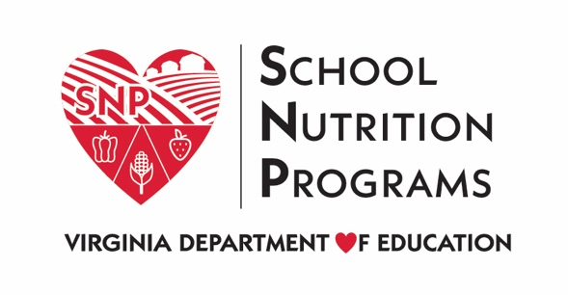

School Year 2020-2021 Waivers - CACFP
Waiver Title | Description | Sponsor Actions | Data Requirements
Nationwide Waiver to Allow Non-congregate Feeding in the Child Nutrition Programs | Program regulations require that participants consume meals onsite in the child nutrition programs. This waiver allows meals to be taken offsite for consumption.  Effective: July 1, 2020 through June 30, 2021 | CACFP Sponsors must request to elect this waiver from the VDOE by completing the 2020-2021 At-Risk CACFP Waiver Survey. | - A summary of the use of the waiver by the state agency and local program operators.  - A description of whether and how this waiver resulted in improved services to program participants.
Nationwide Waiver to Allow Meal Service Time Flexibility in the Child Nutrition Programs | Program regulations set mealtime restrictions for child nutrition programs. This waiver supports access to nutritious meals by eliminating the time requirements.  Effective: July 1, 2020 through June 30, 2021 | CACFP Sponsors must request to elect this waiver from the VDOE by completing the 2020-2021 At-Risk CACFP Waiver Survey. | - A summary of the use of the waiver by the state agency and local program operators.  - A description of whether and how this waiver resulted in improved services to program participants.
Nationwide Waiver to Allow Parents and Guardians to Pick-up Meals for Children | Program regulations site specific times must pass between meals. This waiver allows for sponsors to serve meals that best meet their program needs. This can be through approved pick-up times or delivery plans with designated times for distribution.  This waiver requires an approved non-congregate waiver.  Effective: July 1, 2020 through June 30, 2021 | CACFP Sponsors must request to elect this waiver from the VDOE by completing the 2020-2021 At-Risk CACFP Waiver Survey. | - A summary of the use of the waiver by the state agency and local program operators.  - A description of whether and how this waiver resulted in improved services to program participants.
Nationwide Waiver to Allow Meal Pattern Flexibility in the Child Nutrition Programs | Program regulations require that sponsors follow a prescribed meal pattern. During the public health emergency, sponsors can apply to the state agency for flexibilities in the meal pattern. Under normal emergency feeding, the USDA would have to approve these flexibilities; this waiver allows the state agencies to approve requests from sponsors to waive meal pattern requirements.  This requires justification and approval from the VDOE before implementation.  Effective: July 1, 2020 through June 30, 2021 | CACFP Sponsors must request to elect this waiver from the VDOE by completing the 2020-2021 At-Risk CACFP Waiver Survey. | - A summary of the use of the waiver by the state agency and local program operators.  - A description of whether and how this waiver resulted in improved services to program participants
Nationwide Waiver of Onsite Monitoring Requirements for Sponsors in the CACFP | This waiver allows sponsors of the CACFP to continue to monitor activities offsite. The waiver encourages desk audits.  Effective through September 30, 2021. | CACFP Sponsors must request to elect this waiver from the VDOE by completing the 2020-2021 Monitoring Waivers Survey. | - A summary of the use of the waiver by the state agency and local program operators.  - A description of whether and how this waiver resulted in improved services to program participants.
State Agency Nationwide Waiver of Onsite Monitoring Requirements for State Agencies in the CACFP | This waiver allows the VDOE to conduct CACFP monitoring offsite.  Effective through September 30, 2021. | No Action Required | - A summary of the use of the waiver by the state agency and local program operators.  - A description of whether and how this waiver resulted in improved services to program participants.
Questions and Answers for the Child Nutrition Programs during School Year 2020-2021 #5 | This guidance nullifies the 2018 Final Rule entitled Child Nutrition Program: Flexibilities for Milk, Whole Grains, and Sodium Requirements. The CACFP meal pattern must return to the requirements of the 2012 Final Rule, requiring that flavored milk only be nonfat.  Effective immediately | CACFP Sponsors may request to elect this waiver from the VDOE by completing the 2012 Nutrition Standards Final Rule Waiver Survey. | - A summary of the use of the waiver by the state agency and local program operators.  - A description of whether and how this waiver resulted in improved services to program participants.

