Attachment A, SNP Memo #2020-2021-06

July 17, 2020

Screenshots of New Direct Certification Functionality
School Year 2019-2020: No Direct Certification (DC) matching allowed after June 30 annually.
DC Export File available for download but not for editing.
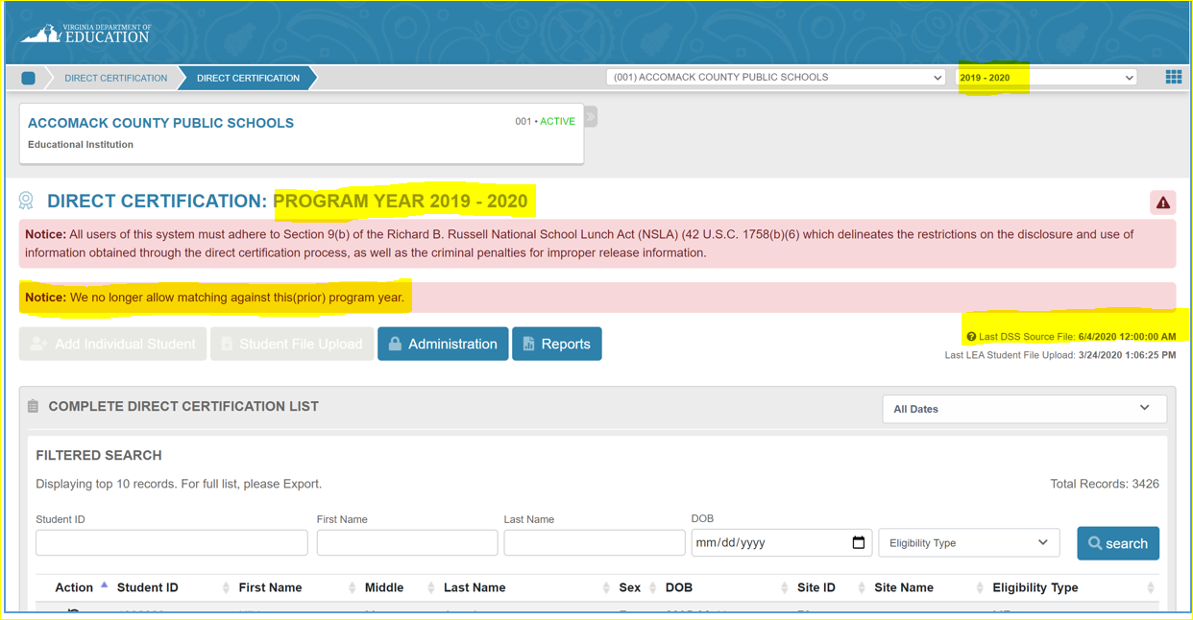

School Year 2020-2021: No DC matching allowed from July 1 until first Department of Social Services source file is available.
See Last DSS source file date for new file in third week of July and monthly after that around the fifteenth of each month through June, annually.
