SNP Memo #2021-2022-44
COMMONWEALTH of VIRGINIA
Department of Education
DATE: June 10, 2022
TO: Directors, Supervisors, and Contact Persons Addressed
FROM: Sandra C. Curwood, PhD, RDN, Sandy

SUBJECT: Summer and School Year 2022–2023 USDA Waiver Tools
The purpose of this memo is to provide information on the election of the U.S. Department of Agriculture (USDA) waivers for the National School Lunch Program (NSLP), School Breakfast Program (SBP), Fresh Fruit and Vegetable Program (FFVP), Seamless Summer Option (SSO), Summer Food Service Program (SFSP), and the At-Risk Afterschool component of the Child and Adult Care Food Program (CACFP). Data reporting is a requirement for all program sponsors utilizing USDA waivers. The Virginia Department of Education, Office of School Nutrition Programs (VDOE-SNP) is collecting waiver data through the USDA Waiver Tools in SNPWeb.
Waivers must be elected by the sponsor and approved by the VDOE-SNP within the USDA Waiver Tools before being implemented by each site. When completing the waiver elections, sponsors must check the box next to “reasons for needing the waiver” for all waivers a site will be utilizing.
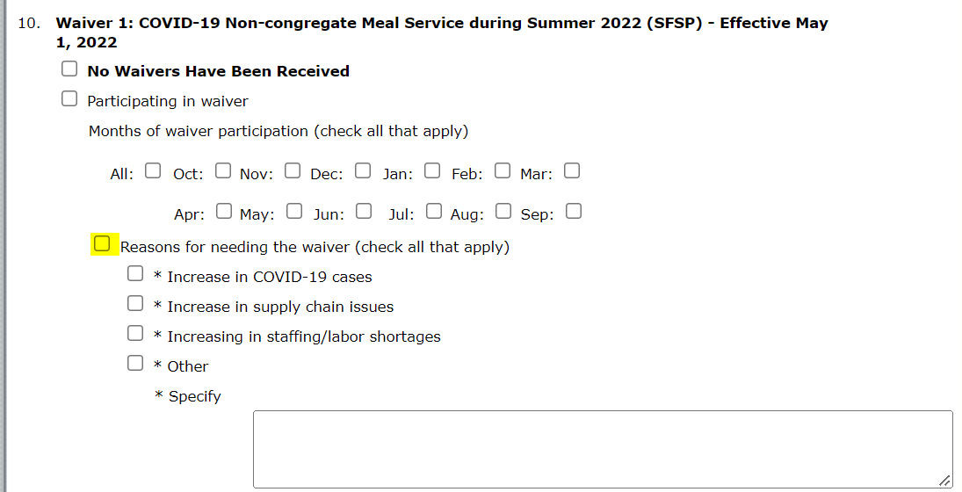
Sponsors must keep all waiver justification documentation on file for three years plus the current year. Please notify your assigned regional specialist via email after waiver tools have been submitted.
Each waiver listed below is located in the SNPWeb USDA Waiver Tools for the specified programs.

Summer Food Service Program/Seamless Summer Option Waivers
The summer 2022 waivers outlined below are effective May 16, 2022–September 30, 2022. However, these waivers must only be implemented by sponsors when congregate meal service is limited by the COVID-19 pandemic.
- Waiver 1: Non-congregate Meal Service during Summer 2022 (SFSP/SSO)
- Waiver 2: Parent and Guardian Meal Pick Up during Summer 2022 (SFSP/SSO)
School food authorities (SFAs) operating the SSO during summer 2022 must elect these waivers within the 2021–2022 SNP waiver tool. Sponsors operating the SFSP during summer 2022 must elect these waivers within the 2021–2022 SFSP waiver tool.

National School Lunch Program/School Breakfast Program Waivers
The waivers for school year 2022–2023 outlined below are intended to provide needed flexibility to support SFAs in continuing to offer nutritious meals. These waivers are available through June 30, 2023, and should only be implemented by sponsors when congregate meal service is limited by the COVID-19 pandemic.
- Waiver 3: Non-Congregate Meal Service (NSLP and SBP)
- Waiver 4: Parent and Guardian Meal Pick Up (NSLP and SBP)
- Waiver 5: Meal Service Times (NSLP and SBP)
- Waiver 6: Offer Versus Serve (NSLP)
- Waiver 26: Carryover Eligibility (NSLP and SBP)

Fresh Fruit and Vegetable Program Waivers
- Waiver 14: Parent and Guardian Pick Up (FFVP)
- Waiver 15: Alternate Site (FFVP)

Child and Adult Care Food Program Waivers
- Waiver 20: Non-Congregate Meal Service (CACFP)
- Waiver 21: Parent and Guardian Meal Pick Up (CACFP)
- Waiver 22: Meal Service Times (CACFP)
For more information about the individual waivers, please refer to SNP Memo #2021-2022-42 or the Summer Feeding and School Year 22-23 Waivers Webinar Recording from May 26, 2022. If you have any questions about waiver election reporting, please contact your assigned SNP or CNP regional specialist.
SCC/AMN

