Attachment B, SNP Memo No. 2022-2023-20

September 2, 2022

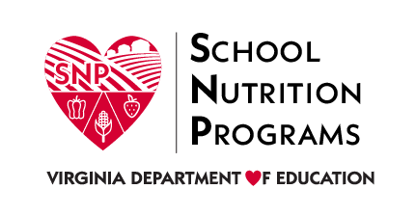
Program Year 2022–2023
At-Risk Portion of the Child and Adult Care Food Program Waivers
Topic | Waivers Available for Program Year 2022–2023 Operations
Non-congregate Meals | This waiver allows sponsors to serve CACFP meals in a non-congregate setting. With this waiver, children do not need to consume meals on-site.
Meal Service Times | This waiver eliminates the requirements for CACFP meal service times allowing sponsors to implement non-congregate feeding and parent/guardian pick-up.
Parent or Guardian Pick-up | This waiver allows At Risk portion of CACFP meals and snacks to be provided to parents or guardians instead of directly to children.

